June 2018 Whisperings from the
Tall Pines Quilt Guild
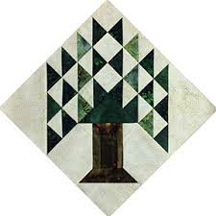

Upcoming Programs and Meetings
July 2 – Winnie Fleming
Stars and Scrap Exchange
July 3 – Winnie Fleming workshop – Stars Table runner

July Birthdays
Susan Thompson 7/8
Barbarra Corcoran 7/10
Marti Hubbard 7/12
Jeanette Allen 7/18
Toni Bruner 7/18
Ann Moore 7/19
Barbara Pearson 7/20
Teresa Cazort 7/26
Ruth West 7/28

Publisher: Diane Carrington Volume Number 109 Issue Number 108
From the President
It is 10:30 in the evening on Friday and I am making my blocks for the block of the month at Fabric Carousel for Saturday morning. Does this sound familiar? I really enjoyed our guest speaker on Monday evening! Those beautiful linens and the "ghost stories" were interesting. Cindy Needham is very talented and also a great teacher. I was able to take the workshop on Monday and Tuesday and learned so much. It will take a lot of practice.
Our donation quilt is ready to display and sell tickets. The tickets are at Fabric Carousel and Doris has them packaged for us to sell. We don't have a picture yet, but take one with your phone and you can show off the beautiful work everyone did. We will be selling tickets at the July Shop Hop and we will need members to sign up to work Friday and Saturday. The sign-up sheet will be at Fabric Carousel.

Hope you all have a wonderful June!

Martha Wilson

Sunshine and Shadows
Congratulations to Melanie Burleson, she has a new granddaughter. Our thoughts and prayers go out to Evelyn Dawson her husband had surgery and is doing well. Helen Cook’s son, Mark, who is 57, is in Kingwood Hospital with a brain tumor discovered this morning. He is in ICU until surgery in the morning to determine if it is benign. The tumor appears to be small but surgery will determine future treatment. Helen requests prayers from her guild friends. Earlier this week, Evelyn Dawson's husband Bill was taken to Conroe Regional Medical Center. The diagnosis was a brain bleed and stroke. He underwent what appears to be a successful operation. He is presently in an induced coma and most likely will be awakened tomorrow and transferred to ICU for several days.
Thanks Ruth West and Betty Gratz
Treasurer’s Report
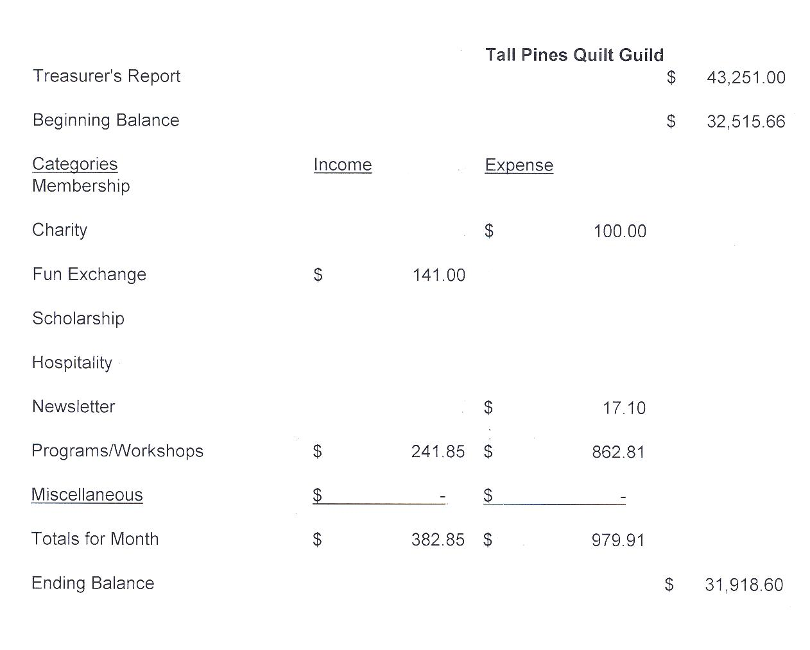
Tall Pines Quilt Guild Minutes of Meeting
Tall Pines Quilt Guild
Meeting Minutes
June 4, 2018
Katy & E.Don Walker Museum

President, Martha Wilson, called the meeting to order, welcomed members and guests and recognized June birthdays.

The May minutes were printed in the newsletter. There being no corrections noted, a motion was made by Janis Voldbakken and seconded by Martha Fielder. Motion passed.

Copies of the treasurer’s report were available for review on the sign-in table.

Diane Carrington reported that the donation quilt is finished and ready for Kristie Munson to take pictures to include with the raffle tickets. Tickets have been ordered and will be ready this Thursday.

By a show of hands, it was decided that t-shirts will be the choice for Airing of the Quilts. More information will be forthcoming.

The Shop Hop is coming up in July. The guild will have a booth where we will display the raffle tickets and sell tickets. Small items will also be sold. Sign-up sheets are available to help set up and also sell tickets and man the booth.

Martha Wilson reported that the Fair on the Square committee has not released the available booth spaces yet. Martha will get an email when that information becomes available. We will not be sharing a booth with Virginia Cooper because she will be selling raffle tickets for a quilt and we do not want to take away any potential customers from her.

Anyone wishing to participate in this year’s TDA Quilt competition should look up the information online. The deadline is July 2nd.

The next charity bee gathering will be on June 19th, at Fabric Carousel. There are quilts that need embellishing and some that need quilting. Please come and help.

Susan Craig showed the baby quilts that she made from the Sesame Street Block Challenge entries. They looked great. Thanks, Susie!

D-Ann Gilmore gave an update on next month’s program and showed a sample of the project for the workshop. A sign-up sheet was available. She also introduced tonight’s program presenter, Cindy Needham. Her topic was For the Love of Linens. Her talk was very interesting and her work was fabulous!

Due to time constraints, no door prizes were awarded and Fun Fund was not held this evening.

Diane Carrington reminded members that information to be included in the newsletter needs to be submitted by noon on Friday. Cathy Wilson reported that there were 59 members and 9 guests present this evening.

Show & Tell was held, hosted by Kelli Anne Langley.

Ashley Buehring will be teaching a jelly roll race class on June 30, from 10-2 and a, beginner’s hexie class on August 4th from 10-2. Both classes will be held at Fabric Carousel. Supply lists are available at that location,

Executive Board meeting for June will be held on June 11, 2018 at 5:30 pm at Fabric Carousel.

There being no further business, the meeting was adjourned.

That’s all??? Frayed Sew!!
Elaine Robinson, Secretary

Programs Updates
TALL PINES QUILT GUILD 2018-2019 PROGRAMS

D-Ann Gilmore, Program Chairman
July 2 – Winnie Fleming will present a program called Stars and Scrap Exchange. Her workshop the following day is a Lone Star Table Runner where we will learn how to make perfect stars without cutting off the points.

August 6 – Peggy Richards is an award-winning quilter whose trunk show will take your breath away. We will also have a show and tell of the summer project made by our young quilters from Alpha Omega.

August 27 – Patti Nethery will give us a demonstration of her rulers entitled Piecing the Ruler Revolution Way along with a trunk show of her beautiful quilts.

October 1 – Open to suggestions

November 5 – UFO Challenge

December 5 – Christmas party

January 7 – Jackie Hillman will give a Powerpoint presentation and trunk show entitled the “Goose is Loose on the Ranch” followed by a workshop the next day using flying geese to make a table runner.

April 1 – Dena Rosenberg will give us a trunk show followed by a workshop the next day making the pattern Seven Sisters.
Members
There are currently 113 members in our guild. At the June meeting, there were 59 members and 9 visitors in attendance.

2018 SCHOLARSHIP:
2018 SCHOLARSHIP WINNERS

The TPQG Scholarship Committee members (Monte Knight, Janis Voldbakken, Judith Oliver) are pleased to announce that once again we have two outstanding scholarship recipients. Many of you are acquainted with our SEWING PROFICIENCY winner – VICTORIA BOUNDS, who has been sewing since the age of six. Victoria has been a participant in the Walker County Fair 4-H competitions and in the Quilt competitions for many years. A graduate of Huntsville High School, Victoria plans to attend Stephen F. Austin University with a major in Interior Design and a minor in Architecture. Our MATH EDUCATION winner is JOSHUA CURRY, a graduate of Coldspring-Oakhurst High School with numerous scholastic and athletic achievements. Joshua plans to pursue a career in math education at Angelina College or Stephen F. Austin. In his five-year plan, Joshua expressed “I want to be the role model that so many young children do not have in their lives”. Both students exhibited outstanding motivational and leadership attributes as well as excelling in their scholastic endeavors. Each recipient will receive a $1,500 scholarship. We cannot thank the membership enough for their support of the youth of our community. Let’s sell lots of tickets for next year’s Donation Quilt so we can continue to provide scholarship opportunities for our accomplished youth.

Fat Quarter Exchange:
We will be having a fat quarter exchange at the next guild meeting. Bring any number of fat quarters and then we will trade with others. You will go home with the same number of fat quarters but a variety. Our colors for the July meeting is RED, WHITE, and BLUE (of course). Remember you can make a nice size top with six fat quarters. If you have any questions just give me a call. Thanks! Janis
Show and Tell
- Janis Voldbakken, Martha Fielder, Jean Garner – Fat Quarter Challenge Group
- Grettle Payne – R2D2 Revised
- Ruth West – Amanda’s Quilt
- Wendy Salsbery – Wall hanging
- Jeanette Allen – Dresden Plate Wall hanging
- Victoria – Eagle
- Ann Moore – Ruler Quilt
- Judy Springer – Wedding Quilt
Bee News
Charity Bee
The next Charity Bee meeting will be Tuesday, June, 19, 2018 at Fabric Carousel (FC). There are several pinned HUGs in the laundry basket at FC needing to be completed with simple quilting and binding. Also, if you can help cutting/sewing walker caddies, Barbara Pearson would ever so much appreciate the help.
Cut-ups
Cut Ups will meet on the 2nd and 4th Friday each month at the Fabric Carousel. All are Welcome. Bring your quilting problems for lots of advice and help from your friends. Bee starts around 10 and lasts all day.
Embroidery Bee
We meet on the third Saturday of the month at 11 AM, at the Ohendalski building, next door to the Chicken place across from the mall. 1425 Brazos Dr. Contact Susan Craig for info. 436-1489
Wanted: Barbara Yoes would like to purchase a used cutting table. If you have one, please contact Barbara at 936 295-5388.
For Sale:
Quilting beads, Craft and Jewelry making supplies for sale. (Make best offer)
OTT lamp for sale (just needs bulb) $45
Beautiful Brooches for sale $8 each

Tasha Fry 936-355-0049
tashdano30@gmail.com
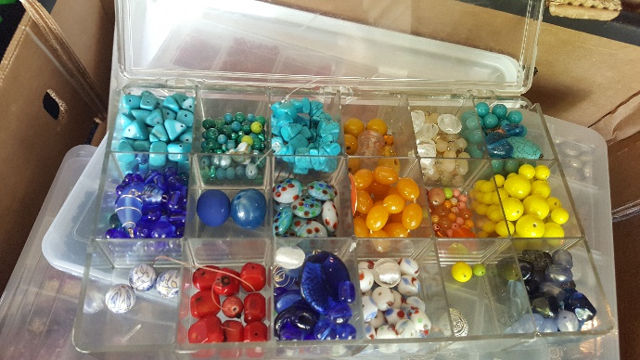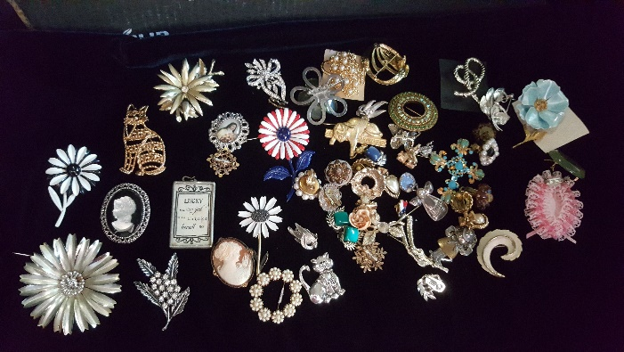

Donation Quilt

The quilt is finished!!! Raffle tickets are available at Fabric Carousel. Pick yours up there and sell, sell, sell!
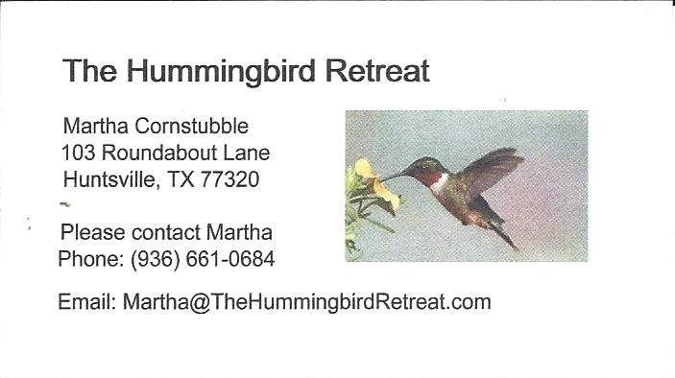
_{Newsletter ad prices are:}
$5.00 a month or $50.00 per year for a business card size advertisement.
$10.00 a month or $100.00 per year for a 3.5” x 4.5” size advertisement.
$18.00 a month or $180.00 per year for a one-half page advertisement.
$36.00 a month or $360.00 per year for a full page advertisement.
Member ads are free and will run for one month per request
Thank you Kim Street for sharing your fabulous cake recipe
Banana Split Dessert.
Ingredients
4-5 bananas, sliced
1 (20 oz) can crushed pineapple, drained
8 oz strawberries, cut in small pieces

1/4 c granulated sugar
2 c Graham cracker crumbs

16 oz Cool Whip
1 stick butter
2 packages cream cheese, softened

1 jar Maraschino cherries
Chocolate syrup

Chopped pecans if desired

Directions
1. Preheat oven to 350*. Spray a glass 9 x 13 pan with cooking spray.
2. Melt butter and mix with Graham Cracker crumbs and sugar. Mix with fork until crumbs are all moistened. Dump crumb mixture into pan and press into even layer. Bake 10 minutes at 350*. Cool completely before adding next layer.
3. Mix cream cheese and 1/2 Cool Whip with mixer on medium speed. Spread evenly over cooled Graham Cracker crust.
4. Put banana slices in a layer on top of cream cheese. Top with an even layer of drained pineapple and then an even layer of cut up strawberries.
5. Cover with the remainder of the Cool Whip. Drizzle chocolate syrup. Add pecans, if desired. Place cherries on top, spacing evenly.
6. Refrigerate at least 2 hours. Enjoy!

Notes
It's better to prepare dessert the same day you are planning on serving it, otherwise the bananas may start to turn brown. Refrigerate any leftovers, covered, for up to 4 days.

_{Tall Pines Quilt Guild}
_{P.O. Box 7272}
_{Huntsville, Texas 77342-7272}

_{Tall Pines Quilt Guild Meeting} _{Guild Calendar Reminders}
You are invited to join us the first Monday of July 2, 2018, 6:30 PM Guild Meeting
each month. The guild has a variety of _{June 19, 2018 Charity Bee}
programs, nationally known speakers, _{Meeting Reminders:}
_{workshop and charity projects.} _{Bring Show and Tell Items}
We meet at the University Heights Baptist Church _{Bring money for Food Bank}
_{2400 Sycamore Ave.} _{UPC Labels from Hobbs batting}
Park in the back lot off Palm Ave. _{FQ Bands from Fabric Carousel}
Refreshments are served at 6:30PM _{For Charity Bee}
and the meeting starts at 7 PM. Visit the web site @ www.tallpinesquiltguild.com
