August 2018 Whisperings from the
Tall Pines Quilt Guild
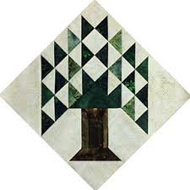

Upcoming Programs and Meetings
8/27 Patti Nethery
Piecing the Ruler Revolution
Aug 21 Charity Bee

September Birthdays

Jammie Ackley 9/3
Grace Burzynski 9/11
Virginia Cooper 9/15
Cynthia Cross 9/17
Mona Smidt 9/18
Cathy Wilson 9/18
Helen Cook 9/30

Publisher: Diane Carrington Volume Number 111 Issue Number 110
From the President

Greetings to my fellow quilters! We had a busy meeting on Monday and what wonderful quilts shown by Peggy Richardson! They were all beautiful. There are a few events coming up for members to get involved in. First, we will be selling raffle tickets for our donation quilt at the Huntsville Antique Show on September 15, 2018. I need volunteers to help sell tickets.

Doris Collins has offered us the front of her classroom to sell things and raffle tickets for the Fair on the Square on October 6, 2018. We also need volunteers to man the area for the day. The sign-up is at Fabric Carousel.

We had a successful first showing of our Donation Quilt at the Shop Hop in July. We sold $425 worth of tickets.

The annual Houston Quilt Festival bus trip will be November 8th. The cost of the trip, which includes a ticket to the show is $50.00.

Don't forget the next meeting for September, will be August 27th due to Labor Day. Looking forward to seeing you there.

Martha Wilson

Sunshine and Shadows
Please keep Evelyn Dawson in your thoughts and prayers for her husband who had a stroke, also keep Eloise McGalliard in your prayers on the loss of her husband, and Nancy Nelson whose husband may have a blood clot. We want to congratulate D-Ann Gilmore on the recent marriage of her daughter. If anyone knows of a Sunshine or Shadows please contact either Ruth West or Betty Gratz
Fair on the Square
We will be participating in Fair on the Square on October 6, 2018. Doris Collins has allowing us to use the front part of her classroom area to set up to sell raffle tickets and other items. If anyone wants to make things to sell, there are forms and tickets at the Fabric Carousel in the classroom area. If you sell items, the guild will get 15% of the price, so price your things accordingly. Please do not include any "garage sale" items for sell. If you are making and selling things, you will be expected to work the sales area at some time during the day. I also have patterns available at Fabric Carousel for members to make things for donation to the guild. If you have any other ideas of items to sell, let me know. Call me at 936-662-9202 if you have questions.

Treasurers Report
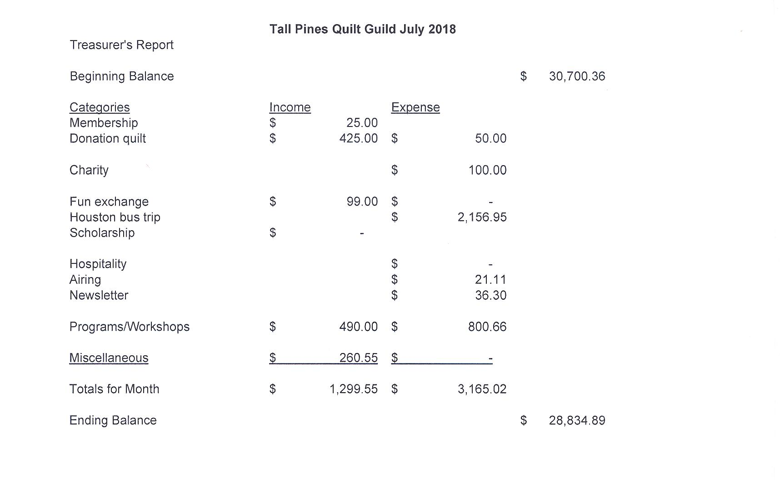

Tall Pines Quilt Guild Minutes of Meeting
Tall Pines Quilt Guild
Meeting Minutes
August 6, 2018
University Heights Baptist Church

President, Martha Wilson, called the meeting to order, welcomed members and guests and recognized August birthdays.

Jane Richmond had tickets for sale for the Raffle Quilt benefiting the Crockett Quilt Guild.

The July minutes were printed in the July newsletter. As there were no additions or corrections noted, Janis Voldbakken made a motion to accept the minutes as printed. Helen Belcher seconded the motion. Motion passed.

Kay Ohendalski provided the treasurer’s report on each table for members’ review. Any questions should be directed to Kay.

Rhonda introduced the young girl’s summer quilt class participants. Each girl showed their quilt and told the group what they had named their quilt. They all did a great job!!!

Judy Oliver introduced the two scholarship winners for this year. Thanks to donations received, two $1,500 scholarships were given this year. One was presented for proficiency in sewing and the other for intent to major in mathematics. Congratulations to both!

Tickets are available to sell for the raffle quilt.

Volunteers are needed to sell raffle tickets for the donation quilt on Saturday 9/15 at the Antique Show held at the Walker County Fairgrounds. There will be two shifts available and at least two people need to be available to fill each of those shifts. The show is from 10-5. Sign-up sheets are available.

Doris Collins has offered the front portion of her classroom area to sell raffle tickets and other items during Fair on the Square on October 6th. There is a sign-up sheet available as volunteers will be needed to oversee the sales. Kits, leftover from last year, and patterns are available to anyone who wishes to make something to sell. If members would like to sell something for themselves, a form is available as well. If you plan on selling personal items, please be sure to volunteer to work.

Tickets for the bus trip to the International Quilt Festival in Houston, on November 8th, will be $50. More information will be forthcoming as the time gets closer.

D-Ann Gilmore reminded members of upcoming programs and also told about a different way that the UFO challenge will be conducted. In December, members who would like to participate, will fill in a form with up to 12 projects listed. These can be as simple as, “complete one block for Christmas quilt” or “sew binding on 30’s quilt”. Each month, a number will be drawn and the corresponding number on your sheet is the task that needs to be completed by the following month’s meeting. For each task successfully completed on time, a ticket will be entered in a drawing which will be held at the end of the year.

This evening’s program was presented by Peggy Richards. Peggy showed the group a wide variety of pieced and appliqued quilts. Beautiful work!!!!!!!!!!

Door prize and Fun Fund tickets were drawn. Congratulations to all the winners.

Cathy Wilson reported that there were 56 members and 27 visitors present this evening

Show & Tell was hosted by Kelli Anne Langley

.The July Executive Board meeting will be held on August 13, 2018 at 5:30 pm at Fabric Carousel.

There being no further business, the meeting was adjourned.

Quilting Binds us Together,
Elaine Robinson, Secretary
Quilt Barn Squares
Everyone is invited to the Davy Crockett Quilt Guild on Tuesday, August 14, 2018 at 6p.m. They meet at the United Methodist Church 3913 US 287 W, Grapeland, Texas. Patti Wolf, the person behind the Quilt Barn Trail in Texas or the newest. Trail in Nacogdoches County. Patti will tell her story and give everyone there ideas on how to get a barn quilt trail started in your area.
Programs Updates
TALL PINES QUILT GUILD 2018-2019 PROGRAMS
D-Ann Gilmore, Program Chairman
August 27 – Patti Nethery will give us a demonstration of her rulers entitled Piecing the Ruler Revolution Way along with a trunk show of her beautiful quilts.

October 1 – Rhonda Dort will present a program on Designing Unique Quilts Using Vintage Linens followed by a hands-on workshop the following day.

November 5 – UFO Challenge

December 5 – Christmas party

January 7 – Jackie Hillman will give a Powerpoint presentation and trunk show entitled the “Goose is Loose on the Ranch” followed by a workshop the next day using flying geese to make a table runner.

April 1 – Dena Rosenberg will give us a trunk show followed by a workshop the next day making the pattern Seven Sisters.
Members
Tall Pines Quilt Guild currently has 117 members. There were 56 members and 24 visitors at the August meeting! Please join me in welcoming our two newest members:

Dee Ross
PO Box 602
Point Blank, 77364
Cell: 936-329-1033
BD: May 24
Spouse: Don
donsgrl@yahoo.com

Patty Sorensen
11 Webb Creek Pl.
The Woodlands, 77382
Cell: 281-825-9134
BD: Feb. 15
Spouse: Craig
psorenhome@comcast.net

Door Prizes:
Two Fall patterns and Fat Quarters – Judy Cannon
Two Fall patterns, Book and Quick Quarter Ruler – Beverly Wiggins
Book “The Sister Blocks” and thread cutter – Toni Bruner
President’s Prize – Dorothy Wolverton
Fun Exchange:
Sycamore fabric and Charms – Pam Ray
Mosaic Line by Shannon Brinkley – Tasha Fry
Mosaic Line by Shannon Brinkley – Cathy Wilson
Show and Tell
- Dorothy Wolverton – 3 feathered star blocks
- Barbara Edmondson – 2 totes
- Diane Carrington – 2 Tablerunners (1 was Virginia Wilson’s)
- Ann Moore – Oregon Trail quilt
- Jean Bradley and Janis Voldbakken – Fat quarter quilts from class
- D-Ann Gilmore – Ahoy baby quilt
- Liz Williams – Deck the Halls block and Noel Embroidery
- Grettle Payne – Christmas tree quilt for Charity
- Grace Burzynski – Vintage butterfly quilt
- Patty Sorensen – Quick tote

Bee News
Charity Bee
$36 was collected for the Good Shepherd Mission Food Bank at the August guild meeting, bringing the YTD total to $362.00.

The next Charity Bee meeting will be Tuesday, August 21, beginning at 9:30 at Fabric Carousel.

We have only four meetings remaining for the year, so if you want to get the HUGs and other charity projects you are currently working on into the December delivery this year, we need them turned in by the November Charity Bee meeting. The laundry basket in the Fabric Carousel workroom is full of HUGs that are pinned and waiting for finishing. If anyone would like to have a HUG prepared for a longarm, let us know.

Thank you to all who continue to work on the HUGs, walker caddies, crocheted baby caps, and donations of Hobbs Batting UPC labels and Fabric Carousel fat quarter wrappers.
Cut-ups
Cut Ups will meet on the 2nd and 4th Friday each month at the Fabric Carousel. All are Welcome. Bring your quilting problems for lots of advice and help from your friends. Bee starts around 10 and lasts all day.
Embroidery Bee
We meet on the third Saturday of the month at 11 AM, at the Ohendalski building, next door to the Chicken place across from the mall. 1425 Brazos Dr. Contact Susan Craig for info. 436-1489

Mexican Cheese Dip

1 pkg good seasoning Italian dress mix, make according to directions
½ bunch cilantro, chopped
4 green onions chopped
4 oz can green chilies chopped
4 oz can chopped black olives
6 roma tomatoes chopped
8 oz Monterey Jack cheese shredded
8 oz pepper jack cheese shredded
Mix all together

Diane’s Tips and Grins

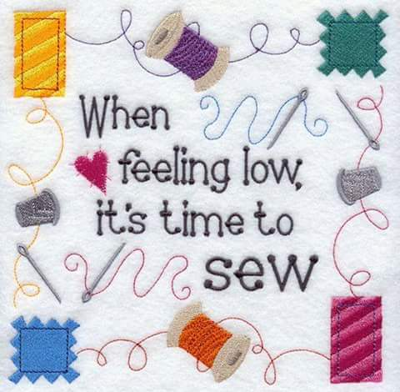
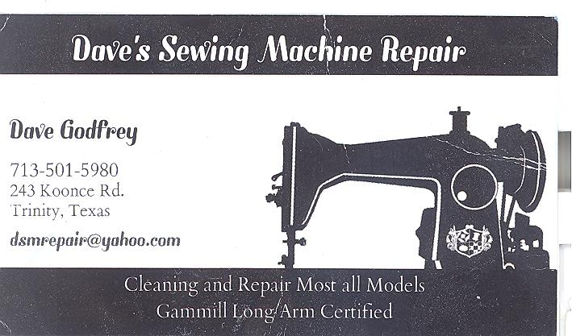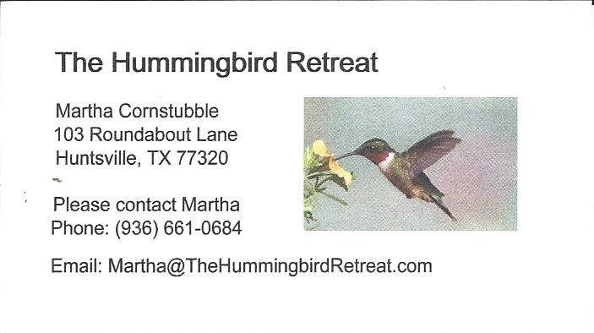
_{Newsletter ad prices are:}
$5.00 a month or $50.00 per year for a business card size advertisement.
$10.00 a month or $100.00 per year for a 3.5” x 4.5” size advertisement.
$18.00 a month or $180.00 per year for a one-half page advertisement.
$36.00 a month or $360.00 per year for a full page advertisement.
Member ads are free and will run for one month per request
_{Tall Pines Quilt Guild}
_{P.O. Box 7272}
_{Huntsville, Texas 77342-7272}

_{Tall Pines Quilt Guild Meeting} _{Guild Calendar Reminders}
You are invited to join us the first Monday of August 27 , 2018, 6:30 PM Guild Meeting
each month. The guild has a variety of _{August 21, 2018 Charity Bee}
programs, nationally known speakers, _{Meeting Reminders:}
_{workshop and charity projects.} _{Bring Show and Tell Items}
We meet at the University Heights Baptist Church _{Bring money for Food Bank}
_{2400 Sycamore Ave.} _{UPC Labels from Hobbs batting}
Park in the back lot off Palm Ave. _{FQ Bands from Fabric Carousel}
Refreshments are served at 6:30PM _{For Charity Bee}
and the meeting starts at 7 PM. Visit the web site @ www.tallpinesquiltguild.com
