September 2017 Whisperings from the
Tall Pines Quilt Guild
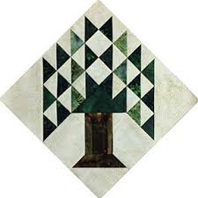

Upcoming Programs and Meetings

October Birthdays

Publisher: Diane Carrington Volume Number 101 Issue Number 100
From the President

Sunshine and Shadows
Our contact info is Betty Grantz phone # 936-438-0465, email lobag1961@gmail.com or Ruth West 847-638-3899, email quilterrw@livecom. We are looking forward to hearing about your Sunshine and Shadows.
Tall Pines Quilt Guild Minutes of Meeting
Program Report

PQG Baby Block Challenge 2017

The Baby Block Challenge will use fabric from the Elmo and Friends collection from Sesame Workshop for Quilting Treasures. The focus fabric is bright and suitable for either boys or girls with lots of color choices. You will get a 10’ square of the focus fabric from Fabric Carousel free of charge. Doris Collins has donated all fabric for the challenge. Use additional fabrics from your stash or check out the fat quarters at the Carousel to complete your block. For those wishing to make more than one block, the fabric used in the challenge is available for purchase at Fabric Carousel. Be sure to follow all instructions for making your block.

Rules:
• Block size 12” finished – 12½” unfinished.
• Must include focus fabric.
• Use coordinating fabric of your choice (100% cotton). You may want to prewash fabrics if using bright colors.
• Can use any pattern on the block but should be appropriate for a baby quilt – no buttons, etc.
• Applique, both machine and hand, will be allowed but designs should be soft, no stiff threads.
• All finished blocks should be returned byOctober 26, 2017 to Fabric Carousel.
• Most of all have fun with designing and constructing your challenge block.
Questions - call Helen Belcher at 936-438-1470 or email at hxb004@shsu.edu
Treasurer’s Report
Membership Updates

Door Prizes
Fun Exchange
Bee News
Charity Bee

Cut-ups
Cut Ups will meet on the 2nd and 4th Friday each month at the Fabric Carousel. All are Welcome. Bring your quilting problems for lots of advice and help from your friends. Bee starts around 10 and lasts all day.
Embroidery Bee
We meet on the third Saturday of the month at 11 AM, at the Ohendalski building, next door to the Chicken place across from the mall. 1425 Brazos Dr. Contact Susan Craig for info. 436-1489

Diane’s Grins and Tips

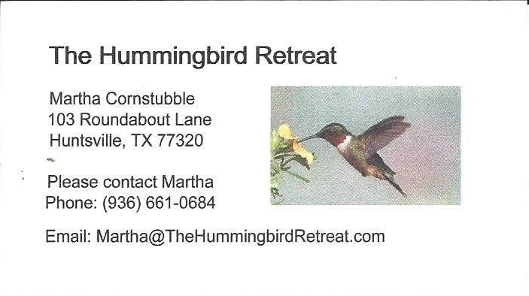
_{Newsletter ad prices are:}
$5.00 a month or $50.00 per year for a business card size advertisement.
$10.00 a month or $100.00 per year for a 3.5” x 4.5” size advertisement.
$18.00 a month or $180.00 per year for a one-half page advertisement.
$36.00 a month or $360.00 per year for a full page advertisement.
Member ads are free and will run for one month per request

_{Tall Pines Quilt Guild}
_{P.O. Box 7272}
_{Huntsville, Texas 77342-7272}

_{Tall Pines Quilt Guild Meeting} _{Guild Calendar Reminders}
You are invited to join us the first Monday of August 7, 2017, 6:30 PM Guild Meeting
each month. The guild has a variety of _{August 15, 2017 Charity Bee}
programs, nationally known speakers, _{Meeting Reminders}
_{workshop and charity projects.} _{Bring Show and Tell Items}
We meet at the University Heights Baptist Church _{Bring money for Food Bank}
_{2400 Sycamore Ave.} _{UPC Labels from Hobbs batting}
Park in the back lot off Palm Ave. _{FQ Bands from Fabric Carousel}
Refreshments are served at 6:30PM _{For Charity Bee}
and the meeting starts at 7 PM. Visit the web site @ www.tallpinesquiltguild.com

