June 2019 Whisperings from the
Tall Pines Quilt Guild
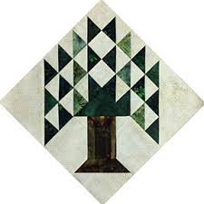

Upcoming Programs and Meetings

June 18th – Charity Bee
June 22nd – Potholder Workshop
July 1st – Guild Meeting

July Birthdays

Renee Page 7/6
Susan Thompson 7/8
Marti Hubbard 7/12
Jeanette Allen 7/18
Toni Bruner 7/18
Ann Moore 7/19
Barbara Pearson 7/20
Judy Cannon 7/21
Wanda Begnaud 7/24
Teresa Cazort 7/26
Ruth West 7/28

Publisher: Diane Carrington Volume Number 118 Issue Number 117
From the President
Greetings Patriots,
I enjoyed listening to and seeing all the quilts that Debby Walters and Kim Buchmann had on Monday night. It was interesting seeing all the stages they have gone through to come to where they are now in their quilting career. My problem is that I like all kinds for quilts, Civil War, 30's, batiks, bright fabrics and of course my favorite, red, white and blue. Maybe I should narrow down my interests!
A reminder to think about the Fair on the Square October 5, 2019. The guild will appreciate items to sell for our money maker this year. Remember, we did not have the Airing so we lost potential income from that show.
One of my favorite holidays is coming up, mostly because I love red, white and blue! Happy Fourth of July!
Martha Wilson

Sunshine and Shadows
Monte Knight’s husband Bob passed away this week. Services are June 19th at 2:00 at the Sam Houston Funeral Home.

SCHOLARSHIP UPDATE
First of all I would like to clarify that I made an error when I gave my scholarship report at our June Guild meeting - it was VIRGINIA COOPER (not Virginia Wilson) who served on our selection committee. Thank you to VIRGINIA COOPER and JANIS VOLDBAKKEN for serving on our Scholarship Selection Committee. This year we awarded two $1,500 scholarships both in the category of Sewing Proficiency:
1) CESAR FLORES of Huntsville High School was the recipient of a $1,500 scholarship. He will be attending SAM HOUSTON STATE UNIVERSITY majoring in Business Management with a minor in Banking. Cesar and his mother were present at our June 10th meeting where he shared his sample of sewing proficiency - a hand-sewn replica of our TPQG Logo. Cesar graciously donated his logo to our guild and it will be on display at our next meeting for your review.
2) ALYSSA CALKIN of New Waverly High School was the other recipient of a $1,500 scholarship. Alyssa plans to attend Blinn College and Texas A & M to pursue a career in neonatal nursing. Alyssa has been sewing with her grandmother (ELAINE ROBINSON) for many years and submitted pictures of her accomplishments. Alyssa will be introduced at our July meeting.
I would like to THANK ALL OF YOU for your hard work in raising funds to provide these scholarships for the young people in our community. Without your support these awards would not be possible. I would also to thank Doris Collins for always providing a meeting place and her encouragement for this project.,
Judy Oliver
TPQG Scholarship Chairman

Tall Pines Quilt Guild Minutes of Meeting
Tall Pines Quilt Guild
Meeting Minutes
June 10, 2019
Katy & E. Don Walker Museum

President, Martha Wilson, called the meeting to order, welcomed members and guests and recognized June birthdays.

The May minutes were printed in the newsletter. Ashlely Buehring made a motion to accept the minutes as printed. Janis Voldbakken seconded the motion. Motion passed.

No treasurer’s report was provided.

Rhonda Lynch showed a pillow which will be made on June 24th, 10-4 at Fabric Carousel. Cost is $25. There is a sign-up sheet for helpers with the young girls’ sewing club which will be held on the 2nd Sunday of each month.

Judy Oliver introduced one of the scholarship recipients. Cesar Flores received a $1500 scholarship from the guild. He showed a mini quilt top that he made as a project which featured the guild logo. Congratulations The other recipient will be recognized in July.

Grettel Payne showed some hotpads that she will teach a class on as a fundraiser for the Fair on the Square. All kits are already made up, just show up ready to sew on June 22nd at Fabric Carousel.

The UFO Challenge number for June is #2. These need to be completed by the July meeting.

The guild will again be participating in Fair on the Square on October 5th. There will be items for sale in the classroom at Fabric Carousel. Members are encouraged to make table runners and other small items for the sale. There is a collection box at Fabric Carousel for finished items.

Door prizes were awarded. Congratulations to the winners. There was no Fun Exchange this evening.

D-Ann reported that the July 1st guild meeting will be a surprise program. On August 26, Jan Matthews of JKMQuilting will present a lecture on the History and Development of Foundation Piecing. The following day, a workshop, featuring a table runner, will be held at Fabric Carousel. Cost is $55. A sign up sheet is available as well as a supply list with directions. See D-Ann Gilmore for more information and to sign up. She also introduced tonight’s presenters, Debby Walters and Kim Buchmann who showed the quilts they have made thru the years.

Committee reports were given.

Ashley Buehring hosted Show and Tell.

There will be no board meeting this month.

There being no further business, the meeting was adjourned.

Quilters Never Cut Corners!
Elaine Robinson, Secretary

Membership
The guild currently has 116 members. This month, we had 52 members and 2 visitors.
At the May meeting, there were 54 members and two visitors in attendance. We had one new member join at the end of April. Please join me in welcoming our newest member!

Georgia Taylor
PO Box 1832
Madisonville, 77864
Cell: 936-348-1136
BD: 5/20
georgiat.1832@hotmail.com

There were no new members tonight.

Programs Updates
D-Ann Gilmore, Program Chairman

July 1 – No program scheduled. REMINDER: Please bring No. 2 listed on your challenge sheet.

August 5 – No program scheduled

August 26 – Jan Mathews of JKMQuilting.com – The History and Development of Foundation Piecing. The workshop on Tuesday will be a table runner named Desert Sky designed by Judy Niemeyer using paper piece techniques.

October 7 - Cynthia Regone’s presentation will be “Kick It Up a Notch (brights at their best)” followed by a workshop the next day with a happy cheerful pattern called Funky Town Stars.

Guild Workshop

Amish Folded Star Potholders (photo attached)
Free workshop - free materials
Saturday, June 22, 11 am - 2 pm, Fabric Carousel
The fabrics are all cut and ready to sew.
Bring your sewing machine and neutral thread.
To sign up, please email grettlep@gmail.com

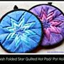

Jelly Roll Race

There will be a jelly roll race at Fabric Carousel July 13th, from 10:00 - 2:00. All fabric will be provided and all the quilts will be donated to charity. Just bring your sewing machine and thread and sew, sew, sew.

Door Prizes

- Book and 3 Fat quarters – Nancy Nelson
- Rotary Cutter – Martha Fielder
- Donuts on plate – Kay Ohendalski

Show and Tell
1.Pam Ray – Charity quilt
2.Diane Carrington – Mini Grandma’s Flower Garden
3. Robin Rodriquez – Charity Top
4. Dee Ross –
5. Janis Voldbakken – Grid Sampler
6. D-Ann Gilmore – Ten Sisters Mosaic
7. Judy Springer – 3 charity quilts
8. Barbara Pearson – Charity quilt
9. Jean Bradley – Small wall hanging
10. Kathy Pittman – Child size quilt
11. Liz Williams – 7 Sisters Table Runner
12. Kim Street – 3 wall hangings
13. Helen Belcher – Sam Houston Courthouse Quilt
14. Grettle Payne – Amish folded star potholders

Bee News
Charity Bee
The next Charity Bee is on Tuesday, JUNE 18, 2019, at Fabric Carousel, beginning at 9:30 am. At this meeting we will focus on cutting 2.5 inch strips for Rory's upcoming Jelly Roll Race (Sat., July 13). Look for Rory's information on this event elsewhere in the newsletter. (Thank you, Rory!) Charity Bee will gladly take donations of 2.5 inch strips and/or fabric that we can cut into strips. Please deliver either to the Fabric Carousel work room (labeled for Jelly Roll Race), bring to Charity Bee on June 18, the next guild meeting on July 1, or even as late as the event itself on July 13. For the Food Bank at the June guild meeting, we collected $22, bringing the YTD total to $201! At the half-way mark of last year (July) we had $326!! Hopefully donations for this worthy cause will pick up. As a reminder, Charity Bee collects Fabric Carousel fat quarter wrappers and Hobbs batting UPC labels. Still hoping that every member of the guild will complete at least one HUG for the year (and EVERY year). (Completing a HUG doesn't mean from start to finish, although that would be fantastic; you can JUST piece a top or you can JUST quilt a pinned top. OR make a baby blanket!) This would really increase our donations to our charitable recipients!! We also donate baby bibs, adult bibs, baby burps, crocheted baby beanies, baby blankets, walker caddies, adult lap quilts (for the wheelchair bound), as well as HUGs of all sizes. As always, big "thank you" to all who participate!

Cut-ups
Cut Ups will meet on the 2nd and 4th Friday each month at the Fabric Carousel. All are Welcome. Bring your quilting problems for lots of advice and help from your friends. Bee starts around 10 and lasts all day.

Embroidery Bee
We meet on the third Saturday of the month at 11 AM, at the Ohendalski building, next door to the Chicken place across from the mall. 1425 Brazos Dr. Contact Susan Craig for info. 436-1489

Diane’s Tips and Grins

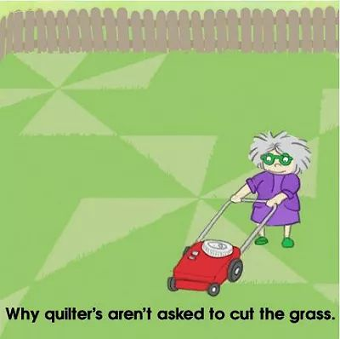

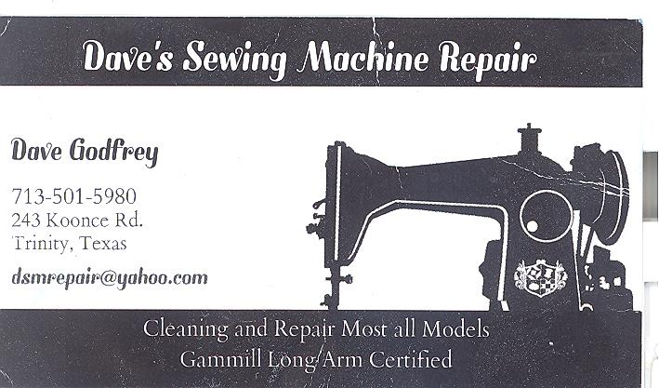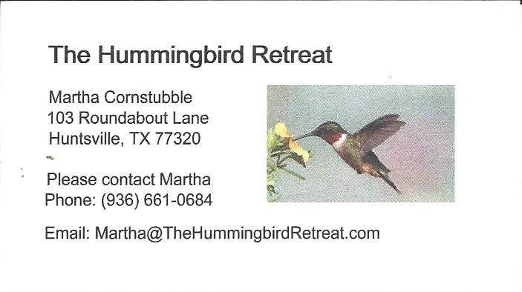
_{Newsletter ad prices are:}
$5.00 a month or $50.00 per year for a business card size advertisement.
$10.00 a month or $100.00 per year for a 3.5” x 4.5” size advertisement.
$18.00 a month or $180.00 per year for a one-half page advertisement.
$36.00 a month or $360.00 per year for a full page advertisement.
Member ads are free and will run for one month per request

_{Tall Pines Quilt Guild}
_{P.O. Box 7272}
_{Huntsville, Texas 77342-7272}

_{Tall Pines Quilt Guild Meeting} _{Guild Calendar Reminders}
You are invited to join us the first Monday of July 1, 2019 6:30 PM Guild Meeting
each month. The guild has a variety of _{June 18, 2019 Charity Bee}
programs, nationally known speakers, _{Meeting Reminders:}
_{workshop and charity projects.} _{Bring Show and Tell Items}
We meet at the University Heights Baptist Church _{Bring money for Food Bank}
_{2400 Sycamore Ave.} _{UPC Labels from Hobbs batting}
Park in the back lot off Palm Ave. _{FQ Bands from Fabric Carousel}
Refreshments are served at 6:30PM _{For Charity Bee}
and the meeting starts at 7 PM. Visit the web site @ www.tallpinesquiltguild.com
