June 2017 Whisperings from the
Tall Pines Quilt Guild
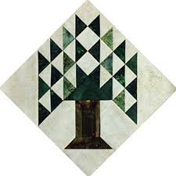

Upcoming Programs and Meetings
July 10th Tips and Tools
July 11th Jeanette Sanford – Paper Piecing Workshop

July Birthdays
Susan Thompson 7/8
Marti Hubbard 7/12
Jeanette Allen 7/18
Toni Bruner 7/18
Ann Moore 7/19
Barbara Pearson 7/20
Jane Presley 7/21
Judy Cannon 7/21
Teresa Cazort 7/26
Ruth West 7/28

Publisher: Diane Carrington Volume Number 98 Issue Number 97
From the President
Hello Summer Quilters,
Greetings from Kay's farmer's market. If you're like me, the Lord has blessed you with an abundance of summer vegetables. The challenge is to find people to give them away to so they won't go bad.
Thank you to everyone who stepped in for me on Monday night. I never worried about a thing. I just was wondering about and trying to imagine all those wonderful salads everyone brought to the meeting. I kept talking about them on my way back-and-forth to the bathroom! I heard what a good presentation our speaker brought. I also heard it was very helpful and informative.
I wish all of you a happy Fourth of July holiday. Remember we will not meet on July 3, but we will meet on July 10, the second Monday. We have a good program lined up for that night so looking forward to see all of you there.
Love you all!
Kay Ohendalski

Sunshine and Shadows
Our prayers go out to Maggie Smith and her family. Her mother passed away last week, please keep her in your thoughts and prayers. We also have some sunshine from Grettle Payne she told us that this coming year she is going to be grandma again. If there is anyone who needs a card let us know.
Our contact info is Betty Grantz phone # 936-438-0465, email lobag1961@gmail.com or Ruth West 847-638-3899, email quilterrw@livecom. We are looking forward to hearing about your Sunshine and Shadows.
Tall Pines Quilt Guild Minutes of Meeting
Tall Pines Quilt Guild
Meeting of Minutes
June 5, 2017
University Heights Baptist Church

In the absence of President, Kay Ohendalski, Martha Wilson called the meeting to order and welcomed members and guests. June birthdays were recognized.
Minutes of the May meeting were printed in the newsletter. Virginia Cooper made the motion to accept the minutes and Jane Richmond seconded the motion. The motion passed.
Treasurer, Martha Wilson gave a review of the Airing of the Quilts. The treasurer’s report will be printed in the newsletter.
Robin Rodriquez brought pillow covers to be taken and filled with batting. Also, hugs to be quilted. The next charity bee will be Tuesday, June 20.
Judy Oliver introduced the 2017 scholarship recipients selected by the scholarship committee from the nine applications received. 2017 Recipients are: Cayleigh Moore, from Lovelady, for Math Education; and Blake Thomason, from Huntsville, for Sewing Proficiency. Both were present at the meeting and received our congratulations.
D-Ann Gilmore went over upcoming programs. Newly added for the July 10 meeting will be Tips and Tools. July 11, Jeanette Sanford will give a workshop on a paper piecing technique without tearing out paper. It will be from 10:00 – 2:30, and the total cost will be $40.00.
August 7th will be Rosie DeLeon-McCreary – Redwork, with a workshop August 8th.
August 28th - Garage Sale
October 2 – T-shirt Quilt lecture, with a workshop October 3rd.
November – UFO Challenge

Door prize winners were Judy Oliver, Beverly Wiggins, and Patricia McCartney.
Our program speaker tonight was Lisa Erlandson – Making Your Best Quilt.
Show and tell was held.
There being no further business the meeting was adjourned.
Respectfully Submitted, Secretary, Cheryl Rempel

Program Report
TALL PINES QUILT GUILD 2017 PROGRAMS
D-Ann Gilmore, Program Chairman
July 10 – Tips and Tools – Demonstrations and samples of various tools, tips and techniques we’ve learned at quilt retreats.
July 11 – Jeanette Sanford who spoke to our guild several years ago is giving us another opportunity to take her workshop on a paper piecing technique that lets you retain your original pattern and you don’t have to tear out the papers. The cost is $40 from 10:00-2:30.
August 7 and 8 – Rosie de Leon McCrady - “Redwork Through the Years”, a history of redwork as well as a variety of vintage and new quilts. The workshop the next day costs $30 + a $25 kit fee. The kit includes needle, needle threader, 2 types of thread, 2 patterns, fat quarter of fabric, pigma pen, Frixon pen, and an embroidery hoop. All you need to bring is a pair of scissors (or she will have some available for purchase) and a thimble if you use one.
August 28 – Immediately following the guild meeting we will have a Garage Sale of sewing and/or craft related items. You may purchase a full table for $10 or half table for $5 – reserve your table soon. Go in with a friend to get rid of unneeded items so you’ll have room for more quilting supplies!
October 2 and 3 - Karen Dupont and Kim Phillips will present a T-shirt quilt lecture, followed by a workshop the next day on how to make a T-shirt quilt.
November 6 – UFO challenge is due

PQG Baby Block Challenge 2017

The Baby Block Challenge will use fabric from the Elmo and Friends collection from Sesame Workshop for Quilting Treasures. The focus fabric is bright and suitable for either boys or girls with lots of color choices. You will get a 10’ square of the focus fabric from Fabric Carousel free of charge. Doris Collins has donated all fabric for the challenge. Use additional fabrics from your stash or check out the fat quarters at the Carousel to complete your block. For those wishing to make more than one block, the fabric used in the challenge is available for purchase at Fabric Carousel. Be sure to follow all instructions for making your block.

Rules:
• Block size 12” finished – 12½” unfinished.
• Must include focus fabric.
• Use coordinating fabric of your choice (100% cotton). You may want to prewash fabrics if using bright colors.
• Can use any pattern on the block but should be appropriate for a baby quilt – no buttons, etc.
• Applique, both machine and hand, will be allowed but designs should be soft, no stiff threads.
• All finished blocks should be returned byOctober 26, 2017 to Fabric Carousel.
• Most of all have fun with designing and constructing your challenge block.
Questions - call Helen Belcher at 936-438-1470 or email at hxb004@shsu.edu
Treasurer’s Report
Tall Pines Quilt Guild
Treasurer's Report |  |  |  | May 31, 2017
Beginning Balance |  |  |  |  | $ 26,556.36
Categories |  | Income |  | Expense
Membership |  | $ 58.50 |  | $ -
Charity |  | $ - |  | $ 100.00
Fun Exchange |  | $ 103.00 |  | $ -
Hospitality |  | $ - |  | $ -
Newsletter |  | $ - |  | $ 14.40
Programs |  | $ - |  | $ -
Donation Quilt |  | $ 1,659.00 |  | $ -
T-shirts for Airing
Airing |  | $ 9,617.82 |  | $ 1,844.02
Misc Income |  | $ 85.00 |  | $ -
Auction Quilt |  | $ -
Sunshine & Shadows |  | $ - |  | $ -
Totals for Month |  | $ 11,523.32 |  | $ 1,958.42
Ending Balance |  |  |  |  | $ 36,121.26
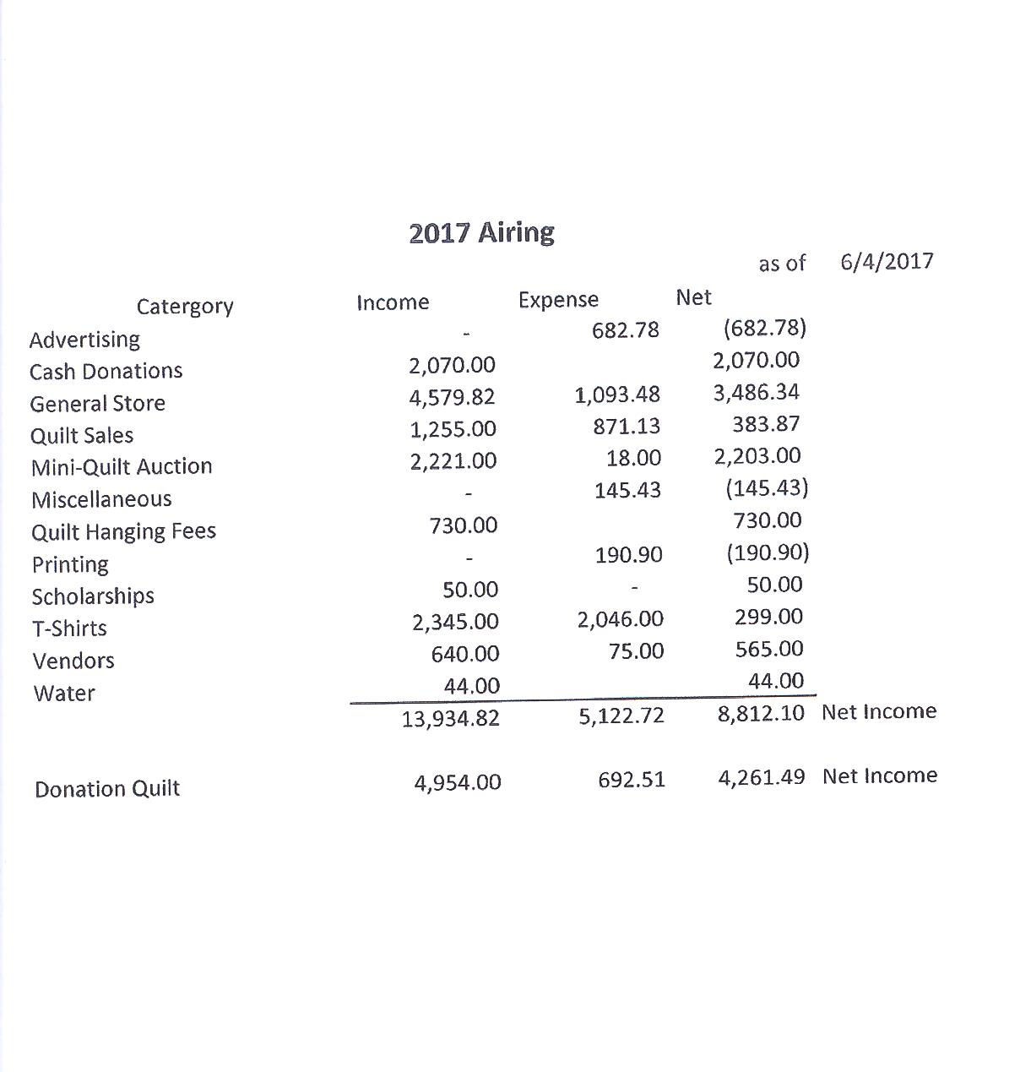
Show and Tell
Jean Bradley – Mesmerizing
Judy Springer – Carpenter’s Square, Greener Pastures, Am I Blue?
Anne Stiles – Red, White and Black Mystery quilt
Patricia McCartney – Hug
Martha Fielder – I Spy
Ashley Buehring – Star Wars, Around Town and the Computer Geek
Jeanette Allen – A Nest for Nesting
Helen Cook – Tinkerbell
Tamara Bobbitt – Spring Bouquet and Raindrops
Mona Smidt – Memory quilt
Dorothy Wolverton – Garlic Knots
Becki Marsh – 3 Charity tops, and bibs
Grettle Payne – Aunt Grace Hearts and Stars
Pam Boyle – Medallion
Membership Updates
Membership Report
We currently have 113 members in the guild. There were 67 people who attended the June meeting- 59 members, 7 visitors, and 1 new member. Please welcome her to Tall Pines!
Barbara Edmondson. Home: 936-636-2921
450 CR 4230. Cell: 281-686-8748
Lovelady, TX 75851 getsewing@windstream.net
BD: 6/17
Carolyn Conan (k_conant@sbcglobal.net) & Ashley Buehring (ashley_buehring@yahoo.com) have renewed their membership.
Scholarship Committee
SCHOLARSHIP COMMITTEE

The Scholarship Selection Committee met on Friday, May 26, 2017 at Fabric Carousel. Serving on the 2017 Selection Committee were Helen Belcher, Ashley Buehring, Monte Knight and Judith Oliver. A total of nine applications were submitted this year. Schools represented were Conroe, Huntsville, Lovelady, Madisonville, Trinity, and one application from a Homeschool Education graduate of Huntsville, Texas. There were three (3) applications submitted for the category of “Intention to Major in Math Education.” One application from this category was disqualified because the stated intention was to major in another subject area. Six (6) applications were submitted in the category of “Demonstrated Proficiency in Sewing.” One application in this category was disqualified because the high school was not in our membership area. Applications were reviewed for experience in leadership, volunteering, work, school organizations, school activities, honors and other interests and activities as well as academic excellence. In addition, each candidate was asked to write an essay on “Where do you want to be in 5 years.

Winner for the 2017 $1,000 TPQG Scholarship award in “Intention to major in Math Education” was CAYLEIGH MOORE, a graduate of Lovelady High School. Cayleigh will be attending Texas Tech University and eventually hopes to become a college mathematics professor.

Winner for the 2017 $1,000 TPQG Scholarship award for “Demonstrated Proficiency in Sewing” was BLAKE THOMASON, a graduate of Huntsville High School. Blake will be attending the University of Texas in Austin, with a long-term goal of becoming a Medical Doctor with a specialty of Dermatology.

Thank you to ALL of our membership who so generously contributed their time and their talents to earning the funds the enabled us to award these scholarships. Both of these candidates are highly qualified and dedicated to their academics, their schools and their communities. They truly exemplify the spirit of our scholarships – “to succeed in life by helping others”. Thank you for supporting the youth of our community.

Door Prizes
Simply Put Kit – Judy Oliver
Vicksburg Pattern – Beverly Wiggins
Easy Big Blocks Pattern – Patricia McCartney

Bee News

Charity Bee
The June donation to the Food Bank was $36.00. YTD total is $249.00. The next Charity Bee meeting will be Tuesday, June 20, beginning at 9:30 at Fabric Carousel. The Handiquilter "sew off" HUGs are trickling back in with the cutest designs. Great job, ladies! Hope to get another batch soon. Reminder that Charity Bee collects Fabric Carousel fat quarter wrappers and Hobbs Batting UPC labels. We look forward to seeing everyone at Charity Bee on the 20th! Any questions, call Robin Rodriquez or Susan Craig.
Cut-ups
Cut Ups will meet on the 2nd and 4th Friday each month at the Fabric Carousel. All are Welcome. Bring your quilting problems for lots of advice and help from your friends. Bee starts around 10 and lasts all day.
Embroidery Bee
We meet on the third Saturday of the month at 11 AM, at the Ohendalski building, next door to the Chicken place across from the mall. 1425 Brazos Dr. Contact Susan Craig for info. 436-1489

Advertisements
PFAFF HOBBYLOCK 786 FOR SALE

Asking $75

All manuals, service records, Shirring Foot (Ruffler).

Purchased October 1971 (next to top of line at that time when Pfaff was still a German company). Purchase price was $811.88.

Currently on Ebay:
Same model starting at $79 (Buy Now Price $119), plus $35.67 shipping
Same model starting at $469 (Buy Now Price $619), plus $32.00 shipping

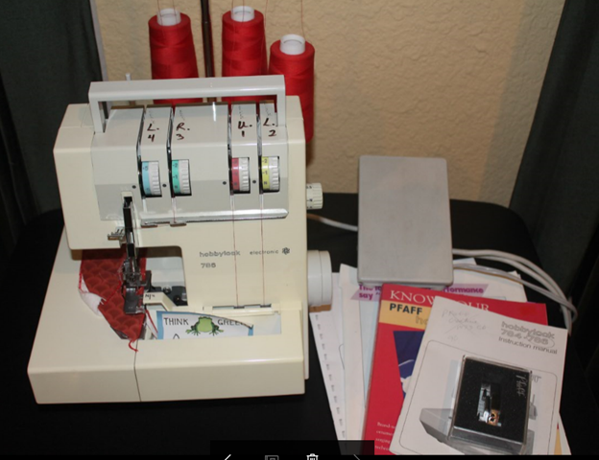

Contact Robin Rodriquez 281/636-7306

Diane’s Grins and Tips

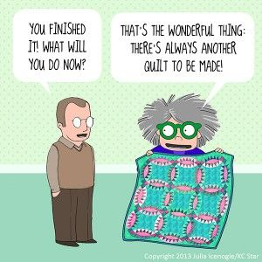

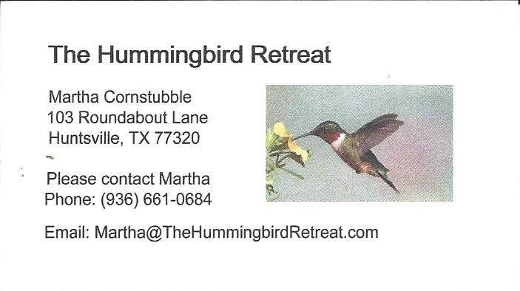
_{Newsletter ad prices are:}
$5.00 a month or $50.00 per year for a business card size advertisement.
$10.00 a month or $100.00 per year for a 3.5” x 4.5” size advertisement.
$18.00 a month or $180.00 per year for a one-half page advertisement.
$36.00 a month or $360.00 per year for a full page advertisement.
Member ads are free and will run for one month per request

_{Talll Pines Quilt Guild}
_{P.O. Box 7272}
_{Huntsville, Texas 77342-7272}

_{Tall Pines Quilt Guild Meeting} _{Guild Calendar Reminders}
You are invited to join us the first Monday of July 10, 2017, 6:30 PM Guild Meeting
each month. The guild has a variety of _{June 20, 2017 Charity Bee}
programs, nationally known speakers, _{Meeting Reminders}
_{workshop and charity projects.} _{Bring Show and Tell Items}
We meet at the University Heights Baptist Church _{Bring money for Food Bank}
_{2400 Sycamore Ave.} _{UPC Labels from Hobbs batting}
Park in the back lot off Palm Ave. _{FQ Bands from Fabric Carousel}
Refreshments are served at 6:30PM _{For Charity Bee}
and the meeting starts at 7 PM. Visit the web site @ www.tallpinesquiltguild.com

