July 2017 Whisperings from the
Tall Pines Quilt Guild
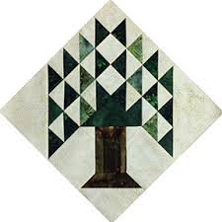

Upcoming Programs and Meetings
8/7 Rosie deLeon McCardy – Redwork Lecture
8/8 Redwork workshop

August Birthdays
Tasha Fry 8/8
Joyce Parish 8/9
Judy Springer 8/9
Anne Stiles 8/15
Helen Belcher 8/18
Lorane Hudson 8/22
Janis Childers 8/25
Vickie Brewer 8/26
D-Ann Gilmore 8/31
Becky Marsh 8/31
Pat Tracy 8/31

Publisher: Diane Carrington Volume Number 99 Issue Number 98
From the President
Greetings Fellow Quilters,
Well, all the plants are dried up (except for the okra) and my summer gardening is done. The shelves are lined with beautiful canned vegetables and corn is in the freezer. I tried a new pickle recipe, bread and butter jalapeño. They are delicious! Hope you have as much fun with your garden as I do.
Now, back to quilting! Yea! First on my agenda is a wedding quilt due in about 2 months. So you will find me with my head down stitching for the next little while! What is better to do when it is a 100 degrees outside than turn the A/C down and sew!
I hope you all enjoyed our program this past Monday. Our program chairman, D-Ann Gilmore, treated us to an amazing hour of quilting tips and techniques that she has learned over her quilting career. D-Ann is a great teacher and lover of quilting. She always makes everything fun and that's what she did at the meeting. Thank you, D-Ann, for all your preparation and generosity in bringing us a wonderful program! We look forward to the next one.
Good luck to all of you designing your block for the baby block challenge. I have a feeling mine will not be finished till the last minute! But I will get it done!
Hope to see all of you at the next meeting. It will be great!
Summer Fun Wishes to all of you!
Kay Ohendalski, President

Be sure to reserve a table for the August 28th Garage Sale at Fabric Carousel.

TIPS, TOOLS AND TECHNIQUES
D-Ann Gilmore
- Zip ties – Make perfect stems for applique. Cut a piece of bias fabric approximately 1” (enough to wrap around your zip tie with room to stitch). With wrong sides together and your zipper foot attachment, wrap the fabric around your zip tie and sew as close to the zip tie as possible. Roll the seam to the underside and press on top of the zip tie. Trim a little of the seam allowance if necessary.
- Substitute Best Press – 3 oz. of potato vodka and 24 oz. of distilled water in a spray bottle
- Small plastic boxes from Dollar Tree – used to store needles, store hexagon pieces, just plain cute!
- Hair rollers – the Velcro type – use to scrub your cutting mat of threads or when you have to rip out a seam, rub the roller over all the little loose threads and it’ll pick them off for you.
- Big tapioca straws – great for turning tubes of fabric
- Magazine inserts – can be cut up for English paper pieces
- Rubber shelf paper liner – cut a piece big enough to put under your presser foot to keep it from sliding
- Empty glue stick refills – save these empty containers to store needles or safely throw away old needles in the trash
- Toilet paper rolls – save these to wrap your binding and bias strips nice and neat
- Laser Marker – from Harbor Freight – no more need to mark your stitching lines – this light mounts on the front of your machine to give you a straight line – just be careful that it doesn’t shine in your eyes
- Skate board tape – buy clear tape, cut with old scissors so you don’t ruin your good scissors and then stick them to the bottom of your rulers to keep them from slipping on your fabric
- Alternative to skate board tape – Nexcare flexible clear tape by 3M – run this tape down the sides of your rulers to keep them from slipping
- Thread holder – ¼” dowel rods cut in 12” lengths. Put ¼” wooden pots on each end. You can organize your thread by color. Store in a shoe box and your threads won’t roll around and get lost
- Adding machine tape – can be used to make paper pieced borders of prairie points and/or half square triangles.
- Post It Notes – they come in 2” or 3” increments. If you have to sew to within 2” or 3” – just put the post it note on your fabric – no measuring needed. Also a small stack can also be placed on your machine as a guide for your fabric
- Disposable mascara brushes – use to clean your bobbin case. Reminder to clean the bobbin area of your machine every 2 bobbin changes
- Seafood fork – use for prepared edge applique or to help guide your fabric on your machine
- Hi-Polymer eraser – erases pencil marks without damaging your fabric
- Golf tee w/magnet – put the tee inside your thread and the magnet will keep your needle from getting lost
- Elmer’s glue – cut off the top of the glue, insert the end of a Bic pencil into the lid – gives you a very fine line of glue. Can be used to put on your binding
- Pool noodles – cover with a sleeve of fabric and then store your quilts around the noodle. Can also be cut and placed on pants hangers to hold your quilt tops until you’re ready to quilt
- Stir sticks with pipe cleaners – use to clean lint out of your machine bobbin area
- Pretty boxes – makes great project boxes
- Clappers – cut a 2x4 into a 5” block. When doing paper piecing, press with your iron and then place the clapper on top and it will set the seam and absorb the heat
Sunshine and Shadows
Our contact info is Betty Grantz phone # 936-438-0465, email lobag1961@gmail.com or Ruth West 847-638-3899, email quilterrw@livecom. We are looking forward to hearing about your Sunshine and Shadows.
Tall Pines Quilt Guild Minutes of Meeting
Tall Pines Quilt Guild
Meeting Minutes
July 10, 2017
University Heights Baptist Church

President Kay Ohendalski called the meeting to order, welcomed members and guests and recognized July birthdays.
Minutes of the July meeting were printed in the newsletter. Since there were no corrections or additions, Janis Voldbakken made a motion to accept and Dorothy Wolverton seconded. Motion passed.
Treasurer’s report is in newsletter.
Robin Rodriguez informed the group that the next Charity Bee will be Tuesday, July 18, 9:30 AM at Fabric Carousel. A diaper-making workshop will be held on Saturday, August 12, at Fabric Carousel. Bring sewing machine and basic sewing supplies. All are welcome.
Pillows and walker caddies were delivered to Creekside.
Robin had two hugs that needed quilted, both were taken by members. Two hugs were turned in.
D-Ann Gilmore and Martha Wilson turned in an article to the newspaper about the guild. Although an older photo was used, good information was put out about the guild to the public.
Patricia McCartney gave information about the East TX Thimble Trail event to be held July 28 and 29 at the Walker County Fairgrounds. This year’s theme is Christmas in July. Thirty-three vendors will be participating. A volunteer sign-up sheet was available. Volunteers gain free admission to the event for the day they agree to work. A caterer will be on site.
Kay Ohendalski spoke about Fair on the Square, coming up on October 7, 2017. Guild is looking into renting one or two booths. Fall and Christmas handmade items will be needed to sell. It’s not too early to start thinking about what you might like to make!

Remember the UFO block challenge. Some blocks have been turned in already. All blocks need to be turned in
before the November meeting.
Election of officers for 2018 is coming up. If you would like to serve, please submit names to Kay.
D-Ann Gilmore informed the group about upcoming programs.
August 7th-Rosie DeLeon-McCreary, redwork, with a workshop on August 8.
August 28-Garage Sale. Tables cost $10 each. You may combine your items with a friend and share the cost of
the table. All sewing and/or craft-related items can be sold.
October 2-T-shirt Quilt lecture with workshop on October 2.
November 6-UFO Challenge results will be shown.
This evening’s program featured D-Ann Gilmore’s “Tips, Tools & Techniques”. She shared lots of great ideas
and gave away some samples. The program was not only informative but entertaining as well. Great job!!
Door prizes winners were Kay Ohendalski, Virginia Wilson and Cindy Rohe.
Fun exchange winners were Martha Wilson, Cindy Rohe and Grace Burzynski
Show and Tell was held:
Kathy Wilson-baby quilt
Rory Ross-Hoffmann Challenge
Martha Wilson-Hug
Pam Boyle-APQ quilt
Barbara Edmondson-quilt
Dorothy Wolverton-purse, embroidered pillow, table runner
Randi Clower-restored antique yellow Irish Chain
Barbara Pearson-quilt
Kathy Shute-quilt
Keli Langley-quilt

EXECUTIVE BOARD MEETING - Monday, July 17, 5:30 pm at Fabric Carousel.
There being no further business, the meeting was adjourned.
“SEW” happy to submit, Elaine Robinson, Secretary
Program Report
TALL PINES QUILT GUILD 2017 PROGRAMS
D-Ann Gilmore, Program Chairman
August 7 and 8 – Rosie de Leon McCrady - “Redwork Through the Years”, a history of redwork as well as a variety of vintage and new quilts. The workshop the next day costs $30 + a $25 kit fee. The kit includes needle, needle threader, 2 types of thread, 2 patterns, fat quarter of fabric, pigma pen, Frixon pen, and an embroidery hoop. All you need to bring is a pair of scissors (or she will have some available for purchase) and a thimble if you use one.
August 28 – Immediately following the guild meeting we will have a Garage Sale of sewing and/or craft related items. You may purchase a full table for $10 or half table for $5 – reserve your table soon. Go in with a friend to get rid of unneeded items so you’ll have room for more quilting supplies!
October 2 and 3 - Karen Dupont and Kim Phillips will present a T-shirt quilt lecture, followed by a workshop the next day on how to make a T-shirt quilt.
November 6 – UFO challenge is due

PQG Baby Block Challenge 2017

The Baby Block Challenge will use fabric from the Elmo and Friends collection from Sesame Workshop for Quilting Treasures. The focus fabric is bright and suitable for either boys or girls with lots of color choices. You will get a 10’ square of the focus fabric from Fabric Carousel free of charge. Doris Collins has donated all fabric for the challenge. Use additional fabrics from your stash or check out the fat quarters at the Carousel to complete your block. For those wishing to make more than one block, the fabric used in the challenge is available for purchase at Fabric Carousel. Be sure to follow all instructions for making your block.

Rules:
• Block size 12” finished – 12½” unfinished.
• Must include focus fabric.
• Use coordinating fabric of your choice (100% cotton). You may want to prewash fabrics if using bright colors.
• Can use any pattern on the block but should be appropriate for a baby quilt – no buttons, etc.
• Applique, both machine and hand, will be allowed but designs should be soft, no stiff threads.
• All finished blocks should be returned byOctober 26, 2017 to Fabric Carousel.
• Most of all have fun with designing and constructing your challenge block.
Questions - call Helen Belcher at 936-438-1470 or email at hxb004@shsu.edu
Treasurer’s Report
Tall Pines Quilt Guild
Treasurer's Report |  |  |  | June 30, 2017
Beginning Balance |  |  |  |  | $ 36,121.26
Categories |  | Income |  | Expense
Membership |  | $ 61.00 |  | $ -
Charity |  | $ 30.00 |  | $ 100.00
Fun Exchange |  | $ 106.00 |  | $ -
Hospitality |  | $ - |  | $ -
Newsletter |  | $ - |  | $ 14.40
Programs/Workshops |  | $ 175.00 |  | $ 728.57
Scholarhips |  | $ 100.00 |  | $ 2,000.00
Airing |  | $ 35.00 |  | $ 932.81
Sunshine & Shadows |  | $ - |  | $ -
Totals for Month |  | $ 507.00 |  | $ 3,775.78
Ending Balance |  |  |  |  | $ 32,852.48

Membership Updates
There were 59 members in attendance at the July meeting and 7 visitors. Two of the visitors joined the guild so we now have a total of 115 members. Please welcome our new members, Pam Ray and Hannah Henley!

Pam Ray
15904 Malibu E.
Willis, 77318
Hm: 936-856-7623
Cell: 832-567-7411
pn.ray56@gmail.com
Bday: 3/28

Hannan Henley
1300 Elkins Lake
Huntsville, 77340
Hm: 936-439-6212

Door Prizes
1. Charm pack and thread won by Kay Ohendalski.
2. Fat Quarter, Note pad, quilting needle and Owl pin cushion won by Virginia Wilson.
3. Charm Squares and Owl pin cushion won by Cindy Rohe
Fun Exchange
- 2 Charm packs and pattern – Grace Burzynski
- “Summer Joy” blocks of the month – Cindy Rohe
- Row by row patterns and $20 Gift certificate (donated by Martha Fielder) – Martha Wilson
Bee News
Charity Bee
The July donation to the Food Bank was $31.00. YTD total is $280.00. The total is not too far off from where we were this time last year. Keep up the great donations! The next Charity Bee meeting will be (in just a few days!)Tuesday, July 18, beginning at 9:30 at Fabric Carousel. Two large bags of soft support pillows were delivered to Creekside last month, as well as the requested number of walker caddies. SPECIAL ALERT (Mark your calendars!): On Saturday, August 12, beginning at 9:30 am at Fabric Carousel, we will have a workshop to learn how to make the diapers for Becky Hernandez that will be delivered to Uganda later this year. All you need to bring is your sewing machine and usual sewing supplies. Everything else will be provided. Stay as long as you are able, but please come and learn so that we might make these diapers as time permits for this ongoing mission effort. Each person is responsible for their own lunch. Reminder that Charity Bee collects Fabric Carousel fat quarter wrappers and Hobbs Batting UPC labels. We look forward to seeing everyone at Charity Bee on the 18th! Any questions, call Robin Rodriquez or Susan Craig.

Cut-ups
Cut Ups will meet on the 2nd and 4th Friday each month at the Fabric Carousel. All are Welcome. Bring your quilting problems for lots of advice and help from your friends. Bee starts around 10 and lasts all day.
Embroidery Bee
We meet on the third Saturday of the month at 11 AM, at the Ohendalski building, next door to the Chicken place across from the mall. 1425 Brazos Dr. Contact Susan Craig for info. 436-1489

Diane’s Grins and Tips

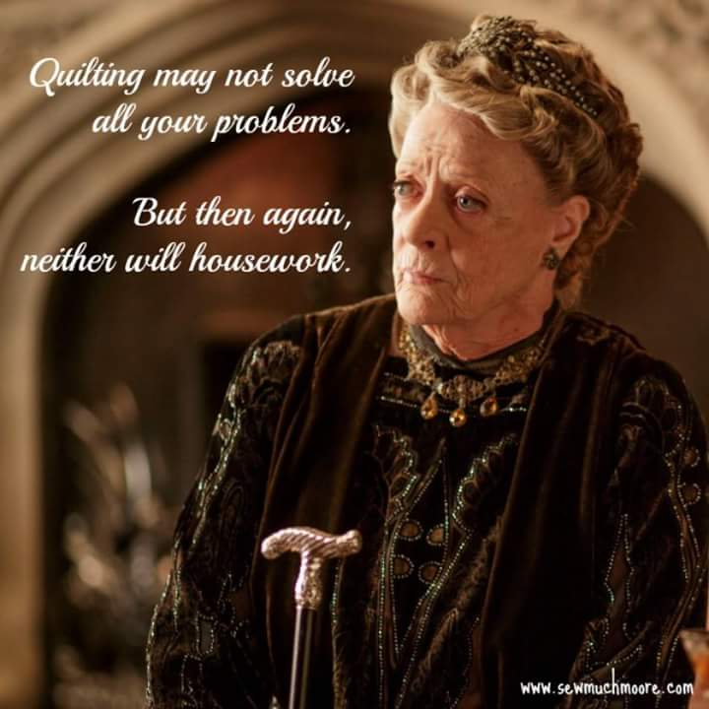

Advertisements
PFAFF HOBBYLOCK 786 FOR SALE

Asking $75

All manuals, service records, Shirring Foot (Ruffler).

Purchased October 1971 (next to top of line at that time when Pfaff was still a German company). Purchase price was $811.88.

Currently on Ebay:
Same model starting at $79 (Buy Now Price $119), plus $35.67 shipping
Same model starting at $469 (Buy Now Price $619), plus $32.00 shipping
Contact Robin Rodriquez 281/636-7306
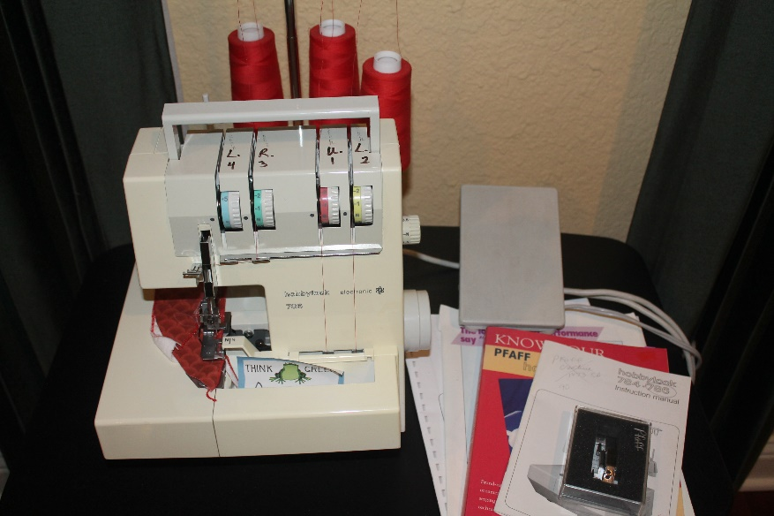
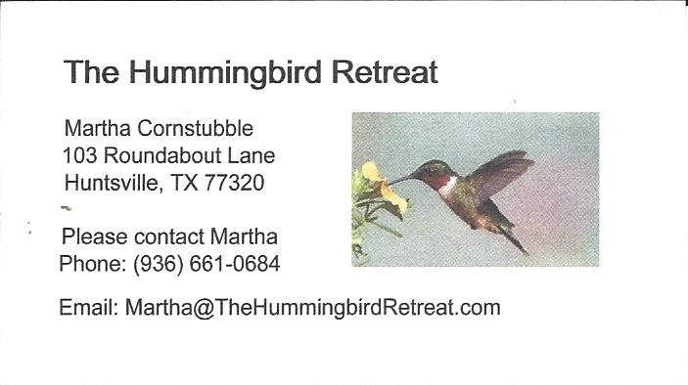
_{Newsletter ad prices are:}
$5.00 a month or $50.00 per year for a business card size advertisement.
$10.00 a month or $100.00 per year for a 3.5” x 4.5” size advertisement.
$18.00 a month or $180.00 per year for a one-half page advertisement.
$36.00 a month or $360.00 per year for a full page advertisement.
Member ads are free and will run for one month per request

_{Tall Pines Quilt Guild}
_{P.O. Box 7272}
_{Huntsville, Texas 77342-7272}

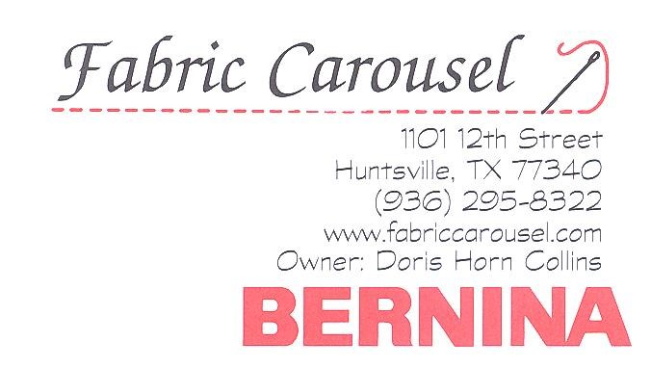
_{Tall Pines Quilt Guild Meeting} _{Guild Calendar Reminders}
You are invited to join us the first Monday of August 7, 2017, 6:30 PM Guild Meeting
each month. The guild has a variety of _{August 15, 2017 Charity Bee}
programs, nationally known speakers, _{Meeting Reminders}
_{workshop and charity projects.} _{Bring Show and Tell Items}
We meet at the University Heights Baptist Church _{Bring money for Food Bank}
_{2400 Sycamore Ave.} _{UPC Labels from Hobbs batting}
Park in the back lot off Palm Ave. _{FQ Bands from Fabric Carousel}
Refreshments are served at 6:30PM _{For Charity Bee}
and the meeting starts at 7 PM. Visit the web site @ www.tallpinesquiltguild.com

