January 2018 Whisperings from the
Tall Pines Quilt Guild
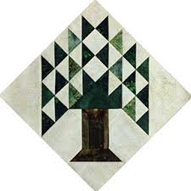

Upcoming Programs and Meetings
February 5th – Brenda Jeschke, Machine Embroidery
February 6th – Machine Embroidery Workshop

February Birthdays
Elaine Robinson 2/2
Kathy Shute 2/9
Pat Gibson 2/13
Mary Ellen Johnson 2/21
Pat Spear 2/24
Jessie Grant 2/25
LaDonyce Hamilton 2/28
Dorothy Wolverton 2/28

Publisher: Diane Carrington Volume Number 104 Issue Number 103
From the President
Happy New Year to all my quilting friends. Hope everyone is winding down from the holidays and staying away from the dreaded flu. I am looking forward to leading this group for the next year.

Mondays meeting was great but a little chaotic, baby gifts, Baby Block challenge and the young quilters all kept things lively. Thanks to all those who furnished the food, it was delicious. Congratulations to the winners of the Baby Block Challenge.

Be sure to start working on the mini quilts for the Veterans Muster in March and finish your quilts to enter in the Walker County Fair. I am looking forward to seeing the beautiful creations from our members.

Happy Quilting
Martha Wilson

Sunshine and Shadows
Happy New Year. Monte Knight and Randy Clower are both having some health issues. Rori Ross’s husband Dick is in the hospital. Our prayers go out to them for a full recovery Thank you Ruth West and Betty Gratz.

Honoring Heros

Ladies in the Tall Pines Quilt Guild will be participating in the first H.E.A.R.T.S. Festival (Muster) on Saturday, March 24, 2018. There will be a quilt show of patriotic quilts and a mini patriotic quilt auction to benefit the veterans museum. Also being honored during the festival will be first responders (law enforcement and EMTs).

If you have questions, please call Toni Bruner, 936-295-5892 or 936-661-0330.

Tall Pines Quilt Guild Minutes of Meeting
Tall Pines Quilt Guild
Meeting Minutes
January 8, 2018
University Heights Baptist Church

President Martha Wilson called the meeting to order, welcomed members and guests and recognized January birthdays. Special guests were representatives from Brenham. Their Spring Blossoms Quilt Show will be held on February 2nd and 3rd. Raffle tickets were available for a beautiful quilt.

Minutes from the December meeting were printed in the newsletter. There being no corrections or additions, Janis Voldbakken made a motion to accept, motion was seconded by Tasha Fry, motion passed.

Helen Belcher installed the officers for the 2018 year. Officers are as follows; PRESIDENT, Martha Wilson, VICE-PRESIDENT, D-Ann Gilmore, TREASURER, Kay Ohendalski, VICE- TREASURER, Dorothy Wolverton and SECRETARY, Elaine Robinson. All committee chairs were also recognized.

A group of young ladies proudly showed the quilts that they made during the August Summer Sewing Class. They also voted to award the Big Bird Award to challenge block #11. All challenge blocks were voted on by members and prizes were awarded to the winning entries.

A representative from the Pregnancy Care Center thanked the group for all the quilts that were donated to the center. She spoke about how thankful the recipients are to receive a handmade quilt for their unborn baby.

Members were informed of the Victoria Quilt Fest to be held on March 3rd and 4th. Members can show quilts if interested.

Door prizes were awarded.

A reminder was given of the upcoming Veterans’ Museum Muster March 24th. Members are encouraged to make quilts or finish up some that have been started. It was also suggested that members could make some mini quilts, 24” x 24”, to auction during the same time frame. Toni Bruner had patterns available. Also, a workshop will be held on Wednesday, January 10th at Fabric Carousel. Both quilts and mini quilts would be due by the March guild meeting. Patriotic quilts could then be entered into the Walker County Fair Quilt exhibit. The fair dates are April 8-14.

It is time to renew memberships for 2018. These are due by the February meeting. Annual dues are $25. Members 70 and over pay $20.

Fun exchange was held.

Diane Carrington gave an update on the raffle quilt. To date, 100 blocks have been made. Lots more need to be made so let’s join together and get to sewing. Diane had printed paper piecing papers available.

D-Ann Gilmore announced the upcoming programs.

Five members participated in Show & Tell. Beautiful work ladies.

UFO challenge sheets were available tonight and will be also be available at Fabric Carousel. Members are encouraged to list some projects that they would like to complete this year. Prizes will be awarded in November. Lists must be turned in by March 16th.

The first Charity Bee for 2018 will be held on January 15th at Fabric Carousel.

Patricia McCartney, owner of Heavenly Threads Quilt Shop in Trinity, invited everyone to her annual Super Bowl Sale on February 4, from 1-4 pm. Buy 12 fat quarters at regular price, get 13 fat quarters for free. What a deal!!!! Also, their annual Shop Hop at the Walker County Fairgrounds will be held on July 13th and 14th. .

The January Executive Board Meeting will be held Monday, January 15th , @ 5:30 pm at Fabric Carousel.

There being no further business, the meeting was adjourned.

“Shear”ing the facts,

Elaine Robinson, Secretary

Treasurer’s Report
 | Tall Pines Quilt Guild
 | Treasurer's Report |  |  |  | December 31, 2018
 | Beginning Balance |  |  |  |  | $ 32,044.36
 | Categories |  | Income |  | Expense
 | Membership |  | $ 455.50 |  | $ -
 | Charity |  | $ 510.00 |  | $ 1,035.00
 | Fun Exchange |  | $ - |  | $ -
 | Hospitality |  | $ 8.90 |  | $ -
 | Goodwill |  |  |  | $ 467.99
 | Newsletter |  | $ - |  | $ 42.00
 | Programs/Workshops |  | $ - |  | $ -
 | Miscellaneous |  | $ - |  | $ 33.91
 | Auction Quilt |  | $ -
 | Totals for Month |  | $ 974.40 |  | $ 1,578.90
 | Ending Balance |  |  |  |  | $ 31,439.86

Programs Updates
TALL PINES QUILT GUILD 2018 PROGRAMS
D-Ann Gilmore, Program Chairman
February 5 – Brenda Jeschke’s – Machine Embroidery Marries Quilts with a presentation of over 30 machine embroidered quilts. The workshop teaches you how to incorporate the machine embroidery into a quilt.

March 5 – Bring silent auction patriotic quilts. If you are participating in the UFO Challenge the sign-up sheet is due to Fabric Carousel by March 16.

April 2 – Shannon Brinkley – Scrappy Applique followed by a workshop the next day to learn the techniques and process.

May 7 – Brenda Asmus, certified teacher for Marti Michell will give a lecture on “Tips from My Template Workbox” followed by a workshop on quick log cabin blocks using only 4 fat quarters.

June 4-5 – Cindy Needham, a nationally known speaker, will give a fabulous program entitled “For the Love of Linens”. Take this opportunity to take her 2-day workshop on Heirloom Feathers and Backgrounds. The 2-day workshop is Monday and Tuesday. We have already started a wait list for this class.

July 2 – Winnie Fleming will give a 2 for 1 program – trade exchanges and star quilts. Her workshop the following day will teach you how to make perfect stars without cutting off the points.

August 6 – Peggy Richards is an award-winning quilter whose trunk show will take your breath away. I would love for her to demonstrate her prepared edge applique if I have enough people sign up for a workshop.

October 1 – Open to suggestions

November 5 – UFO Challenge

December 5 – Christmas party

Membership Update
Happy New Year everyone! A new year means it's time to renew your membership in the guild and it promises to be an exciting year with lots of great workshops and presenters coming to Huntsville! So far, only half of our 120 members have renewed so please be sure to get your dues to me by the end of February or your information will not be included in the new directory which will be ready in March. Dues are $25, $20 for members 70 or older, and $5 for junior members up to age 18. You can renew by paying at the next guild meeting, leaving your payment at Fabric Carousel, or mail it to me at:
Cathy Wilson
29479 Red Top Rd
Richards, TX 77873

There were 52 members present at the January meeting, one new member, and 14 visitors. please welcome our newest member:
Mariette Curnutt
7717 Rocky Ridge Lane
Madisonville, 77864
those2texans@gmail.com
Home: 936-349-0348
Cell: 936-668-1849
BD: Jan. 11
spouse: Jean-Marc
Fun Exchange
Layer cake and ½ yard pieces – Patricia McCartney
Layer cake and ½ yard pieces – Cathy Steinbach
Six ½ yard cuts (donated by Cathy Steinbach) – Pam Boyle
Door Prizes
Book “Sassy Cats” – Grettle Payne
Pincushion and Quilt pin – Jeanette Allen
Pincushion and Sewing pin – Barbara Pearson
Show and Tell
Pam Boyle - A beautiful Oriental leafs pattern
Jean Bradley - A cute "milk can" quilt and a Happy Camper pillow she made for her son
Kim Street - Belated Christmas tree skirt and a Judy Martin quilt (lovely)
Grettle Payne - An adorable little purse and "This is not the Droid You are Looking For" quilt
Helen Belcher - Cowboy boot quilt
D-Ann Gilmore - Basket of fruit stencil wallhanging made as a donation to Master Gardeners

Bee News
Charity Bee
The amount collected for the Food Bank at the January guild meeting was $38.00! Great start! A delivery was received from Handiquilter for another box of their sew-off material (already quilted fabric) and will be cut into HUGs at the next Charity Bee meeting. Those of you who enjoy decorating these already quilted HUGs with appliques should be able to pick up one (or more) on or after Tuesday, January 16, at Fabric Carousel. January 16 is the date of the next Charity Bee meeting and I hope everyone is ready to get back into the groove of making items for our local charity recipients. We did a great job last year and I hope we do as well or better for this year. Happy New Year!

Cut-ups
Cut Ups will meet on the 2nd and 4th Friday each month at the Fabric Carousel. All are Welcome. Bring your quilting problems for lots of advice and help from your friends. Bee starts around 10 and lasts all day.
Embroidery Bee
We meet on the third Saturday of the month at 11 AM, at the Ohendalski building, next door to the Chicken place across from the mall. 1425 Brazos Dr. Contact Susan Craig for info. 436-1489
Donation Quilt
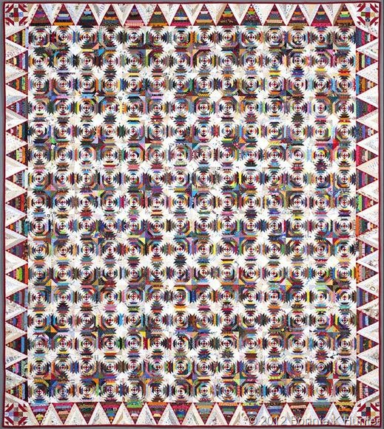
We are working hard on the donation quilt. We need 256 blocks for the center, 60 blocks for the border and 4 for the corners. That’s 320 blocks. We have 110 blocks completed and more coming in all the time. We need everyone’s help. I have the papers for the blocks at Cutups or at the Guild meetings. WE HAVE 210 BLOCKS TO GO!!!!!

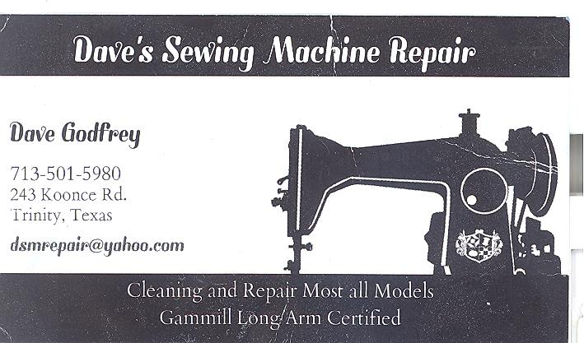

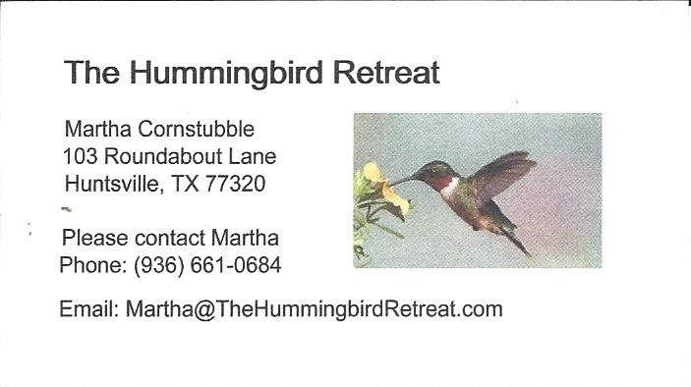
_{Newsletter ad prices are:}
$5.00 a month or $50.00 per year for a business card size advertisement.
$10.00 a month or $100.00 per year for a 3.5” x 4.5” size advertisement.
$18.00 a month or $180.00 per year for a one-half page advertisement.
$36.00 a month or $360.00 per year for a full page advertisement.
Member ads are free and will run for one month per request

_{Tall Pines Quilt Guild}
_{P.O. Box 7272}
_{Huntsville, Texas 77342-7272}

_{Tall Pines Quilt Guild Meeting} _{Guild Calendar Reminders}
You are invited to join us the first Monday of February 5, 2018, 6:30 PM Guild Meeting
each month. The guild has a variety of _{January 16, 2018 Charity Bee}
programs, nationally known speakers, _{Meeting Reminders}
_{workshop and charity projects.} _{Bring Show and Tell Items}
We meet at the University Heights Baptist Church _{Bring money for Food Bank}
_{2400 Sycamore Ave.} _{UPC Labels from Hobbs batting}
Park in the back lot off Palm Ave. _{FQ Bands from Fabric Carousel}
Refreshments are served at 6:30PM _{For Charity Bee}
and the meeting starts at 7 PM. Visit the web site @ www.tallpinesquiltguild.com
