January 2017 Whisperings from the
Tall Pines Quilt Guild
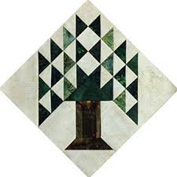

Upcoming Programs and Meetings
January 11 10:00 a.m.
Airing Meeting at Fabric Carousel

February 6
Mary Massey will present her new topic “pieces of the Past”.
February 7
Mary Massey Workshop at Fabric Carousel. $35.00

March 6
LouAnn Nichols presents a stunning trunk show of her quilts.

January Birthdays
1/1 Jan Hill
1/5 Pam Boyle
1/5 Debbie Sapp
1/6 Debbie Walton
1/8 Betty Gratz
1/9 Tamara Bobbit
1/10 Nancy Nelson
1/10 Rhonda Lynch
1/18 Pat Dittfurth
1/23 Jean Bradley
1/25 Sandra McKaskle
1/29 Martha Fielder
1/31 Cindy Rohe
1/31 Virginia Wilson

1/28 Patsy Biggs

Publisher: Diane Carrington Volume Number 93 Issue Number 92
From the President
Happy New Year fellow quilters and friends,
It was good to see so many of you at our January meeting. Thank you once again for your generosity with the pregnancy Care Baby Center. Kathy, one of the directors, was overwhelmed with the love shown by our guild and its members. Everyone seemed to like the antique quilt show and tell that we had. Many of you suggested that we do it again next year. We will probably do just that!
Congratulations to our very own Jane Richmond who was awarded the quilt angel for 2016. It was a great choice made by our members. Some of you may or may not know, but Jane lives in Crockett Texas about an hour away. So everything she does for the guild is definitely a time commitment for her. We are so proud to have her in our guild and we definitely appreciate all the hard work that she does.
Now is the time to direct our attention to the Airing of the quilts. This will be held on Saturday, May 6, 2017. There is much work to be done and we will begin by having an organizational meeting this Wednesday, January 11. This will be at the Fabric Carousel workroom at 10:00 am. If you were a committee chairman in the past, we really would appreciate if you could attend the meeting. We need your input, advice, and help to plan everything that needs to be done. We will be working on the entry forms, dates, and deadlines. If you are new to the guild, we want you to come to the meeting as well. It will be a good time to get involved and learn what the airing is all about. The Airing requires every member of the guild to participate in some way or another. So please mark your calendar's now and keep May 6 open for working at the Airing!
Blessings,
Kay Ohendalski, President

Sunshine and Shadows
Happy New Year Everyone; Please keep in your thoughts and prayers, Kathy Shute- back surgery, Grettle Payne’s husband David – knee surgery and Barbara Flebbe’s grandson John Springer – health issues.
Our contact info is Betty Grantz phone # 936-438-0465, email lobag1961@gmail.com or Ruth West 847-638-3899, email quilterrw@livecom. We are looking forward to hearing about your Sunshine and Shadows.

Tall Pines Quilt Guild Minutes of Meeting
President Kay Ohendalski called the meeting to order and welcomed members and guests. December birthdays were recognized.
Minutes of the December meeting were printed in the newsletter. Janis Voldbakken made the motion to accept the minutes and Jane Richmond seconded the motion. The motion passed.
The treasurer’s report will be printed in the newsletter.
Robin Rodriquez gave an update on charity bee. Ninety hugs were delivered December 2, along with blankets, pillowcases, walker caddies, gift cards and checks to Hospitality House, SAAFE House, CPS, HeadStart, Huntsville Pregnancy Care Center, and local nursing homes. Our goal as a guild is for each member to make a hug in 2017!
Pat and Janet were our guests from the West Houston Quilt Guild selling tickets for “Lotus”. The quilt will be raffled at their quilt show and garage sale March 3 and 4, at the Berry Center in Cypress.
It’s time to start thinking of ideas and putting together committees for the Airing of the Quilts coming up May 6. The first planning meeting will be January 11, at 10:00 at Fabric Carousel. Committee chairs will be called and asked to continue in their positions. See Martha Wilson with any ideas for items to sell at the general store. Forms for selling quilts will be available next month. They will be due the first week in March.
Kay Ohendalski announced Jane Richmond as Quilt Angel for 2017. Jane’s biggest project for the guild in 2016 was heading up our raffle quilt project, putting in many hours to make our beautiful Texas raffle quilt happen! Jane is also our guild librarian.
D-Ann went over our upcoming programs:
February: Mary Massey — Pieces of the Past program and workshop.
March: Lou Ann Nichols, winner of Best of Show at the 2015 Conroe Quilt Show —Trunk Show

Tonight, we celebrate 33 years as a guild. Happy Birthday TPQG. Our program was our annual Huntsville Pregnancy Care Center baby shower. Kathy Hazlewood from PCC was our guest to accept our baby gifts and tell us a little about PCC. Also, part of the program was our first antique quilt show and tell.
Door prizes went to Helen Belcher, Rory Ross, and Cathy Wilson. Fun Exchange winners were Barbara Flebbe, Becky Marsh, Ruth West, and Rennie Bauer.
Regular show and tell was also held.
There being no further business the meeting was adjourned.
Respectfully submitted,
Cheryl Rempel, Secretary
Program Report
MEALS ON WHEELS CHRISTMAS TREE PROJECT - Thank you

The project was a great success and very much appreciated by the Meals on Wheels recipients, many who cannot get out and have a very meager Christmas. Thank you to all who participated in making the Christmas Tree Ornaments - those who designed them and those who sewed them. They were beautiful!

- 146 "goodie" bags with TPQG Christmas trees were delivered.
- Each tree had a message "Love" from the Tall Pines Quilt Guild, Huntsville, Texas 2016
- Each goodie bag contained crackers, fruit candy, and a candy cane in addition to our Tree Ornament
- Recipients included clients from Huntsville, New Waverly area, Riverside area, Phelps, Dodge, Bedias.
- FYI - clients in areas other than Huntsville receive their meals on a weekly basis (all meals are frozen except the meal on the day delivered.)
- Huntsville recipients receive a hot meal every day - Mondaythrough Friday. These meals are prepared at the Walker County Senior Center in Huntsville, Texas and delivered by volunteers.
- FYI - also want to thank Martha Wilson and Tom and Susan Craig for making extra trees. We were originally planning for 124 so the extra trees were needed.

Thank you so much for your participation in this worthy project. You touched the hearts of many in our community who are often overlooked.

Judy Springer, 2016 Program Chairman
Judy Oliver - Meals on Wheels Project Co-Chairman

Upcoming Programs

D-Ann Gilmore, Program Chairman
February – Mary Massey will present her new topic “Pieces of the Past”. It all started because she was asked to repair an old quilt. After that she began looking for old quilt tops and old quilts. She has an assortment of old quilts, reproduction quilts and old embroidery pieces she has made into quilts that makes up her trunk show. The workshop will be making a small quilt using a kite shaped template. The pattern is known as The Rose or Kite pattern, circa 1825-1850. The cost of the workshop is $35.00 and Mary will provide the kite shaped template.
March - LouAnn Nichols will give us a stunning trunk show of her many beautiful quilts. LouAnn was the winner of Best of Show at the Golden Needles Quilt Show last year and the same quilt was accepted at International Quilt Festival in 2016. There will be no workshop.

April and May - Planning for Airing of the Quilts, May 6th. Sign-up sheets for volunteers will be available. Turn in your miniature quilts for the Silent Auction.

Miniature Quilts for Silent Auction
GUIDELINES - The miniature quilt must be no larger than 24” x24” and must have hanging sleeve and label on the back. Miniature quilts are donated to Tall Pines Quilt Guild with all proceeds from the Silent Auction benefiting the guild. Miniature quilts can be turned in at the February, March and April guild meetings or anytime at at Fabric Carousel. Entry deadline is Monday, April 28, 2017. Contact Judy Springer, if you have questions.

Treasurer’s Report
 |  |  |  | December 31, 2016
Beginning Balance |  |  |  |  | $ 24,791.52
Categories |  | Income |  | Expense
Membership |  | $ 362.00 |  | $ -
Charity |  | $ 669.00 |  | $ 1,447.24
Fun Exchange |  |  |  | $ -
Hospitality |  | $ - |  | $ 112.47
Newsletter |  | $ - |  | $ 51.27
Programs |  | $ - |  | $ 121.92
Donation Quilt |  | $ - |  | $ -
Goodwill (UHBC) |  | $ - |  | $ 400.00
Fair on the Square |  | $ 20.00 |  | $ 42.50
Miscellaneous |  | $ - |  | $ -
Sunshine & Shadows |  | $ - |  | $ 58.62
Totals for Month |  | $ 1,051.00 |  | $ 2,234.02
Ending Balance |  |  |  |  | $ 23,608.50
Show and Tell
Virginia Wilson, Janis Voldbakken, Diane Carrington – Town and Country 365 Quilt
Susan Craig – 2015 Bow Tie Exchange Quilt
Kristie Munson – quilt
Renne Bauer – Christmas Feathered Star
Dorothy Wolverton – Purse, baby quilt, Stick and Stones, Roll, Roll, Cotton Boll
Cathy Steinback – 3 quilts
Deb Mundell – Stepping Stone quilt
Helen Cook – Baby quilt
Donna Hoffman – Irish Chain quilt
Door Prizes
- A Celebration of Hearts Book won by Helen Belcher
- Pioneer Spirit Book won by Rory Ross
- A Quilt for All Seasons Book won by Cathy Wilson
Fun Exchange
- Alex Anderson Wallhanging Kit – Rennie Bauer
- Prairie Bouquet Wallhanging Kit – Ruth West
- Blue Basket of layer cake and fat quarters – Barbara Flebbe
New Members
Janis Childers. B.D.- 8/25
229 Hickory
Huntsville 77320
Home phone: 936-295-5378

Apri Miller. B.D.- 4/5/51
3704 Spring Dr
Huntsville 77340
Cell phone: 801-389-4104

Nancy Hageland. B.D.- 9/27
PO Box 401
Point Blank 77364
Home phone: 936-438-9159

Rhonda Lynch B.D.- 1/10
169 FM 1696 West
Huntsville, 77320
Home phone: 936-661-4872

Bee News
Charity Bee
We're starting off the year great for the Food Bank donations! We collected $37.00 at the January guild meeting. The next Charity Bee meeting will be on Tuesday, January 17, beginning 9:30, at Fabric Carousel. Hope to see all members turn in a HUG this year. With about 120 members, we would surpass the total for 2016 by at least 30!!! Let's all RESOLVE to make at least one HUG for 2017!! You can make your own creation or pick up a quilt top kit in the work room closet at Fabric Carousel. It's not necessary to attend the Charity Bee meetings to make the HUGs, but we love it when you come, and we appreciate any and all help. And of course, there are quite a few HUGs pinned and ready for simple quilting. You can find those in the Fabric Carousel work room in a laundry basket under the clock. Some have prepared binding attached. If you want to apply it, great, and if not, just return the quilted HUG and someone will apply the binding. And if binding is not furnished with a HUG, feel free to add your own, or just return and binding will be applied at Charity Bee. Our local charities who receive these HUGs for their clients are always excited when they receive their HUG deliveries each year. Let's get them REAL excited this year!!! For questions, please call Robin Rodriquez or Susan Craig.
Cut-ups
Cut Ups will meet on the 2nd and 4th Friday each month at the Fabric Carousel. All are Welcome. Bring your quilting problems for lots of advice and help from your friends. Bee starts around 10 and lasts all day.
Embroidery Bee
We meet on the third Saturday of the month at 11 AM, at the Ohendalski building, next door to the Chicken place across from the mall. 1425 Brazos Dr. Contact Susan Craig for info. 436-1489
Advertisements
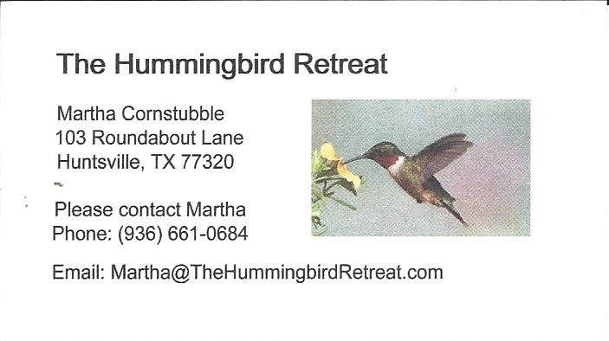
_{Newsletter ad prices are:}
$5.00 a month or $50.00 per year for a business card size advertisement.
$10.00 a month or $100.00 per year for a 3.5” x 4.5” size advertisement.
$18.00 a month or $180.00 per year for a one-half page advertisement.
$36.00 a month or $360.00 per year for a full page advertisement.
Member ads are free and will run for one month per request
Diane’s Tips and Grins
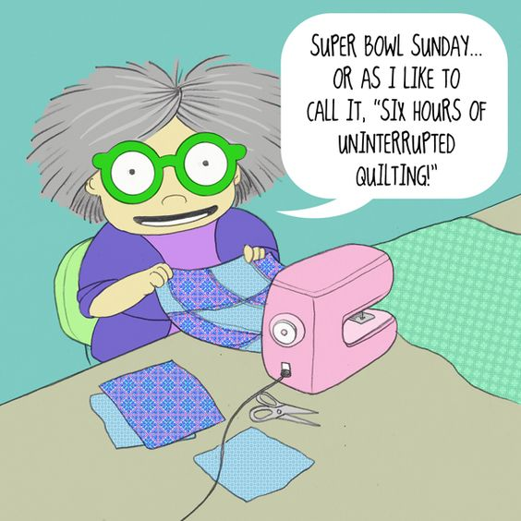

_{Tall Pines Quilt Guild}
_{P.O. Box 7272}
_{Huntsville, Texas 77342-7272}

_{Tall Pines Quilt Guild Meeting} _{Guild Calendar Reminders}
You are invited to join us the first Monday of _{Feb.6, 6:30 PM Guild Meeting}
each month. The guild has a variety of _{Jan. 17, Charity Bee}
programs, nationally known speakers, _{Meeting Reminders}
_{workshop and charity projects.} _{Bring Show and Tell Items}
We meet at the University Heights Baptist Church _{Bring money for Food Bank}
_{2400 Sycamore Ave.} _{UPC Labels from Hobbs batting}
Park in the back lot off Palm Ave. _{FQ Bands from Fabric Carousel}
Refreshments are served at 6:30PM _{For Charity Bee}
and the meeting starts at 7 PM. Visit the web site @ www.tallpinesquiltguild.com

