September 2018 Whisperings from the
Tall Pines Quilt Guild
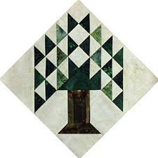

Upcoming Programs and Meetings
October 1st – Rhonda Dort
Designing Quilts Using Vintage Linens

October Birthdays
Tracy Elgersma 10/2
Janie Krick 10/3
Judy Moorer 10/3
Alura Galbraith 10/7
Evelyn Dawson 10/10
Eloise McGalliard 10/12
Donna Gardner 10/17
Monte Knight 10/22
Beverly Wiggins 10/25
Hannah Henley 10/27
Elaine Eakin 10/28
Kelli Anne Langley 10/29
Alisa Willson 10/29

Publisher: Diane Carrington Volume Number 112 Issue Number 111
From the President
Hope you all enjoyed the meeting Monday night. Good food and great information from Patti Nethery. I love her rulers and the neat things she can do with them. Just wish I had more time!

The Guild will be selling tickets for the donation quilt at the Huntsville Antique Show on September 15th. Please come out and show your support for the producers of this show as they are giving us a small space for free. There should be lots of goodies to buy. I am also looking forward to the Fair on the Square on October 6th. There are forms and at Fabric Carousel if you would like to make and sell items. The Guild will retain 15% of the sales, so price accordingly. If you can make something to donate to the guild to sell that would be great. There are patterns also at Fabric Carousel that you can use.

Looking forward to October meeting and learning from Rhonda Dort. If you are taking her workshop, the Huntsville Antique Show will be a good place to pick up old linens, etc. to use in her class.

Happy Quilting
Martha Wilson

Sunshine and Shadows
Jeanne Boucher a former guild member is now on Hospice, we need to keep her and her family in our thoughts and prayers. Also keep Betty Gratz and her family in our prayers, her son Edward is starting hospice care. If you hear of any members in need of prayer or with happy events in their lives be sure to contact Betty Gratz or Ruth West

Treasurers Report
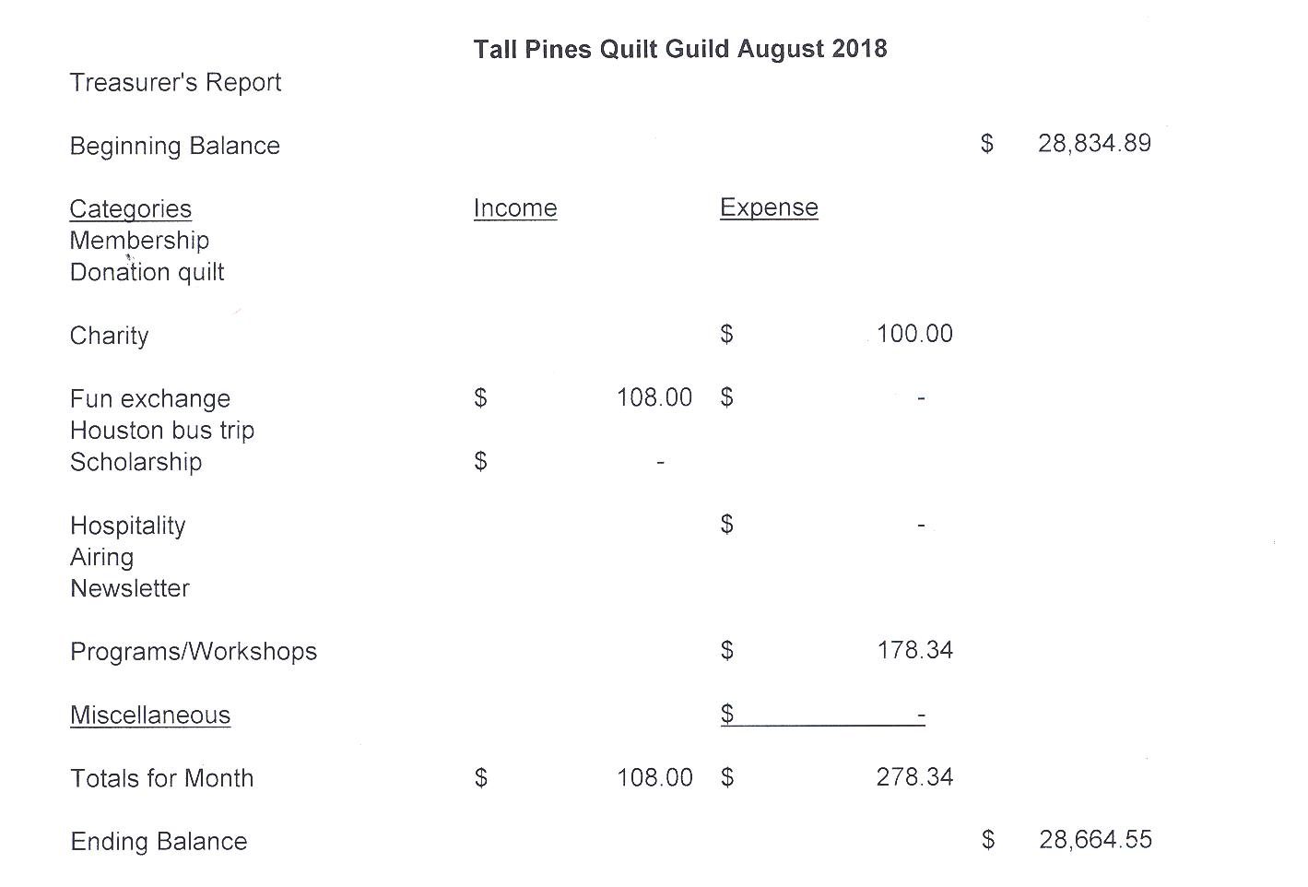

Tall Pines Quilt Guild Minutes of Meeting

Tall Pines Quilt Guild
Meeting Minutes
August 27, 2018
University Heights Baptist Church

President, Martha Wilson, called the meeting to order, welcomed members and guests and recognized September birthdays.
The August minutes were printed in the August 6th newsletter. As there were no additions or corrections noted, Ashley Beuhring made a motion to accept the minutes as printed. Ruth West seconded the motion. Motion passed.
Kay Ohendalski provided the treasurer’s report for members’ review. Any questions should be directed to Kay.
Cathy Wilson introduced the 5 newest members to the guild. Member,s please be sure to make them feel welcome at future meetings.
Rhonda Lynch is heading up the young girls’ sewing group at Fabric Carousel. They will be meeting once a month. The quilts will be 4-H projects and shown at the Walker County Fair. Sign-up sheets are available.
Tickets are available to sell for the raffle quilt. All members are encouraged to get tickets from Doris Collins.
The raffle quilt will be on display at the Huntsville Antique Show on September 15th. Volunteers have signed up to sell tickets during that day. Please support the vendors and show our appreciation for them letting us have free booth space for our quilt.
Doris Collins has offered the front portion of her classroom area to sell raffle tickets and other items during Fair on the Square on October 6th. There is a sign up sheet available as volunteers will be needed to oversee the sales. Kits, leftover from last year, and patterns are available to anyone who wishes to make something to sell. If members would like to sell something for themselves, a form is available as well. If you plan on selling personal items, please be sure to volunteer to work.
Tickets for the bus trip to the International Quilt Festival in Houston, on November 8th, will be $50. Payment must be made by October 15th to reserve your seat. Direct questions to Dorothy Wolverton.
Door prize and Fun Fund drawings were held. Congratulations winners.
- Ann Gilmore gave an update on upcoming programs and also reviewed the rules for the 2019 UFO Challenge which will begin in December of 2018. Forms were available for anyone who wants to participate.
Patti Nethery was tonight’s presenter. The title of her presentation was Ruler Revolution.
Kelli Anne Langley hosted Show and Tell.
The next Executive Board meeting for all officers and committee chairs will be September 10, at 5:30 PM at Fabric Carousel. Anyone is welcome to attend.
There being no further business, the meeting was adjourned.

Fabricadabra,that’s all folks,
Elaine Robinson, Secretary

Fair on the Square
We will be participating in Fair on the Square on October 6, 2018. Doris Collins has allowing us to use the front part of her classroom area to set up to sell raffle tickets and other items. If anyone wants to make things to sell, there are forms and tickets at the Fabric Carousel in the classroom area. If you sell items, the guild will get 15% of the price, so price your things accordingly. Please do not include any "garage sale" items for sell. If you are making and selling things, you will be expected to work the sales area at some time during the day. I also have patterns available at Fabric Carousel for members to make things for donation to the guild. If you have any other ideas of items to sell, let me know. Call me at 936-662-9202 if you have questions.

Programs Updates
TALL PINES QUILT GUILD 2018-2019 PROGRAMS
D-Ann Gilmore, Program Chairman
October 1 – Rhonda Dort will present a program on Designing Unique Quilts Using Vintage Linens followed by a hands-on workshop the following day.

November 5 – UFO Challenge. Bring your finished projects you listed earlier this year for a special show and tell and a chance to win a prize for completing your challenges.

December 5 – Christmas party

January 7 – Jackie Hillman will give a Powerpoint presentation and trunk show entitled the “Goose is Loose on the Ranch” followed by a workshop the next day using flying geese in unusual arrangements to make a table runner.

February 4 – Pregnancy Care baby shower

March 4 – A Block by Any Other Name will be the title of the program by Mary Anne Fay from Fat Quarter Café. Mary Ann will talk to us about all the different names that have been given blocks. At the workshop we will take our scraps and make blocks that free us from trying to be perfect.

April 1 – Dena Rosenberg will give us a trunk show followed by a workshop the next day making the pattern Seven Sisters.

June 3-4 – Debby Walters and her daughter Kim Buchmann will give us a mother daughter trunk show from the many quilts they have made over the years. There will be a 2-day workshop on Designing with Strips and Curves using Louisa L. Smith’s templates.

Members
There were 54 members and 4 visitors present at our September meeting. We now have 118 members. Please join me in welcoming our newest member, Kimberly Carney!

Kimberly Carney
1910 20th St.
Huntsville, 77340
Cell: 618-812-4469
karney52@gmail.com
BD: March 24

Door Prizes:
3 Snowman Patterns – Donna Gardner
3 Christmas Patterns – Debbie Walton
Patrick Lose Christmas Book – Jean Bradley

Fun Exchange:
Hexie Calendar – Ashley Buehring
Charms and 2 yards of fabric – Janis Voldbakken
Organizer with charms and notions – Diane Roman
Charms and 2 yards of fabric – Cathy Steinbeck

Show and Tell
- Rory Ross – fabric bowls
- Tasha Fry – Kingsize and Lap Quilt
- Kay Ohendalski – Charity quilt
- Donna Gardner – Rescue quilt
- Liz Williams – Deck the Halls block, From the Heart Block 7
- Jean Bradley – “Helen” the cow
- D-Ann Gilmore – In the Meadow redwork for Fair on the Square
- Janis Voldbakken – Fat quarter Challenge
- Ashley Buehring – trunk show
Bee News
Charity Bee
Charity Bee will be September 18 at Fabric Carousel.
Cut-ups
Cut Ups will meet on the 2nd and 4th Friday each month at the Fabric Carousel. All are Welcome. Bring your quilting problems for lots of advice and help from your friends. Bee starts around 10 and lasts all day.
Embroidery Bee
We meet on the third Saturday of the month at 11 AM, at the Ohendalski building, next door to the Chicken place across from the mall. 1425 Brazos Dr. Contact Susan Craig for info. 436-1489
Diane’s Tips and Grins

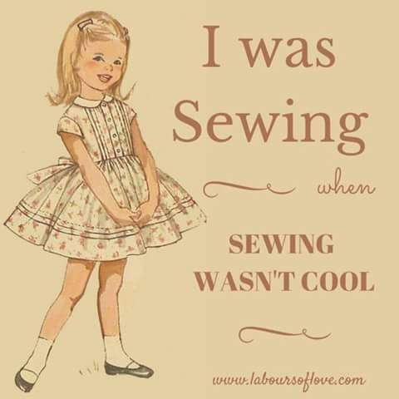

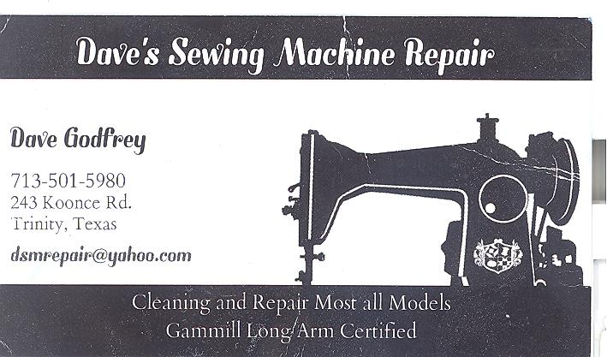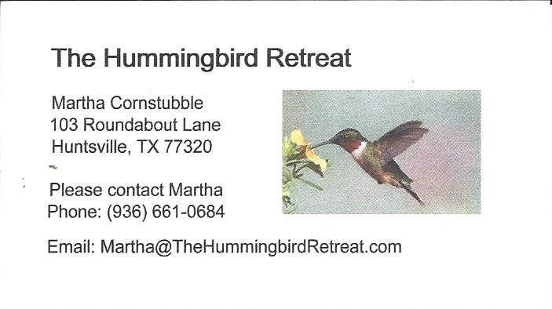
_{Newsletter ad prices are:}
$5.00 a month or $50.00 per year for a business card size advertisement.
$10.00 a month or $100.00 per year for a 3.5” x 4.5” size advertisement.
$18.00 a month or $180.00 per year for a one-half page advertisement.
$36.00 a month or $360.00 per year for a full page advertisement.
Member ads are free and will run for one month per request

_{Tall Pines Quilt Guild}
_{P.O. Box 7272}
_{Huntsville, Texas 77342-7272}

_{Tall Pines Quilt Guild Meeting} _{Guild Calendar Reminders}
You are invited to join us the first Monday of October 1 , 2018, 6:30 PM Guild Meeting
each month. The guild has a variety of _{September 18, 2018 Charity Bee}
programs, nationally known speakers, _{Meeting Reminders:}
_{workshop and charity projects.} _{Bring Show and Tell Items}
We meet at the University Heights Baptist Church _{Bring money for Food Bank}
_{2400 Sycamore Ave.} _{UPC Labels from Hobbs batting}
Park in the back lot off Palm Ave. _{FQ Bands from Fabric Carousel}
Refreshments are served at 6:30PM _{For Charity Bee}
and the meeting starts at 7 PM. Visit the web site @ www.tallpinesquiltguild.com
