April 2019 Whisperings from the
Tall Pines Quilt Guild
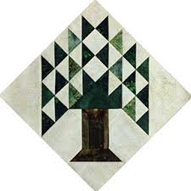

Upcoming Programs and Meetings

May 6th – Sherry Mark
Importance of Batting
April 16th – Charity Bee

May Birthdays

Debbie Birdwell 5/3
Judy Oliver – 5/9
Patricia McCartney – 5/12
Kathy Perry – 5/13
Martha Wilson – 5/14
Martha Hoover – 5/18
Dee Ross – 5/24
Maggie Smith – 5/27

Publisher: Diane Carrington Volume Number 117 Issue Number 116
From the President
Happy Easter!

Hope you find all the eggs and win the prize. Monday's meeting was very enjoyable and we enjoyed a packed house! I was able to take the workshop on Tuesday to make the Seven Sister's block. The block goes together easily and the seams are precise, but that means you have to cut it right the first time. I did a little re-cutting, but everyone's block was beautiful. Mostly all of us were able to finish at least one block.

Currently there are no pending events coming up soon. The Fair on the Square will be in October so be thinking of things to make and sell at the show. We will probably be holding our sale inside Fabric Carousel like we did last year.

I am very saddened to hear of the passing of Betty Bell. She has been a constant in the Guild since I became a member. Her humor and sweetness will be missed!

Martha Wilson

Sunshine and Shadows
We wish a speedy recovery to Jesse Grant who recently had surgery.

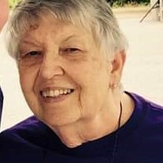 We will miss you Betty. Love and Prayers to your family.

Treasurers Report
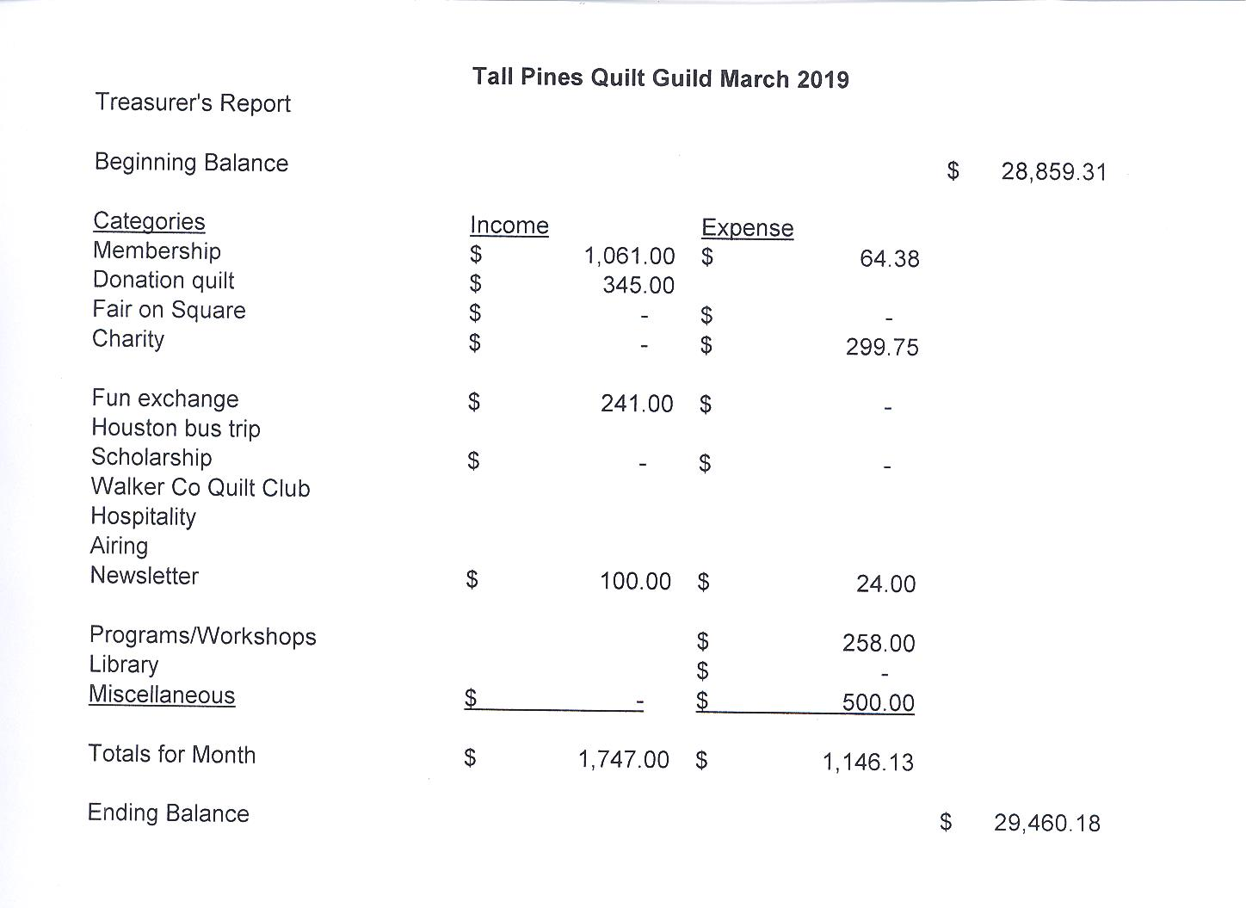
Tall Pines Quilt Guild Minutes of Meeting
Tall Pines Quilt Guild
Meeting Minutes
April 1, 2019
University Heights Baptist Church

President, Martha Wilson, called the meeting to order, welcomed members and guests and recognized April birthdays.

The March minutes were printed in the newsletter. Ashley Buehring made a motion to accept the minutes as printed. Dee Ross seconded the motion. Motion passed.

Kay Ohendalski provided the treasurer’s report for members’ review.

Cathy Wilson reported that there were 58 members present tonight, 8 visitors and 2 new members.

Rhonda Lynch announced that the 4-H sewing club has completed their first year with 14 girls attending. Some of the girls showed their quilts. Their quilts were shown and judged at the Walker County Fair. Several ribbons were won. A new club will start up in October.

Diane Carrington reported that the quilt show at the Walker County Fair was a huge success with 70 quilts displayed this year. She also announced all the winners. Congratulations to all!

Martha Wilson gave a report on the Veterans Muster, the silent auction made $1,000 for the museum.

The donation quilt drawing will be held on May 4th. Tickets are still available. Return your money and/or tickets by April 20th to Fabric Carousel.

Remember to bring your recyclable plastics for the Lion’s Club.

Door prizes were awarded and fun exchange tickets were drawn. Congratulations to the winners.

#7 was drawn for the UFO.

Ann Gilmore told about upcoming programs and about a Saturday sampler that will begin on April 6th. The initial cost is $20 and $5/mth for fabric afterwards. You will need 1 3/4 - 2 yards of white background fabric. The class will begin at 9 AM at Fabric Carousel.

Tonight’s program featured a trunk show by Dena Rosenberg.

Committee reports were given.

Kelli Anne Langley hosted Show and Tell.

The next Executive Board meeting for all officers and committee chairs will be April 8, 2019, at 5:30 PM at Fabric Carousel. Anyone is welcome to attend.

There being no further business, the meeting was adjourned.
Nuts about Bolts,,
Elaine Robinson, Secretary
Membership
If you have not picked up a new membership directory, it is available to pick up at each meeting and I will leave some with Doris at Fabric Carousel. It is also updated each month on the Tall Pines website.
There are currently 115 members in the guild. At the April meeting, we enjoyed the company of 60 members, 8 visitors, and 2 new members. Please join me in welcoming our newest members!

Lynn Downing
3341 FM 946N
Oakhurst, 77359
Home: 936-377-3189
Cell: 936-327-1756
BD: June 17
Spouse: Bob
lmdown58@gmail.com

Debbi Kiersz (rhymes w. 'Sears')
96 Hilltop Rd
Huntsville, 77320
Cell: 281-382-1258
BD: October 31
Spouse: Tim
debkiersz@aol.com

Programs Updates

D-Ann Gilmore, Program Chairman
May 6 – Sherry Mark with Loft Supply will give a presentation on the importance of batting you use in your quilt and the various choices you have available. There will not be a workshop. Please remember to bring No. 7 on your challenge list.

June 3-4 – Debby Walters and her daughter Kim Buchmann will give us a mother daughter trunk show from the many quilts they have made over the years. There will be a 2-day workshop on Designing with Strips and Curves using Louisa L. Smith’s templates.

Fun Exchange
- Jen Kingwell layer cake – Pam Ray
- Layer cake and yardage for kid’s quilt – Susan Craig
- Quilt squares and fabric – Helen Belcher
- Double wedding ring templates – Lynda Muzyka

Door Prizes

- Fat quarters and Sarong – Jo R.
- Book and Pincushion – Lynda Muzyka
- Pattern and Pincushion – Nancy Nelson

Show and Tell
- Kelli Langley – cross-stitches
- Grettle Payne – Doggone It and Meet Me at the Courthouse
- Martha Wilson – Mini yo yo quilt
- Dee Ross – Aggie quilt
- Helen Cook – 4 quilts
- Kay Ohendalski – Posies quilt
- Wendy Salsbery – 3 charity quilts
- D-Ann Gilmore – Lola the Llama
- Dorothy Wolverton – Fierce Ladies Mini quilt
- Kathy Perry – Jungle Songs
- Barb Edmondson – Tablerunner
- Virginia Cooper – Seth’s Farm
- Ashley Buehring – hexies
- Cathy Wilson – Baby quilt

Bee News
Charity Bee
The next Charity Bee is on Tuesday, April 16, at Fabric Carousel, beginning at 9:30 am. For the Food Bank at the April guild meeting, we collected $30, bringing the YTD total to $143! There are several HUGs (quilts) that are pinned and ready for quilting/finishing. They are located in the white laundry basket under the clock in the Fabric Carousel workroom. If you need one prepared for a longarm, please let me know and we will fix you up! As a reminder, Charity Bee collects Fabric Carousel fat quarter wrappers and Hobbs batting UPC labels. Still hoping that every member of the guild will complete at least one HUG for the year. This could really increase our donations to our charitable recipients!! We also donate baby bibs, adult bibs, baby burps, crocheted baby beanies, baby blankets, walker caddies, adult lap quilts (for the wheelchair bound), as well as HUGs of all sizes. A big "thank you" to all who participate!

Cut-ups
Cut Ups will meet on the 2nd and 4th Friday each month at the Fabric Carousel. All are Welcome. Bring your quilting problems for lots of advice and help from your friends. Bee starts around 10 and lasts all day.

Embroidery Bee
We meet on the third Saturday of the month at 11 AM, at the Ohendalski building, next door to the Chicken place across from the mall. 1425 Brazos Dr. Contact Susan Craig for info. 436-1489

2019 County Fair

Thank you to all the participants and a special thank you to Doris Collins/Fabric Carousel who sponsored the event. Also Helen Belcher for all your help and information. It was a wonderful event.

Best of Show – Rennie Bauer Civil War Sampler
Judge’s Choice – Janis Voldbakken Free Range Hippy Chicks
Junior Division
1st Place – Zoe Clark
2nd Place – Emma Ainsworth
3rd Place – Callie Lynch

Wall Quilts Category 1
1st Place – Dorothy Wolverton
2nd Place – Virginia Wilson
3rd Place – Jean Bradley

Wall Quilts Category 2
1st Place – Randi Clower
2nd Place – Nancy Pasket
3rd Place – Becky Nichols

Wall Quilts Category 3
1st Place – Virginia Cooper
2nd Place - Jean Bradley
3rd Place – Tasha Fry

Small Quilts Category 1
1st Place – Janis Voldbakken
2nd Place – Virginia Wilson
3rd Place – Jean Bradley

Small Quilts Category 2
1st Place – Dorothy Wolverton
2nd Place – Grace Burzynski
3rd Place – Rennie Bauer

Large Quilts Category 1
1st Place – Virginia Wilson
2nd Place – Rennie Bauer
3rd Place – Diana Hunziker

Large Quilts Category 2
1st Place - Dorothy Wolverton
2nd Place – Rennie Bauer
3rd Place – Randi Clower

Hand Quilted
1st Place – Rennie Bauer
2nd Place – Donna Hoffman
3rd Place – Lauren Gardner

Hand Applique/Hand Embroidery
1st Place – Kay Ohendalski
2nd Place – Jean Bradley
3rd Place Diane Carrington

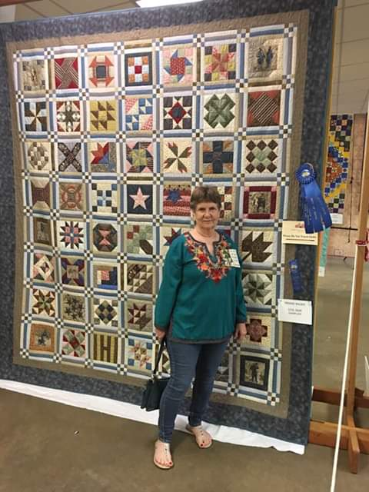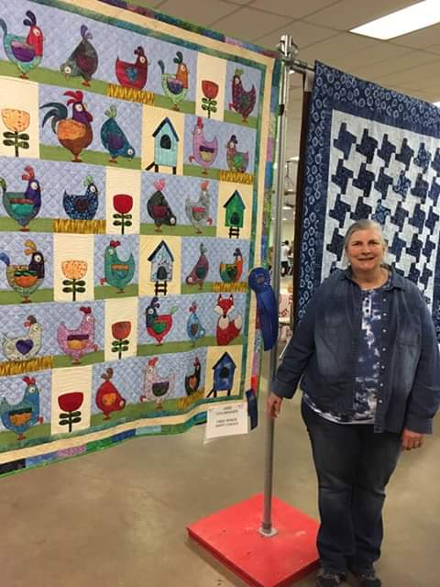

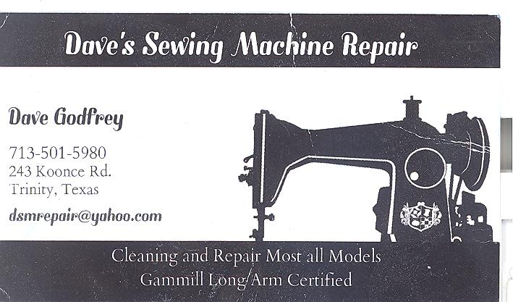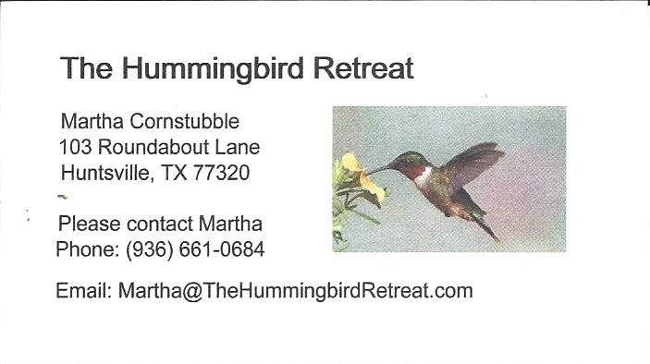
_{Newsletter ad prices are:}
$5.00 a month or $50.00 per year for a business card size advertisement.
$10.00 a month or $100.00 per year for a 3.5” x 4.5” size advertisement.
$18.00 a month or $180.00 per year for a one-half page advertisement.
$36.00 a month or $360.00 per year for a full page advertisement.
Member ads are free and will run for one month per request
_{Tall Pines Quilt Guild}
_{P.O. Box 7272}
_{Huntsville, Texas 77342-7272}

_{Tall Pines Quilt Guild Meeting} _{Guild Calendar Reminders}
You are invited to join us the first Monday of May 6, 2019 6:30 PM Guild Meeting
each month. The guild has a variety of _{April 16, 2019 Charity Bee}
programs, nationally known speakers, _{Meeting Reminders:}
_{workshop and charity projects.} _{Bring Show and Tell Items}
We meet at the University Heights Baptist Church _{Bring money for Food Bank}
_{2400 Sycamore Ave.} _{UPC Labels from Hobbs batting}
Park in the back lot off Palm Ave. _{FQ Bands from Fabric Carousel}
Refreshments are served at 6:30PM _{For Charity Bee}
and the meeting starts at 7 PM. Visit the web site @ www.tallpinesquiltguild.com
