March 2019 Whisperings from the
Tall Pines Quilt Guild
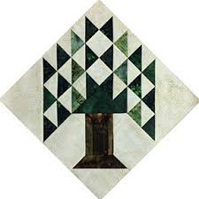

Upcoming Programs and Meetings
March 22 – Turn in quilts for County Fair
March 19th Charity Bee
April 1st Dena Rosenberg
Seven Sisters Quilt

April Birthdays

Melanie Burleson 4/1
Linda Cauthen 4/1
Martha Cornstubble 4/1
Mary Courtney 4/17
Rennie Bauer 4/19
Kathleen Pittman 4/27
Rory Ross 4/27
Randi Clower 4/29

Publisher: Diane Carrington Volume Number 116 Issue Number 115
From the President
Greetings fellow quilters!

Happy Spring, or whatever this is that we are having. Freezing one day and sweating the next. I thoroughly enjoyed our meeting and lecture on Monday night. Not only did we get to see some great vintage items, it was a learning experience too. I learned to sew using feed sack fabric, because it was free! My grandmother and aunt both raised chickens and my uncle worked at the flour mill. Wish I had all those sacks now! I do have a small collection, but not ones that came from my family.

The Veteran's Muster is coming up on March 30th and we still need donation items for the silent auction and I also need workers to help us out that day. We will be selling tickets for our donation quilt plus monitoring the silent auction. The proceeds from the silent auction go to the Veteran's Museum. Please drop off your donation at Fabric Carousel and make sure you have your name on it. There will be prizes!

Next event will be Walker County Fair which starts on 3/24/19. Quilt turn-in will be 3/22/19 and quilt hanging will be 3/24/19. Please come out on Sunday morning and help us get the quilts displayed.

Martha Wilson

County Fair
If you live in Walker County this is your opportunity to show off your quilts. There is a $5.00 entry fee for each quilt. Each quilt must have a sleeve and label. Turn in your entry at Fabric Carousel, March 22 between 1-5.

Scholarships
This year the Tall Pines Quilt Guild will be offering two (2) $1,500 scholarships to graduating seniors residing within the TPQG membership area. Public, private and home school graduating seniors are eligible to apply.
The Scholarships are available in two categories
- SEWING PROFICIENCY – any major is eligible, but pictures of demonstrated proficiency in sewing must be submitted with the required documentation & completed application.

OR

- MATH EDUCATION – requires that the student intends to major or minor in Math Education.
Applications have been sent to the fourteen high schools (including one private school) that are located within our membership area. Applications are available through the high school counseling office, at Fabric Carousel, and can be downloaded from the TPQG website www.tallpinesquiltguild.com under the Scholarships tab. If you have any questions, or are interested in participating on the Selection Committee, please feel free to contact me. Applications must be submitted by Friday, May 17, 2019. Winners will be announced in June 2019.
Judith Oliver (judith-oliver@sbcglobal.net) 936 439-0980 (2019 TPQG Scholarship Chairman)

Veteran's Muster - March 30, 2019, 10:00 AM to 4:00 PM

Tall Pines Quilt Guild will be participating in the Veteran's Muster again this year. We will not be able to hang all the quilts like before, as our frames will be at the Walker County Fair Quilt Show. However, we will have a mini-quilt, table-runner, or small wall hanging silent auction to benefit the Museum. In return, the Museum is allowing us to present our Donation Quilt and sell tickets at the event. We are asking for members to donate a small quilt, mini-quilt, table-runners that can be used in the Silent Auction. Please be sure to attach your name to these when you turn them in because there will be prizes! One prize for the most donated and one prize will be drawn for all that donate a quilted item. We will need help that day to sell tickets and monitor the auction. There will be a sign-up sheet at the next meeting and then at Fabric Carousel. Any questions? Contact Martha Wilson.

Sunshine and Shadows

Betty Bell has been diagnosed with cancer. We are not aware of all the details but it appears to be quite serious.

Treasurers Report
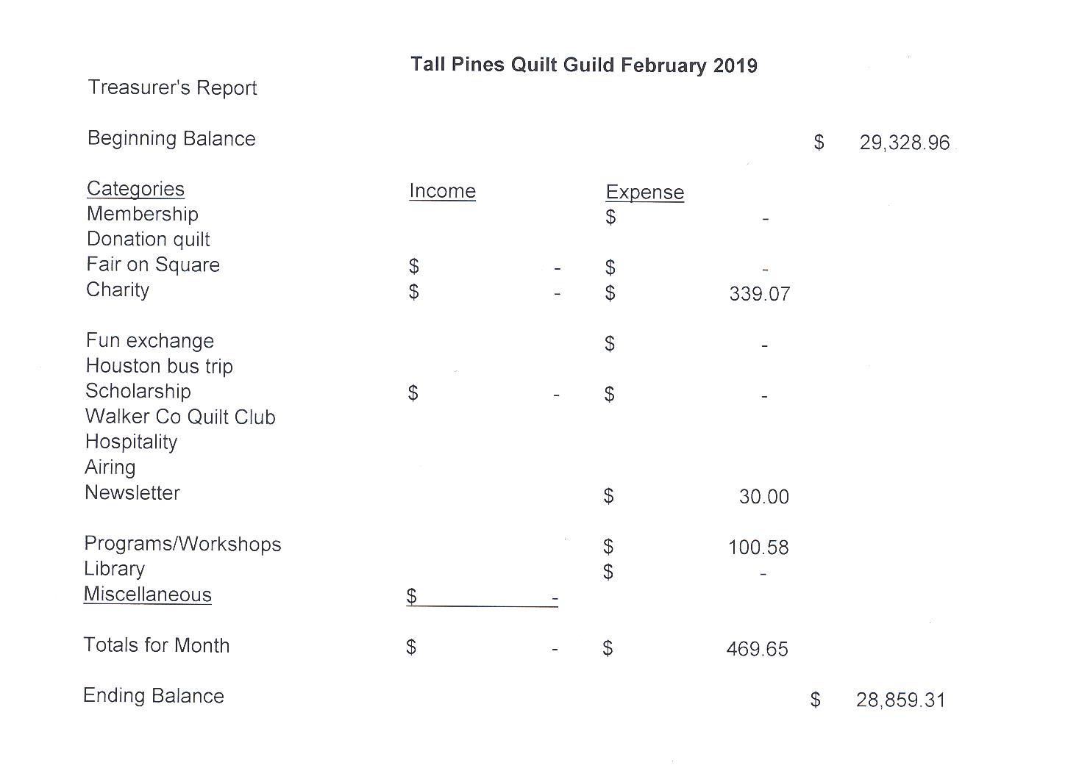

Tall Pines Quilt Guild Minutes of Meeting

Tall Pines Quilt Guild
Meeting Minutes
March 4, 2019
University Heights Baptist Church

President, Martha Wilson, called the meeting to order, welcomed members and guests and recognized March birthdays.

The February minutes were printed in the newsletter. Ashley Buehring made a motion to accept the minutes as printed. Janis Voldbakken seconded the motion. Motion passed.

Kay Ohendalski provided the treasurer’s report for members’ review.

Judy Oliver reported that the 2019 scholarship forms are now available. Deadline for submission is May 17th.

Cathy Wilson recognized the two new members to the guild.

The 2019 budget was available on each table. Susan Craig made a motion to accept the budget. Ruth West seconded the motion.

There are three events coming up in March. Please sign up to help at these events.
The donation quilt will be at the Rusty Chippy Show at the Walker County Fairgrounds on March 9th.
The donation quilt will be at the Veterans Muster on March 30th. Donations of mini quilts, small wall-hangings and table runners are needed for a silent auction benefiting the museum. Donated items need to be turned in by March 22nd at Fabric Carousel.

Walker County Fair Quilt Show is being headed up by Diane Carrington and Helen Belcher. Turn in quilts on March 22nd at Fabric Carousel between 11 and 5. Hanging of the quilts will be on March 24th and quilts will be taken down on March 30th. Please plan to pick up your quilts between 10-12 or make other arrangements.

Guild members need to come up with ideas to generate income for the group.

#11 was drawn for the UFO Challenge. These items need to be brought to the April meeting. Lynda Muzyka gave a report on the upcoming programs and workshops and introduced tonight’s speaker, Dr. Maggie McGuire who spoke on the history of feed sacks and their uses for clothing,

Door prizes were awarded and fun exchange tickets were drawn. Congratulations to the winners.

Students from SHSU showed the 11quilts that they made. These will be donated to children at Head Start.

The Brazos County Bluebonnet Quilt Show will be held on September 6th and 7th in Bryan.

Committee reports were given.

Kelli Anne Langley hosted Show and Tell.

The next Executive Board meeting for all officers and committee chairs will be March 11, 2019, at 5:30 PM at Fabric Carousel. Anyone is welcome to attend.

There being no further business, the meeting was adjourned.
Sew in Piece,
Elaine Robinson, Secretary

Membership
As of March 7, the guild has 113 members who have recently joined or renewed their membership. At the March meeting, there were 60 members, 2 new members, and 8 visitors in attendance. Please join me in welcoming our newest members!

Barbara Barnes
435 Elkins Lake
Huntsville, 77340
Cell: 210-364-0695
BD: Nov. 14
Spouse: David
Email: spikeb1960@gmail.com

Rebecca Lewis
38 Wood Lodge Dr
Huntsville, 77320
Home: 936-295-7301
Cell: 936-355-1227
BD: March 9
Email: rebaka3599@gmail.com

Programs Updates

TALL PINES QUILT GUILD 2019 PROGRAMS
D-Ann Gilmore, Program Chairman
April 1 – Dena Rosenberg will give a trunk show followed by a workshop the next day making the pattern Seven Sisters. Rulers will be available for purchase from the teacher.

May 6 – Sherry Mark with Loft Supply will give a presentation on the importance of the batting you use in your quilt and the various choices you have available.

June 3-4 – Debby Walters and her daughter Kim Buchmann will give us a mother daughter trunk show from the many quilts they have made over the years. There will be a 2-day workshop on Designing with Strips and Curves using Louisa L. Smith’s templates.

Fun Exchange

- “Seeing Red” items – Cindy Rohe
- Wool felt owl applique – Elaine Aiken
- 2 Charmpacks – Elaine Aiken
- Batik fat quarters and book – Virginia Cooper

Door Prizes

- Sewing Basket – Elaine Robinson
- Charm Park – Elaine Robinson
- Mini Sewing Kit – Betty Gratz

Show and Tell
- Kelli L – Apostle’s Creed
- Susan C – Baby Nines and Charity quilt
- Tasha Fry – Fat Quarter Wall Hanging
- Ruth West – Blue wall hanging
- Jean Bradley – Purple wall hanging and Spicerack
- Marth Fielder – Lemon tablerunner
- Janis Voldbakken – What Do You Do With A Layer Cake
- Martha Wilson – Kitty quilt
- Kim Street – Christmas Quilt
- Cindy Rohe – 2 baby quilts and Easter eggs
- Jammie Ackley – Quilting of quilt
- Kay Ohendalski – Emily’s quilt
- Grace Burzynski – 2 Grandma’s quilts
- Ann Moore – Tote Bag, Pillow, Quilt and Wallhanging
- Deb Mundell – Quilt of Valor
- Jeanette Allen – Easter eggs
- Virginia Cooper – Tablerunner
- Nancy Nelson – Lone Star State quilt

Bee News
Charity Bee
$39 collected for the Food Bank, bringing the YTD total to $113! Next Charity Bee meeting is Tuesday, March 19, from 9:30 to ??, at Fabric Carousel. Thanks to everyone who took a kit to sew at the guild meeting.

Cut-ups
Cut Ups will meet on the 2nd and 4th Friday each month at the Fabric Carousel. All are Welcome. Bring your quilting problems for lots of advice and help from your friends. Bee starts around 10 and lasts all day.

Embroidery Bee
We meet on the third Saturday of the month at 11 AM, at the Ohendalski building, next door to the Chicken place across from the mall. 1425 Brazos Dr. Contact Susan Craig for info. 436-1489

Diane’s Tips and Grins

You know that feeling you get when all your UFO’s are
finished and your sewing room is neat and tidy…

Me neither…

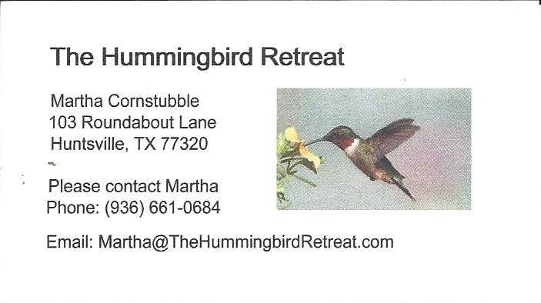
_{Newsletter ad prices are:}
$5.00 a month or $50.00 per year for a business card size advertisement.
$10.00 a month or $100.00 per year for a 3.5” x 4.5” size advertisement.
$18.00 a month or $180.00 per year for a one-half page advertisement.
$36.00 a month or $360.00 per year for a full page advertisement.
Member ads are free and will run for one month per request

_{Tall Pines Quilt Guild}
_{P.O. Box 7272}
_{Huntsville, Texas 77342-7272}

_{Tall Pines Quilt Guild Meeting} _{Guild Calendar Reminders}
You are invited to join us the first Monday of April 1, 2019 6:30 PM Guild Meeting
each month. The guild has a variety of _{March 19, 2019 Charity Bee}
programs, nationally known speakers, _{Meeting Reminders:}
_{workshop and charity projects.} _{Bring Show and Tell Items}
We meet at the University Heights Baptist Church _{Bring money for Food Bank}
_{2400 Sycamore Ave.} _{UPC Labels from Hobbs batting}
Park in the back lot off Palm Ave. _{FQ Bands from Fabric Carousel}
Refreshments are served at 6:30PM _{For Charity Bee}
and the meeting starts at 7 PM. Visit the web site @ www.tallpinesquiltguild.com
