January 2019 Whisperings from the
Tall Pines Quilt Guild
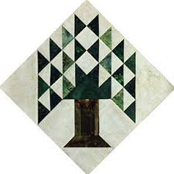

Upcoming Programs and Meetings
Jan 22 – Charity Bee
Feb 4 – Baby Shower for Pregnancy Care Center

February Birthdays
Elaine Robinson 2/2
Cathy Shute 2/9
Cynthia McCurdy 2/9
Callie Lynch 2/12
Pat Gibson 2/13
Patty Sorensen 2/15
Mary Ellen Johnson 2/21
Pat Speer 2/24
Jessie Grant 2/25
Dorothy Wolverton 2/28

Publisher: Diane Carrington Volume Number 114 Issue Number 113
From the President
Happy January!

I would like to thank the Guild for my Christmas present, it was a tote bag (made by Susan Craig) and a gift certificate. I have been using the tote bag a lot and have the gift certificate on hold at Fabric Carousel. Hope you all had a Happy Holiday season.

The presentation by Jackie Hillman Monday night was very interesting! Her things are so different than the normal quilting patterns. I just loved her process she uses with different flying geese. I was unable to take the workshop but did buy a kit from her (pumpkins, of course) to try out her method.

In case you were not at the meeting Monday, I announced that we would not be having the Airing of the Quilts this year. We need to put our heads together to come up with some other event to have to raise money for our speakers, etc. Put your thinking caps on and let me know!

Don't forget to bring your baby gifts next month for the Pregnancy Care Center.

Happy Quilting

Martha Wilson

Sunshine and Shadows
Congratulations to D-Ann she is going to be a new grandma in July. Our prayers go out to Helen Belcher, her husband isn't feeling well. Also we continue to send prayers to Jesse Grant and her family over the loss of her grandson. Let's. Keep Betty Gratz and her family in. our prayers, her son is very ill.

Treasurers Report
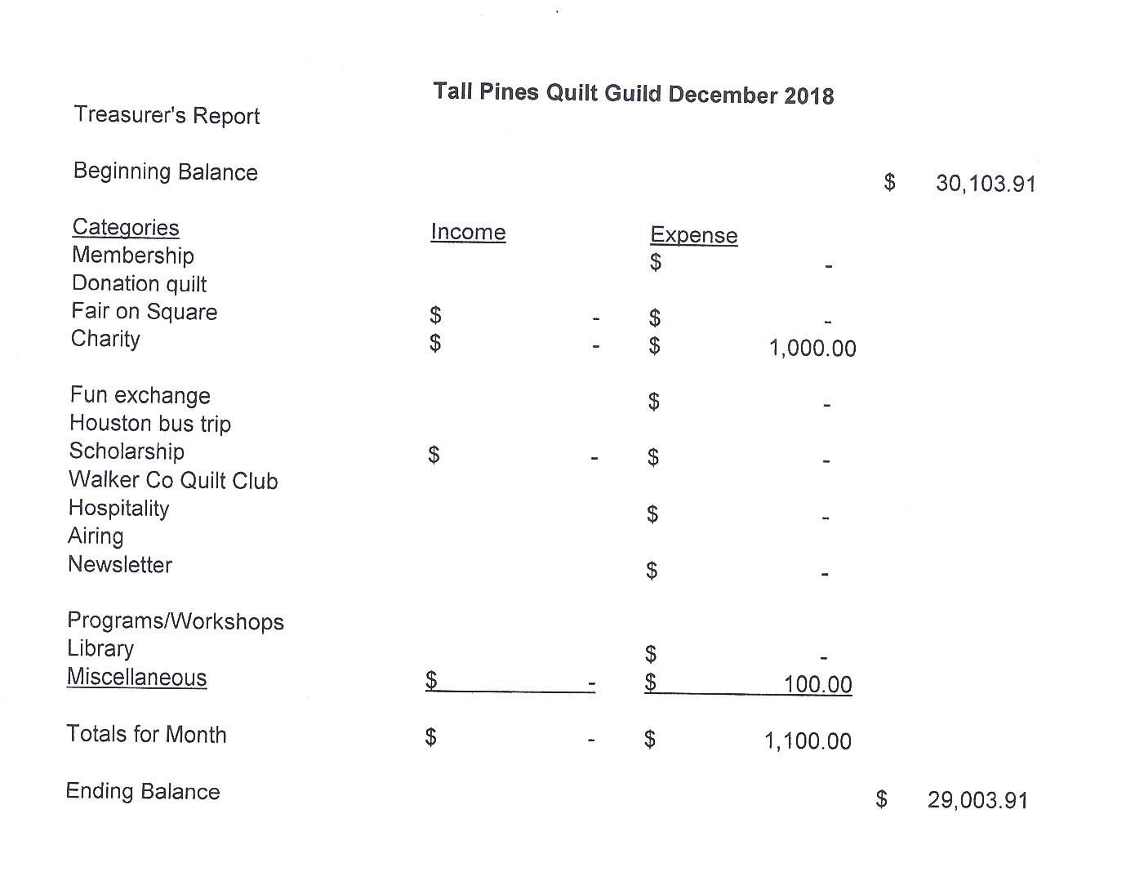
Tall Pines Quilt Guild Minutes of Meeting
Tall Pines Quilt Guild
Meeting Minutes
January 7, 2019
University Heights Baptist Church
President, Martha Wilson, called the meeting to order, welcomed members and guests and recognized January birthdays.
The December minutes were printed in the newsletter. As there were no additions or corrections noted, Ashley Beuhring made a motion to accept the minutes as printed. Kimberly Carney seconded the motion. Motion passed.
Kay Ohendalski provided the treasurer’s report for members’ review.
Rhonda Lynch gave an update on the 4-H sewing club. The next meeting will be on January 13.
Cathy Wilson recognized the newest members of the guild. Welcome!!
Tickets for the raffle quilt are available from Doris Collins.
Diane Carrington is heading up the quilt display at this year’s Walker County Fair. Quilts need to be turned in on March 22nd, at Fabric Carousel.
Martha Wilson will get in touch with Toni Bruner regarding the upcoming Veterans’ Muster. The museum is requesting patriotic quilts for display and also some for sale. More info will be forthcoming.
There is still a need for a few people to help set up and take down tables etc. for guild meetings.
The consensus of the survey concerning Airing of the Quilts was that it should not be held this year. It is too late to contact vendors and to submit articles for advertising. We need ideas on where we can display the raffle quilt and sell tickets. It will be displayed at the Antique Show in March.
D-Ann Gilmore drew #9 for the UFO challenge. These will be due at the February meeting in order to receive a ticket for a drawing in December. She also gave an update on upcoming programs. Tonight’s presentation was Jackie Hillman’s collection of quilts featuring unique ways to use flying geese pieces. The February meeting will be the annual baby shower for the Care Center. Remember to bring diapers and other baby items to the meeting.
Charity Bee will be held on January 22nd. Hugs will be put together so members are encouraged to pick one up at Fabric Carousel, get it quilted and bound and it will be donated.
Door prizes were awarded and fun fund tickets were drawn. Congratulations to the winners.
Rory Ross will be in charge of a jelly roll race at Fabric Carousel.
Judy Springer read a thank-you note from a Meals on Wheels representative thanking the guild members for the ornaments and gift bags that were donated in December.
Kelli Anne Langley hosted Show and Tell.
The next Executive Board meeting for all officers and committee chairs will be January 14, 2019, at 5:30 PM at Fabric Carousel. Anyone is welcome to attend.

Membership
Thanks to everyone who has already renewed their membership! Your dues for 2019 are now due! Less than half of our members have paid this year’s dues so please get them in by Feb. 15 or your information will not be included in the new membership roster which will be available at the March meeting. Dues are $25, $20 for members over 70, and $5 for junior members under 18. You may pay at the February meeting, at Fabric Carousel (Thanks, Doris!), or by mailing them to me:
Cathy Wilson
29479 Red Top Rd,
Richards, TX 77873

At this month's meeting, we had 57 people present which included 47 members, 3 visitors, and 7 new members which brings our total membership to 128! Please join me in welcoming our new members!

Wanda Begnaud
110 Wycliffe Dr
Montgomery, TX 77356
Home: 936-597-8202
Cell: 713-303-3130
BD: July 24
wbegnaud@hotmail.com

Leigh Corsi
13669 Lakeside Place Dr
Willis, TX 77318
Cell: 619-997-1386
BD: October 1
leighcorsi1@aol.com

Lauren Gardner
180 Stewart Rd
New Waverly, TX77358
Home: 903-504-6877
BD: October 10
laueli1112@gmail.com

Cynthia McCurdy
8 Cauthen Dr
Huntsville, TX 77320
Home: 936-435-5516
BD: February 9
Cynthia.mccurdy@gmail.com

Kathleen Pittman
15 Mossback St
Huntsville, TX 77320
Cell: 936-661-1730
BD: April 27
rpittman121@yahoo.com

Peggy Richards
12862 Pelican Blvd.
Willis, TX 77318
Cell: 281-435-7423
BD: December 20
dprichards@suddenlink.net

Tracy Szymczak
144 Int.45N #701
Huntsville, TX 77320
Cell: 281-787-9907
BD: September 1
tracina_proffler06@yahoo.com
Programs Updates
TALL PINES QUILT GUILD 2019 PROGRAMS
D-Ann Gilmore, Program Chairman
February 4 – Pregnancy Care baby shower, please bring baby items to make our gifts the best shower ever. Please bring Item No. 9 from your UFO Challenge list.

March 4 – Sam Houston State students will present their quilts they have made for Program Head Start.

April 1 – Dena Rosenberg will give a trunk show followed by a workshop the next day making the pattern Seven Sisters.

May 6 – Sherry Mark with Loft Supply will give a presentation on the importance of the batting you use in your quilt and the various choices you have available.

June 3-4 – Debby Walters and her daughter Kim Buchmann will give us a mother daughter trunk show from the many quilts they have made over the years. There will be a 2-day workshop on Designing with Strips and Curves using Louisa L. Smith’s templates.

Fun Exchange
- Somerset pattern and fat quarters – Kimberly Carney
- “I Spy” pattern and fabric – Kay Ohendalski
- “Organize Your Life” kit – Cindy Rohe
- Coral Bell Fabrics and Charms – Kathy Pittman
Door Prizes
- Oven Mitt kit – Virginia Cooper
- Calendar and Ruler – Linda Cauthen
- Quilt Journal - Lee

Show and Tell
- Barbara Edmondson – 3 Quilts and a sweater
- Susan Craig – Bag and Tablerunner
- Rory Ross – Embroidered Shirt
- Janis Volbakken – Fat Quarter Challenge Fancy Free
- Virginia Wilson – Ultimate Travel Bag
- D-Ann Gilmore – Elli the Elephant and Spool of Thread
- Debbie Mundell – Texas Lone Star
- Kristie Munson – Dinosaur Quilt and pillowcase
- Ashley Buehring – Space Out
- Rhonda Lynch – Scrappy Squares and Woodlands
Bee News
Charity Bee
The donation for the Food Bank for January, 2019 was $33. A great start for the New Year! The next Charity Bee meeting is Tuesday, January 15, beginning at 9:30 at Fabric Carousel. It's a new year, so let's all commit to completing at least one HUG for our local charitable recipients. We had a great year in 2018. The Jelly Roll "race" really helped with last year's HUG numbers. Maybe we can do that again this year. I hope everyone enjoyed their holidays and time off (no Bee in Dec.) and are ready to get back to making HUGs and other items for this year's donation! The need is always great.
Cut-ups
Cut Ups will meet on the 2nd and 4th Friday each month at the Fabric Carousel. All are Welcome. Bring your quilting problems for lots of advice and help from your friends. Bee starts around 10 and lasts all day.
Embroidery Bee
We meet on the third Saturday of the month at 11 AM, at the Ohendalski building, next door to the Chicken place across from the mall. 1425 Brazos Dr. Contact Susan Craig for info. 436-1489

Diane’s Tips and Grins

For Sale – Tin Lizzy 18 RAM with frame $2,000

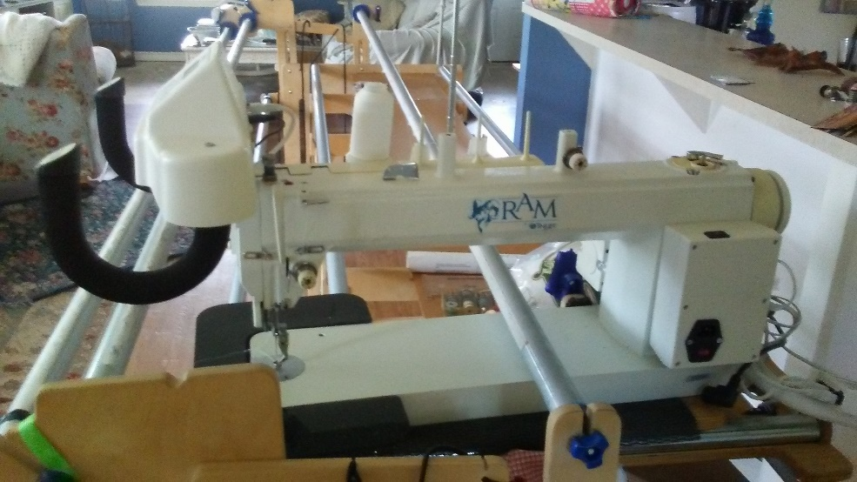

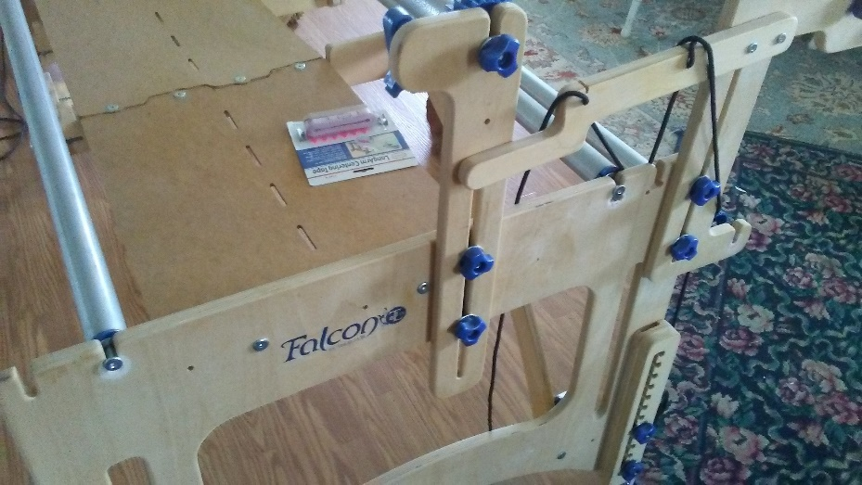

Also includes leader cloths, and rulers valued at over $400.00
If you have always wanted a longarm this is a great opportunity.
Contact Diane Carrington 936/661-1382

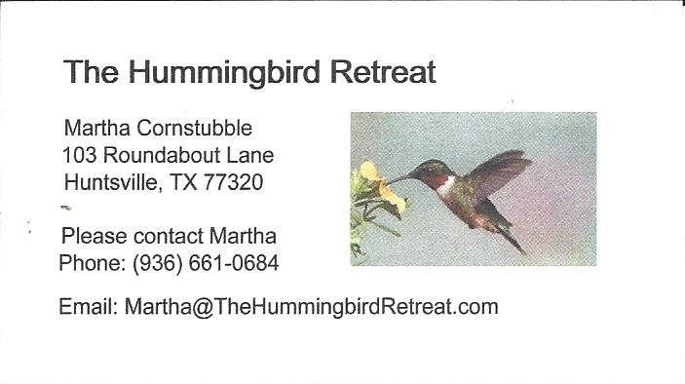
_{Newsletter ad prices are:}
$5.00 a month or $50.00 per year for a business card size advertisement.
$10.00 a month or $100.00 per year for a 3.5” x 4.5” size advertisement.
$18.00 a month or $180.00 per year for a one-half page advertisement.
$36.00 a month or $360.00 per year for a full page advertisement.
Member ads are free and will run for one month per request

_{Tall Pines Quilt Guild}
_{P.O. Box 7272}
_{Huntsville, Texas 77342-7272}

_{Tall Pines Quilt Guild Meeting} _{Guild Calendar Reminders}
You are invited to join us the first Monday of February 4, 2019 6:30 PM Guild Meeting
each month. The guild has a variety of _{January 22, 2019 Charity Bee}
programs, nationally known speakers, _{Meeting Reminders:}
_{workshop and charity projects.} _{Bring Show and Tell Items}
We meet at the University Heights Baptist Church _{Bring money for Food Bank}
_{2400 Sycamore Ave.} _{UPC Labels from Hobbs batting}
Park in the back lot off Palm Ave. _{FQ Bands from Fabric Carousel}
Refreshments are served at 6:30PM _{For Charity Bee}
and the meeting starts at 7 PM. Visit the web site @ www.tallpinesquiltguild.com
