FOR  SALE  QUILTS  ONLY | 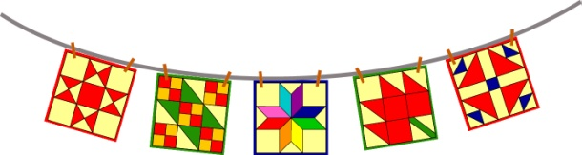  Airing of the Quilts  First Saturday in May  Historic Downtown Huntsville, Texas | For Guild Use Only  Entry Number ____________  Entry Fee _______________  Payment ________________

Name of Exhibitor:
Address:
City, State and Zip:
Cell Phone Number: |  |  | Home Phone number:
Title of Quilt:
Sale Price: |  | Dimensions: Height: Width:

Maximum of 5 quilts per seller. Entry Fee of $5.00 per quilt for displaying in Quilts-For-Sale area. Completed forms with quilts and fees are to be turned in Saturday morning of the Airing, before 9:00 a.m.

Sale Price is subject to 85% (Seller) /15% (Tall Pines Quilt Guild) split.

RELEASE OF LIABILITY
Neither the City of Huntsville nor the Tall Pines Quilt Guild or its members are responsible for loss due to theft, fire, vandalism or acts of God to any quilt, display item, or any associated material left with the Airing of the Quilts Committee. I acknowledge that I have read the above statement and agree to abide by the City of Huntsville and the Tall Pines Quilt Guild show rules.

Signature __________________________________________________ Date __________________
____________________________________________________________________________________

Name of Quilt:_______________________________________________ Dimensions: Height:_________ Width________

Seller:______________________________________________________ Cell Phone Number:______________________

Sale Price:__________________________________________________

DISPLAY NUMBER:

