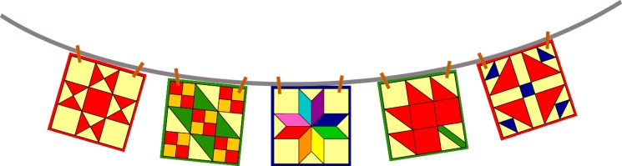

For Guild Use Only

Entry Number:

_____________________
W________ L_________

Size:_______________

Airing of the Quilts
May 6, 2017
Historic Downtown Huntsville Texas

Miniature Quilts Silent Auction
Donation Form

GUIDELINES - The miniature quilt must be no larger than 24” x24” and must have a hanging sleeve and label on the back. Miniature quilts are donated to Tall Pines Quilt Guild with all proceeds from the Silent Auction benefiting the guild.
Miniature quilts can be turned in at the February, March and April guild meetings or at Fabric Carousel. Entry deadline is the last Saturday in April.
Entered by:
Phone:
Pattern Name or Name of Quilt:
Width: _________ Length:_________ Sleeve: Y N Label: Y N

Your name will be entered into a drawing for a $25.00 gift certificate from Fabric Carousel for each miniature quilt donated.
Judy Springer, Silent Auction Chairman, 936-661-8126

