July 2018 Whisperings from the
Tall Pines Quilt Guild
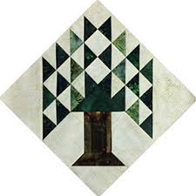

Upcoming Programs and Meetings
July 13 -14 Thimble Trail Shop Hop at the Fairgrounds
July 17th – Charity Bee
August 6th – Peggy Richards Trunk Show

August Birthdays
Tasha Fry 8/8
Joyce Parish 8/9
Judy Springer 8/9
Anne Stiles 8/15
Helen Belcher 8/18
Diane Roma’n 8/20
Janis Childers 8/25
D-Ann Gilmore 8/31
Pat Tracy 8/31

Publisher: Diane Carrington Volume Number 110 Issue Number 109
From the President
What a wonderful program by Winnie Fleming on Monday night. Her quilts are beautiful and after taking her class on Tuesday, I know how much hard work goes into making all those stars! It was a lot of fun, but I can't see me making more than the four blocks required to make the table runner. I like big pieces that go together quickly! We also had a lot of great food! Winnie shared her ideas about exchange blocks and how her guild does the UFO Challenge. We are going to try the UFO Challenge next year.

Be sure to attend the East Texas Thimble Trail at the Walker County Fairgrounds on July 13th and 14th. Our guild will have a booth there to sell tickets for our 2019 Donation Quilt. Call Patricia McCartney at Heavenly Threads Quilt Shop to volunteer to help her out during the show. It should be a fun show!

See you in August 6th to view Peggy Richards trunk show.

Martha Wilson

Sunshine and Shadows
We send our love and prayers to Nancy Nelson who lost her mother. We also send prayers to Helen Cook’s son that is recovering from a serious illness.

Treasurers Report
No report this month.

Tall Pines Quilt Guild Minutes of Meeting
Tall Pines Quilt Guild
Meeting Minutes
July 2, 2018
University Heights Baptist Church

President, Martha Wilson, called the meeting to order, welcomed members and guests and recognized July birthdays.

The June minutes were printed in the newsletter. There being no corrections noted, a motion was made by Ashley Beuhring and seconded by Helen Belcher. Motion passed.

Toni Bruner had tickets for sale for the Donation Quilt benefiting the Veterans’ Museum.

Due to Kay Ohendalski’s illness, the treasurer’s report will be printed in the newsletter.

Doris Collins reported that tickets and pictures of the raffle quilt were available.

The East Texas Thimble Trail Shop Hop will be held on July 13 and 14 at the Walker County Fairgrounds. The guild will have a booth and items from storage will be sold as well as small items made by members. Trinity Cafe will provide food for the event. There are 37 vendors, of which 13 are new to the event. Along with the Shop Hop, attendees can pick up a passport for the East Texas Tourist Trail. Participants will have 2 weeks to visit the local businesses. Upon completion, there will be a drawing for a night in a hotel and $50 cash.

The price for a booth at Fair on the Square, in October, is $165. We would sell raffle quilt tickets and other items A decision has not yet been made as to whether or not we will have the booth.

Robin Rodriquez reminded members that the next Charity Bee will be on July 17 at Fabric Carousel.

Door prizes were awarded.

D-Ann Gilmore reported on the upcoming programs. There will be no September meeting. She also introduced this evening’s presenter, Winnie Fleming, whose presentation was entitled “Stars and Scrap Exchange”. Winnie’s collection of quilts was stunning. A table runner workshop will be held on Tuesday, July 3, at Fabric Carousel

Doris Collins held the Fun Fund drawing.

Show & Tell was hosted by Kelli Anne Langley.

Robin Rodriquez reported that several newborn hats were donated tonight. These will be given to the Care Center at a later date.

The July Executive Board meeting will be held on July 9, 2018 at 5:30 pm at Fabric Carousel.

There being no further business, the meeting was adjourned.

Sew Many Projects,
Elaine Robinson, Secretary

Programs Updates
TALL PINES QUILT GUILD 2018-2019 PROGRAMS
D-Ann Gilmore, Program Chairman
August 6 – Peggy Richards is an award-winning quilter whose trunk show will take your breath away. We will also have a show and tell of the summer project made by our young quilters from Alpha Omega.

August 27 – Patti Nethery will give us a demonstration of her rulers entitled Piecing the Ruler Revolution Way along with a trunk show of her beautiful quilts.

October 1 – Rhonda Dort will present a program on Designing Unique Quilts Using Vintage Linens followed by a hands-on workshop the following day.

November 5 – UFO Challenge

December 5 – Christmas party

January 7 – Jackie Hillman will give a Powerpoint presentation and trunk show entitled the “Goose is Loose on the Ranch” followed by a workshop the next day using flying geese to make a table runner.

April 1 – Dena Rosenberg will give us a trunk show followed by a workshop the next day making the pattern Seven Sisters.
Members.
There were 50 members and 7 visitors who attended the July meeting. There are currently 114 members in the guild.
Door Prizes:
Book “Sunbonnet Sue” – Tasha Fry
Charm Pack – Elaine Robinson
Magnetic Pin holder and Notepad – Vickie Lambright

Fun Exchange:
Books of Puzzles – Dorothy Wolverton
Curve ruler/pattern/fabric – Loretta Doyle
Box of Goodies – Lynda Muzyka

Show and Tell
- Liz Williams – From the Heart blocks and Embroidery
- Martha Wilson – Blue and white baby quilt
- Janis Voldbakken – Fat Quarter Challenge
- Martha Fielder – Fat Quarter Challenge
- Dorothy Wolverton – Kaffee Churndash and Thirties Trip Around the World
- Judy Springer – Baby Quilt and pad, table topper, bluebonnet quilt
- Becki Marsh (Shown by Jane) – Red, White and blue quilt
- Annemarie Hoffzimmer – Bonnet and Italian Host family gifts
- Anne Barker – Christmas and Patriotic quilts
- Barbara Edmondson – 2 bags
- D-Ann Gilmore – Mimi quilt, Bridesmaid quilt, and modified jelly roll quilt
- Ashley Buehring – Jelly Roll Race (2)
- Patricia McCartney – All is Calm Quilt, Chenille quilt and bag
- Kimberly – cross stitch
- Vickie – 1st year quilt

Bee News
Charity Bee
$40 was collected for the Good Shepherd Food Bank at the July guild meeting, bringing the YTD total to $326.00.

The next Charity Bee meeting will be Tuesday, July 17, beginning at 9:30 at Fabric Carousel.

Thank you to all who continue to work on the HUGs, walker caddies, crocheted baby caps, and donations of Hobbs Batting UPC labels and Fabric Carousel fat quarter wrappers.

Cut-ups
Cut Ups will meet on the 2nd and 4th Friday each month at the Fabric Carousel. All are Welcome. Bring your quilting problems for lots of advice and help from your friends. Bee starts around 10 and lasts all day.
Embroidery Bee
We meet on the third Saturday of the month at 11 AM, at the Ohendalski building, next door to the Chicken place across from the mall. 1425 Brazos Dr. Contact Susan Craig for info. 436-1489

Donation Quilt

The quilt is finished!!! Raffle tickets are available at Fabric Carousel. Pick yours up there and sell, sell, sell!

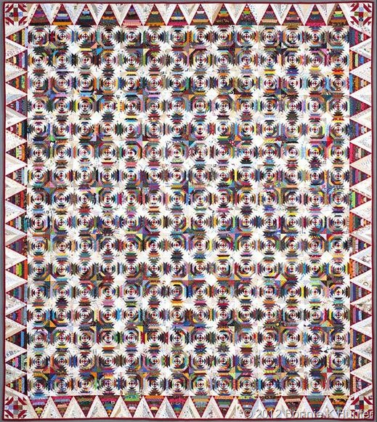

Diane’s Tips and Grins

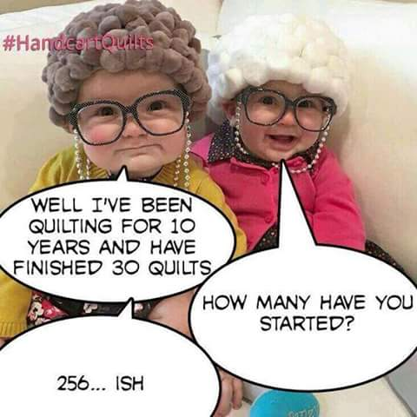
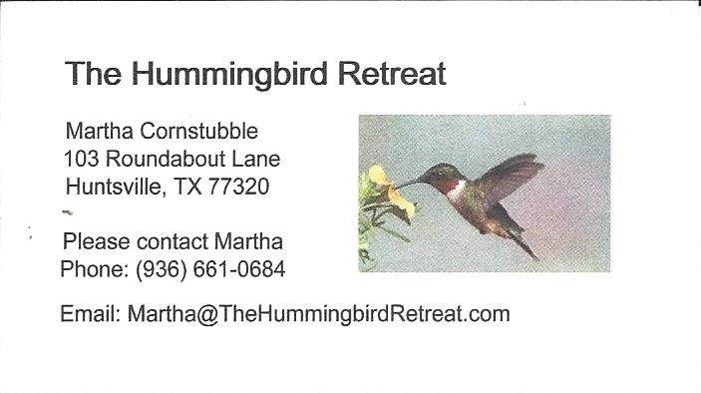
_{Newsletter ad prices are:}
$5.00 a month or $50.00 per year for a business card size advertisement.
$10.00 a month or $100.00 per year for a 3.5” x 4.5” size advertisement.
$18.00 a month or $180.00 per year for a one-half page advertisement.
$36.00 a month or $360.00 per year for a full page advertisement.
Member ads are free and will run for one month per request

Reminder, the Airing of the Quilts is May 4 2019. It will be here before we know it. We needs lots of volunteers to head committees, workers, and community support. There will be sign-up sheets for workers but if you have interest in being in charge of a committee please see Martha Wilson.

_{Tall Pines Quilt Guild}
_{P.O. Box 7272}
_{Huntsville, Texas 77342-7272}

_{Tall Pines Quilt Guild Meeting} _{Guild Calendar Reminders}
You are invited to join us the first Monday of August 6 , 2018, 6:30 PM Guild Meeting
each month. The guild has a variety of _{July 17, 2018 Charity Bee}
programs, nationally known speakers, _{Meeting Reminders:}
_{workshop and charity projects.} _{Bring Show and Tell Items}
We meet at the University Heights Baptist Church _{Bring money for Food Bank}
_{2400 Sycamore Ave.} _{UPC Labels from Hobbs batting}
Park in the back lot off Palm Ave. _{FQ Bands from Fabric Carousel}
Refreshments are served at 6:30PM _{For Charity Bee}
and the meeting starts at 7 PM. Visit the web site @ www.tallpinesquiltguild.com

