October 2017 Whisperings from the
Tall Pines Quilt Guild
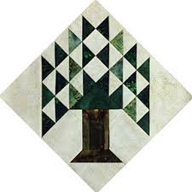

Upcoming Programs and Meetings
November 6th – UFO Challenge. Do you have your projects done???

November Birthdays
Donna Hoffman 11/9
Barbara Luning 11/11
Jean Garner 11/4
Karen Fisher 11/12
Barbara Barnes 11/14
Anne Barker 11/18
Barbara Yoes 11/20
Robin Rodriquez 11/24
Loretta Doyle 11/25
Julie Woods 1126
Dona Curren 11/27
Kay Kawkins 11/27

Publisher: Diane Carrington Volume Number 101 Issue Number 100
From the President
Greetings Guild Members,
Wow, so much going on this fall concerning our guild. I love it when we are in the community, doing charity work, and hopefully making a difference ( for the good) in someone's' lives. Don't you?
First of all, remember to get out and support our guild this weekend at fair on the Square. Martha will be in the booth with Virginia Cooper selling some of the items that we have had left over from other events. Stop by and say hello and maybe relieve one of them so they can take a break. We didn't have official sign up sheets because the booth will only hold a couple of people at a time and we didn't need a large amount of people. Hope to see you there.
Next, remember the Christmas stocking workshop on October 17 at Fabric Carousel. This will be during the charity bee day. The more people we have sewing, the faster this project will be finished. The stockings, and cuffs, and hangers, are already cut out. If you can, bring your sewing machine and some green thread, or any color thread really, and let's get these stockings finished. Remember, we will be stuffing these with items that will bless the meals on wheels program in Walker County at Christmas. Judy Oliver is heading up this committee and this project. We raised $135 at the meeting Monday night to assist with purchasing the items for the stockings. Any additional items that we need will be purchased by the guild. Thank you to all of you for your generosity. Remember to watch your email on Tuesday or Wednesday and we will let you know if we need to continue this project on Saturday, 21 October. If we have to go to Saturday, it will probably be just half-day. It will be held at fabric Carousel starting about 9:00.
I want to offer a great big thank you to our three charity bee members who attended the pregnancy care center banquet last Monday. We look forward to hearing their report. A preliminary report said that the staff of the care center highly praised our guild and thanked us for all the quilts that we make for the center.
Hope all of you are continuing to work on your UFO projects. Also don't give up on the baby block challenge. We need more entries and Helen has extended the deadline by few weeks.
Happy fall to everyone.
Kay Ohendalski, President

Sunshine and Shadows
Our prayers go out to Debbie Birdwell, Her daughter passed away last Saturday. Also we hope Betty Gratz has a speedy recovery from her broken leg. Please keep both families in your thoughts and prayers. Thank you from Sunshine and Shadows.

Our contact info is Betty Grantz phone # 936-438-0465, email lobag1961@gmail.com or Ruth West 847-638-3899, email quilterrw@livecom. We are looking forward to hearing about your Sunshine and Shadows.
Tall Pines Quilt Guild Minutes of Meeting
Tall Pines Quilt Guild
Meeting Minutes
October 2, 2017
University Heights Baptist Church

President Kay Ohendalski called the meeting to order, welcomed members and guests and recognized September and October birthdays.

Ruth West made a motion to accept the minutes, Virginia Cooper seconded and the motion passed.

Kay gave the Charity Bee update in the absence of Robin Rodriquez, who is representing the guild at the Care Center banquet. The next bee will be on Tuesday, October 17. November will be the last Charity Bee meeting for 2017. All items made will be distributed in December.

Charity Bee will host a Christmas stocking making workshop on October 17th. All members are encouraged to come help sew the 175 stockings needed. Any unfinished stockings will be made on the following Saturday at 9 am at Fabric Carousel. Judy Oliver will decide how stockings will be stuffed, using purchased items. Monetary donations are needed to help cover costs. Stockings will be stuffed at the December guild meeting.

A representative from the Tri-County Guild was present tonight featuring their Red Hot Feathered Star Quilt which will be raffled off at their festival on March 2nd and 3rd. in Cypress.

Kay reported that a former guild member, Margaret Kessler, won best of show in Indiana for her art guild. A newspaper article was passed around.

The treasurer’s position still needs a volunteer. The announcement of 2018 officers will be at the November meeting and voting will take place in December.

The guild will share a double booth space with Virginia Cooper at this year’s Fair on the Square. Volunteers are needed mid-day to relieve workers and also help is needed at the end of the day to take down the booth tables etc. See Martha Wilson to sign up.

Tonight is the final night to sign up for and pay for a seat on the bus going to the International Quilt Festival. After tonight, it will be open to non-members.

Plans are underway for the 2018-19 raffle quilt. Diane, Janis and D-Ann are heading this up. Diane showed blocks from a Pineapple Quilt that she is currently making. She suggested that this pattern would be a good choice because more people could be involved in the sewing of this quilt. There will be a workshop on Monday, October 9th at Fabric Carousel for anyone who wants to see how this block is constructed and learn how to paper-piece. Quilt-shop quality fabric scraps are needed. Scraps must be very dark or very light. Blocks will be due in February of 2018. All members are encouraged to help in some way, either constructing blocks or by donating fabric.

October 26th is the deadline for the Baby Block Challenge. Blocks may be turned in to Fabric Carousel. Results will be presented at the December meeting.

Jane Richmond reported that the Crockett Quilt Show will be on November 18th. This is a fun day with lots of additional activities.

D-Ann reported on upcoming programs. UFO challenge results will be revealed at the November meeting. Prizes will be given in various categories. Tonight’s program was presented by Karen DuPont and Kim Phillips, Houston firefighters, who showed several t-shirt quilts and gave tips on making them. A workshop will be held on Tuesday.

Door prizes and Fun Exchange prizes were awarded.

Show and Tell was held. Ten Collage quilts were shown by members. They did an amazing job. Forty-one projects were also shown by members, everyone has been very busy! Good job!

The next board meeting will be Monday, October 9th, at 5:30 pm at Fabric Carousel.

There being no further business, the meeting was adjourned.

“Sew” that’s it for this month,
Elaine Robinson, Secretary.

PQG Baby Block Challenge 2017

The Baby Block Challenge will use fabric from the Elmo and Friends collection from Sesame Workshop for Quilting Treasures. The focus fabric is bright and suitable for either boys or girls with lots of color choices. You will get a 10’ square of the focus fabric from Fabric Carousel free of charge. Doris Collins has donated all fabric for the challenge. Use additional fabrics from your stash or check out the fat quarters at the Carousel to complete your block. For those wishing to make more than one block, the fabric used in the challenge is available for purchase at Fabric Carousel. Be sure to follow all instructions for making your block.

Rules:
• Block size 12” finished – 12½” unfinished.
• Must include focus fabric.
• Use coordinating fabric of your choice (100% cotton). You may want to prewash fabrics if using bright colors.
• Can use any pattern on the block but should be appropriate for a baby quilt – no buttons, etc.
• Applique, both machine and hand, will be allowed but designs should be soft, no stiff threads.
• All finished blocks should be returned byOctober 26, 2017 to Fabric Carousel.
• Most of all have fun with designing and constructing your challenge block.
Questions - call Helen Belcher at 936-438-1470 or email at hxb004@shsu.edu
Treasurer’s Report
 | Tall Pines Quilt Guild
 | Treasurer's Report |  |  |  | August 31, 2017
 | Beginning Balance |  |  |  |  | $ 31,609.57
 | Categories |  | Income |  | Expense
 | Membership |  | $ 40.50 |  | $ -
 | Charity |  | $ 60.00 |  | $ 100.00
 | Fun Exchange |  | $ 85.00 |  | $ -
 | Hospitality |  | $ - |  | $ -
 | Newsletter |  | $ - |  | $ 16.80
 | Programs/Workshops |  | $ 1,310.18 |  | $ 1,521.20
 | Donation |  | $ 15.00 |  | $ -
 | Festival Bus Trip |  | $ - |  | $ 944.15
 | Auction Quilt |  | $ -
 | Bank Correction |  | $ 0.80 |  | $ -
 | Totals for Month |  | $ 1,511.48 |  | $ 2,582.15
 | Ending Balance |  |  |  |  | $ 30,538.90

Programs Updates
TALL PINES QUILT GUILD 2017/2018 PROGRAMS
D-Ann Gilmore, Program Chairman
November 6 – UFO challenge. Bring all finished projects that you listed on your challenge sheet.

December 6 – Baby block challenge, Christmas party and making stocks for Meals on Wheels.

January 8 – Baby shower for the Pregnancy Crisis Center

February 5 – Brenda Jeschke’s – Machine Embroidery Marries Quilts with a presentation of over 30 machine embroidered quilts. The workshop teaching you how to incorporate the machine embroidery into a quilt.

April 2 – Shannon Brinkley – Scrappy Applique followed by a workshop the next day to learn the techniques and process.

May 7 – Brenda Asmus, certified teacher for Marti Michell will give a lecture on “Tips from My Template Workbox” followed by a workshop on quick log cabin blocks using only 4 fat quarters.

June 4-5 – Cindy Needham, a nationally known speaker will give a fabulous program entitled “For the Love of Linens”. Take this opportunity to take her 2-day workshop on Heirloom Feathers and Backgrounds. The workshop is Monday (the day of the guild meeting) and Tuesday.
Membership Update
There were 60 members and 9 visitors at the meeting.
Door Prizes
- Book “Noodle Soup” – Jane Richmond
- Book “ Hand-stitched Home” – Barbara Edmondson
- Book “ Ultimate Quilters Visual Guide” – Virginia Cooper
Fun Exchange
- Old Cambridge layer cake and fat quarters – Judy Springer
- Halloween and Fall kits – April Miller
- Christmas Bundle – Anna Marie
Show and Tell
- Collage Quilts – D-Ann Gilmore, Lynda Muzyka, Jean Bradley, Janis Voldbakken, Anne Barker, Judy Springer, Virginia Wilson, Diane Carrington
- Liz Williams – Witch’s Boot and Dance by the Light of the Moon
- Grace Burzynski – quilt
- Diane Carrington – small Baltimore Album
- Tasha Fry – Spain Mini quilt and 60’s pillow
- Ruth West – Mini and Hug
- D-Ann Gilmore – Crown Royal quilts and T shirt Quilt
- April Miller – quilts
- Judy Springer – HST Table Runner
- Martha Wilson – Table Runner and Vintage quilt
- Virginia Cooper – Table runners
- Helen Belcher – Rooster Table quilt, Pepper Table quilt, Halloween wall hanging, Minnie mouse quilt
- Barbara Edmondson – Civil War quilt , Fall wall hanging
- Grettle Payne – Claire’s Perfect Heart
- Diane Harris – Small flower quilt
- Anne Barker – Dwellings
- Virginia Wilson – Quilts for Twins Senior Gift and one Redwork
- Mona Smidt – Blooming 9-Patch
Bee News
Charity Bee
For the local Food Bank, $20 was collected at the October guild meeting. There are LOTs of pinned HUGs in the laundry basket at Fabric Carousel (FC) needing to be quilted. There are HUG kits prepared in a small container just inside the closet at FC. These tops do not have to be all the way completed, but you're welcome to do so. The next Charity Bee meeting will be on Tuesday, October 17, beginning at 9:30 am at FC. At this meeting, the focus will be on constructing Christmas Stockings that will be stuffed with goodies at the December guild meeting. If necessary, there is a work day planned for Saturday, October 21, to complete the stockings. These stuffed stockings will be gifts to recipients of Meals on Wheels. We will need about 160 stockings, so we need as many participants as possible. They are very simple to make. The kits to make these stockings are prepared and only require sewing with your machine. After the Charity Bee meeting, an update will go out regarding the work day on October 21. For the Christmas stockings for Meals on Wheels, any donations would be greatly appreciated in order to purchase the "stuffings". November (next month!) will be the last Charity Bee meeting for 2017. If you have HUGs completed, please bring them to the November guild meeting or drop them off at FC. At the November meeting, all HUGs, and other items, will be sorted for delivery to our local recipients in early December. Thank you to all who do their part to further the Guild's mission and PURPOSE.
Cut-ups
Cut Ups will meet on the 2nd and 4th Friday each month at the Fabric Carousel. All are Welcome. Bring your quilting problems for lots of advice and help from your friends. Bee starts around 10 and lasts all day.
Embroidery Bee
We meet on the third Saturday of the month at 11 AM, at the Ohendalski building, next door to the Chicken place across from the mall. 1425 Brazos Dr. Contact Susan Craig for info. 436-1489
Donation Quilt
Reminder – Monday October 9th we will be having a workshop for paper piecing our Pineapple Crazy quilt. Bring lots of dark and light scraps, fat quarters or yardage. Bring your sewing machine, Supplies and a small iron if you have one. We will have the papers to sew on. We want to use papers from one printer so please don’t print your own. We need all the blocks completed by February 28th and hope that the quilt will be completed by the end of March 2018. We need everyone to get involved!!!

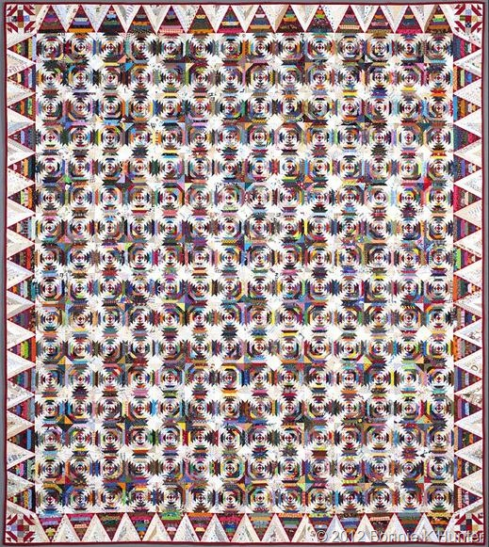

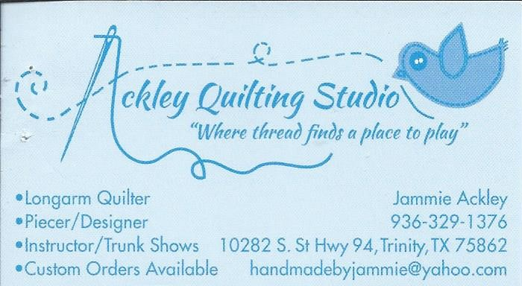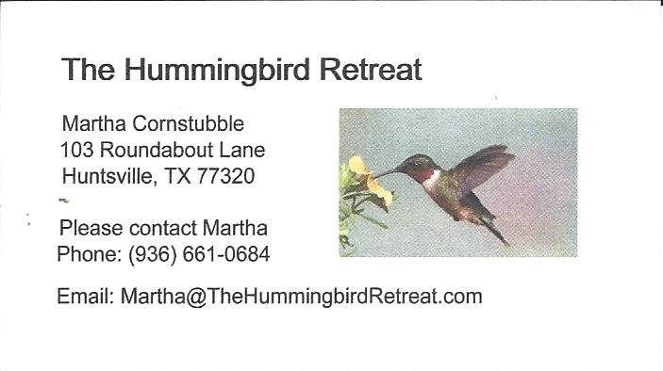
_{Newsletter ad prices are:}
$5.00 a month or $50.00 per year for a business card size advertisement.
$10.00 a month or $100.00 per year for a 3.5” x 4.5” size advertisement.
$18.00 a month or $180.00 per year for a one-half page advertisement.
$36.00 a month or $360.00 per year for a full page advertisement.
Member ads are free and will run for one month per request
_{Tall Pines Quilt Guild}
_{P.O. Box 7272}
_{Huntsville, Texas 77342-7272}

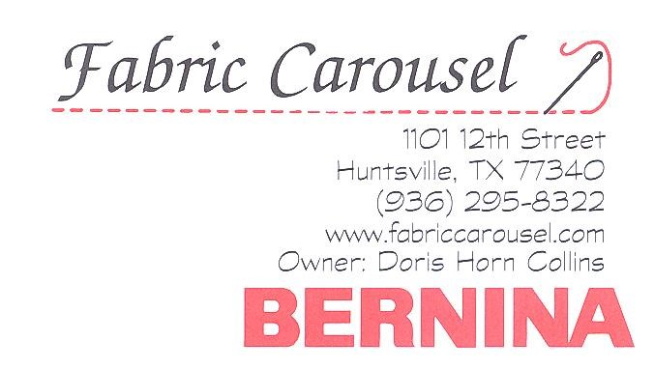
_{Tall Pines Quilt Guild Meeting} _{Guild Calendar Reminders}
You are invited to join us the first Monday of November 6, 2017, 6:30 PM Guild Meeting
each month. The guild has a variety of _{October 17, 2017 Charity Bee}
programs, nationally known speakers, _{Meeting Reminders}
_{workshop and charity projects.} _{Bring Show and Tell Items}
We meet at the University Heights Baptist Church _{Bring money for Food Bank}
_{2400 Sycamore Ave.} _{UPC Labels from Hobbs batting}
Park in the back lot off Palm Ave. _{FQ Bands from Fabric Carousel}
Refreshments are served at 6:30PM _{For Charity Bee}
and the meeting starts at 7 PM. Visit the web site @ www.tallpinesquiltguild.com

