November 2017 Whisperings from the
Tall Pines Quilt Guild
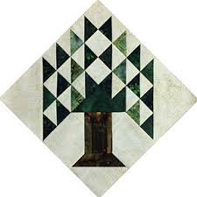

Upcoming Programs and Meetings
December 4th
Guild Holiday Party

December Birthdays
Glenda Swor 12/14
Lynda Muzyka 12/23

Publisher: Diane Carrington Volume Number 102 Issue Number 101
From the President
Greetings fellow guild members,
I hope you are all enjoying this cool weather. It is certainly something we been waiting for! Pull out the long lost sweaters!
Congratulations to all of you who participated in the UFO challenge this past year. The results and turn out at the meeting Monday night were fabulous! Some of you really put a lot of work into getting your quilts finished. If you would like to do the UFO challenge again next year, let our program chairman know. Thank you especially to D-Ann Gilmore for organizing the challenge and Fabric Carousel for sponsoring the prizes for the challenge. Good work!!!
Also remember that you have another week or so to get your baby block challenge turned in to Fabric Carousel. The contest will take place during our January meeting. This is the same night as the Care Center baby shower. Now is a good time to start gathering items for the baby shower. You might find things on sale or bargains as you are shopping for Christmas gifts.
I would like to offer additional thank you's to all of you who have agreed to be an officer of our guild or serve as a committee chairman for our guild. Some of you have held your position many terms, and I just want you to know that you are very much appreciated. I look forward to Martha Wilson taking over as president of our guild for the next few years. She is very capable, willing to go the extra mile, and loves our guild members very much. We can rest assured that our guild leadership is in good hands.
Hope you all have a wonderful Thanksgiving with your families.
Kay Ohendalski, President

Sunshine and Shadows

Our contact info is Betty Grantz phone # 936-438-0465, email lobag1961@gmail.com or Ruth West 847-638-3899, email quilterrw@livecom. We are looking forward to hearing about your Sunshine and Shadows.

Tall Pines Quilt Guild Minutes of Meeting
Tall Pines Quilt Guild
Meeting Minutes
November 6, 2017
University Heights Baptist Church

President Kay Ohendalski called the meeting to order, welcomed members and guests and recognized November birthdays.

Minutes from October meeting were printed in the newsletter. There being no corrections or additions, Janis Voldbakken made a motion to accept, motion was seconded by Barbara Flebbe, motion passed.

Rory Ross asked that anyone interested in painting on the pole decorating project should plan to meet at the Legacy Building on Saturday, November 11, at 11 am. This decoration will be placed on the pole by Fabric Carousel for the Christmas holidays as part of a city program.

Judy Oliver showed a sample of the Christmas stockings that will be filled and an ornament that will be decorated at the December guild meeting. These will be distributed to the Meals on Wheels recipients. Please bring a felt-tip marker, scissors and embellishments to the meeting.

Kelli Langley asked for donations of 6” x 6”, 9” x 9” or 12” x 12” blocks to be made into quilts and given to people in California that have lost everything due to the fires. Kelli will collect the blocks and mail them to a friend in California for assembling.

A big thanks to Lynda Muzyka for all the work involved in organizing the bus trip to the International Quilt Festival in Houston.

Robin Rodriquez announced that the next Charity Bee will be on Tuesday, November 21 at Fabric Carousel. They will be sorting the remaining hugs, getting them ready for donation. The Christmas stocking workshop was a big success. The sewers made up all the stockings needed for the Meals on Wheels project. There will be no Charity Bee in December.

The deadline for the baby block challenge is November 17th. Blocks will be revealed at the January guild meeting.

The list of Officer Nominees was read by Kay Ohendalski. Motion was made to accept the nominations by Virginia Cooper and seconded by Janis Voldbakken. Voting will be at the December meeting.

D-Ann Gilmore gave a report on the upcoming programs. Tonight’s program was the results of the UFO challenge. Twenty-six members signed up for the challenge. Thirteen people turned in projects this evening. Of those thirteen, five completed all five of the projects on their list. Members showed their finished projects and gave a brief history of how long that project had been a UFO. Gift certificates from Fabric Carousel were awarded in several categories.

The drawing for the door prizes was held.

Jane Richmond invited everyone to the Crockett Quilt Guild Christmas event to be held on November 18th at the First United Methodist Church. One hundred quilts will be displayed.

Fun Exchange was held by Doris Collins.

Ruth West gave a report on Betty Gratz who will be continuing her recuperation at Betty’s house. No other committee reports were given.

Five members had projects to share during Show & Tell.

There being no further business, the meeting was adjourned.

“Piece”fully submitted,
Elaine Robinson, Secretary

Treasurer’s Report
 | Tall Pines Quilt Guild
 | Treasurer's Report |  |  |  | October 31, 2017
 | Beginning Balance |  |  |  |  | $ 31,251.65
 | Categories |  | Income |  | Expense
 | Membership |  | $ - |  | $ -
 | Charity |  |  |  | $ 100.00
 | Fun Exchange |  | $ 128.00 |  | $ -
 | Hospitality |  | $ - |  | $ 23.62
 | Newsletter |  | $ - |  | $ 49.00
 | Programs/Workshops |  | $ 300.00 |  | $ 425.00
 | Fair on the Square |  | $ 789.25 |  | $ 286.90
 | Festival Bus Trip |  | $ 765.00 |  | $ -
 | Auction Quilt |  | $ -
 | Accountant Fee Income Tax |  |  |  | $ -
 | Totals for Month |  | $ 1,982.25 |  | $ 884.52
 | Ending Balance |  |  |  |  | $ 32,349.38

Programs Updates
TALL PINES QUILT GUILD 2017/2018 PROGRAMS
D-Ann Gilmore, Program Chairman
December 6 – Christmas party, including making Christmas ornaments and filling stockings for Meals on Wheels.

January 8 – Baby block challenge and shower for the Pregnancy Crisis Center, hand out sheets for UFO Challenge

February 5 – Brenda Jeschke’s – Machine Embroidery Marries Quilts with a presentation of over 30 machine embroidered quilts. The workshop teaching you how to incorporate the machine embroidery into a quilt.

April 2 – Shannon Brinkley – Scrappy Applique followed by a workshop the next day to learn the techniques and process.

May 7 – Brenda Asmus, certified teacher for Marti Michell will give a lecture on “Tips from My Template Workbox” followed by a workshop on quick log cabin blocks using only 4 fat quarters.

June 4-5 – Cindy Needham, a nationally known speaker will give a fabulous program entitled “For the Love of Linens”. Take this opportunity to take her 2-day workshop on Heirloom Feathers and Backgrounds. The workshop is Monday (the day of the guild meeting) and Tuesday.

November 5 – UFO Challenge

Membership Update
Door Prizes
- Christmas Patterns and Starch – Barbara Pearson
- Christmas Patterns and Starch – Diane Carrington
- Christmas Patterns and Starch – Dorothy Wolverton
Fun Exchange
- Layer Cake – Cathy Steinbach
- Jinny Beyer Tablerunner – Cathy Steinbach
- Batik Bundle – Kathryn Denmark
- Tablerunner Pattern and Fabric – Kathryn Denmark
Show and Tell
- Rory Ross – Hoffman Challenge Quilt
- Susan Craig – 3 Quilts
- Teresa Cozort – Crochet
- Martha Wilson – 1 Quilt
- Virginia Wilson – 2 Quilts
- Robin Rodriquez – Tee Shirt Workshop Quilt
- Deb Mundell – 3 Quilts and a wallhanging
- Carol Griffin – Crazy quilt
Bee News
Charity Bee
For the local Food Bank, $44 was collected at the November guild meeting. This brings the total so far to $386. (This time last year was $551.) One month remaining to collect. Let's dig deep for December and make up for the month we missed due to Hurricane Harvey! There are LOTs of pinned HUGs in the laundry basket at Fabric Carousel (FC) needing to be quilted. There are HUG kits prepared in a small container just inside the closet at FC. These tops do not have to be all the way completed, but you're welcome to do so. The next Charity Bee meeting will be on Tuesday, November 21, beginning at 9:30 amat FC. At this meeting, we will sort all the HUGs and other items we've made throughout this year to be delivered in early December to our local charitable organizations. If you have HUGs completed and want to include them in this year's count, please bring them to FC by November 21. Thank you to all who do their part to further the Guild's mission and PURPOSE. THERE WILL BE NO BEE MEETING IN DECEMBER.
Cut-ups
Cut Ups will meet on the 2nd and 4th Friday each month at the Fabric Carousel. All are Welcome. Bring your quilting problems for lots of advice and help from your friends. Bee starts around 10 and lasts all day.
Embroidery Bee
We meet on the third Saturday of the month at 11 AM, at the Ohendalski building, next door to the Chicken place across from the mall. 1425 Brazos Dr. Contact Susan Craig for info. 436-1489

Donation Quilt
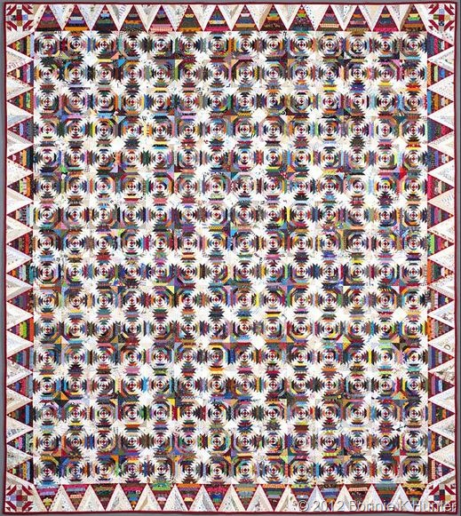
We are working hard on the donation quilt. We need 256 blocks for the center, 60 blocks for the border and 4 for the corners. That’s 320 blocks. We have 41 blocks completed and more coming in all the time. We need everyone’s help. I have the papers for the blocks at Cutups or at the Guild meetings. WE HAVE 279 BLOCKS TO GO!!!!!

Cake Recipe
Pig Pick’n Cake
1 Duncan Hines yellow cake mix
½ Cup oil
2 eggs
1 can Mandarin oranges (11 oz not drained)
Mix all ingredients thoroughly. Bake in 3 - 8” or 9” pans
(1 cut wax paper to fit the pans) Bake at 350 until done about 20 minutes
Cool completely
Frost heavily between layers with:
1 – 8oz Cool whip
1 small can crushed pineapple (not drained)
1 – 3 ¾ oz pkg vanilla instant pudding mix
Mix all thoroughly
Keep refrigerated

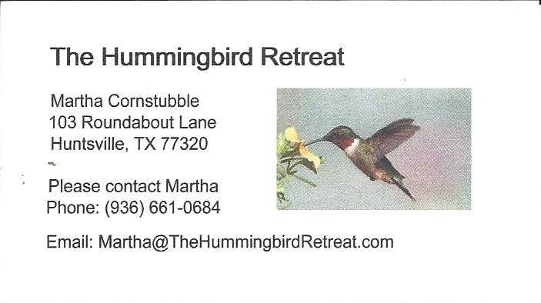
_{Newsletter ad prices are:}
$5.00 a month or $50.00 per year for a business card size advertisement.
$10.00 a month or $100.00 per year for a 3.5” x 4.5” size advertisement.
$18.00 a month or $180.00 per year for a one-half page advertisement.
$36.00 a month or $360.00 per year for a full page advertisement.
Member ads are free and will run for one month per request

_{Tall Pines Quilt Guild}
_{P.O. Box 7272}
_{Huntsville, Texas 77342-7272}

_{Tall Pines Quilt Guild Meeting} _{Guild Calendar Reminders}
You are invited to join us the first Monday of December 4, 2017, 6:30 PM Guild Meeting
each month. The guild has a variety of _{November 21 , 2017 Charity Bee}
programs, nationally known speakers, _{Meeting Reminders}
_{workshop and charity projects.} _{Bring Show and Tell Items}
We meet at the University Heights Baptist Church _{Bring money for Food Bank}
_{2400 Sycamore Ave.} _{UPC Labels from Hobbs batting}
Park in the back lot off Palm Ave. _{FQ Bands from Fabric Carousel}
Refreshments are served at 6:30PM _{For Charity Bee}
and the meeting starts at 7 PM. Visit the web site @ www.tallpinesquiltguild.com
