May 2019 Whisperings from the
Tall Pines Quilt Guild
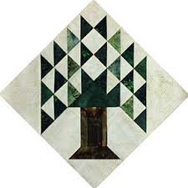

Upcoming Programs and Meetings
5/21 – Charity Bee
6/10 – June Guild Meeting at
Walker Ed. Building at the Sam Houston Museum

June Birthdays

Wendy Salsbery 6/5
Jane Richmond 6/9
Janis Voldbakken 6/10
Gloria Riley 6/13
Diane Carrington 6/16
Barbara Edmondson 6/17
Lynn Downing 6/17
Deb Mundell 6/18
Cathy Steinbach 6/21
Diane Harris 6/24

Publisher: Diane Carrington Volume Number 117 Issue Number 116
From the President
Happy Mother's Day!

I hope you all have a lovely Mother's Day and get all the presents you want. If you still have your mother, make sure to visit or call - time is short!

I enjoyed learning about Batting on Monday night. The speaker was very knowledgeable. I resisted buying any batting, because I never finish anything. The food was delicious too!

Important Announcement: The June meeting will take place on June 10, 2019 at the Katy & E. Don Walker, Sr. Education Center, in the W.S. Gibbs Conference Hall. Address is 1402 19th St
Huntsville, TX 77340. This is date change and venue change. University Heights will be holding Bible School on our regular meeting date. Hope to see you there!

I am requesting that you all think of something to make and donate to Tall Pines Quilt Guild for the Fair on the Square in October. We will be selling things out of the Fabric Carousel in the classroom area. I will try to put together patterns or ideas of things to make.

Happy May!
Martha Wilson

Sunshine and Shadows
Congratulations to Helen Cook’s son for being in remission from Cancer.

SCHOLARSHIP UPDATE
Deadline for submission of this year's scholarship application is Friday, May 17, 2019. This year we are offering two (2) $1,500 Scholarships in the categories of SEWING PROFICIENCY or INTENTION TO MAJOR IN MATH EDUCATION. Applications are available at the high school campuses in the counselor's office or on our website www.tallpinesquiltguild.com (tab - ABOUT US - Scholarships). The scholarships are available for all graduating students (Public, Private and Home school) that reside in our membership area.
If you are interested in serving on the selection committee or if you have any questions, please email me (judith-oliver@sbcglobal.net) or leave me a message on my home answering machine 936 439-0980. I will get back to you as quickly as possible. The selection committee will meet before the end of May and the winner(s) will be announced in June 2019.
Thank you for all of your support.

Treasurers Report
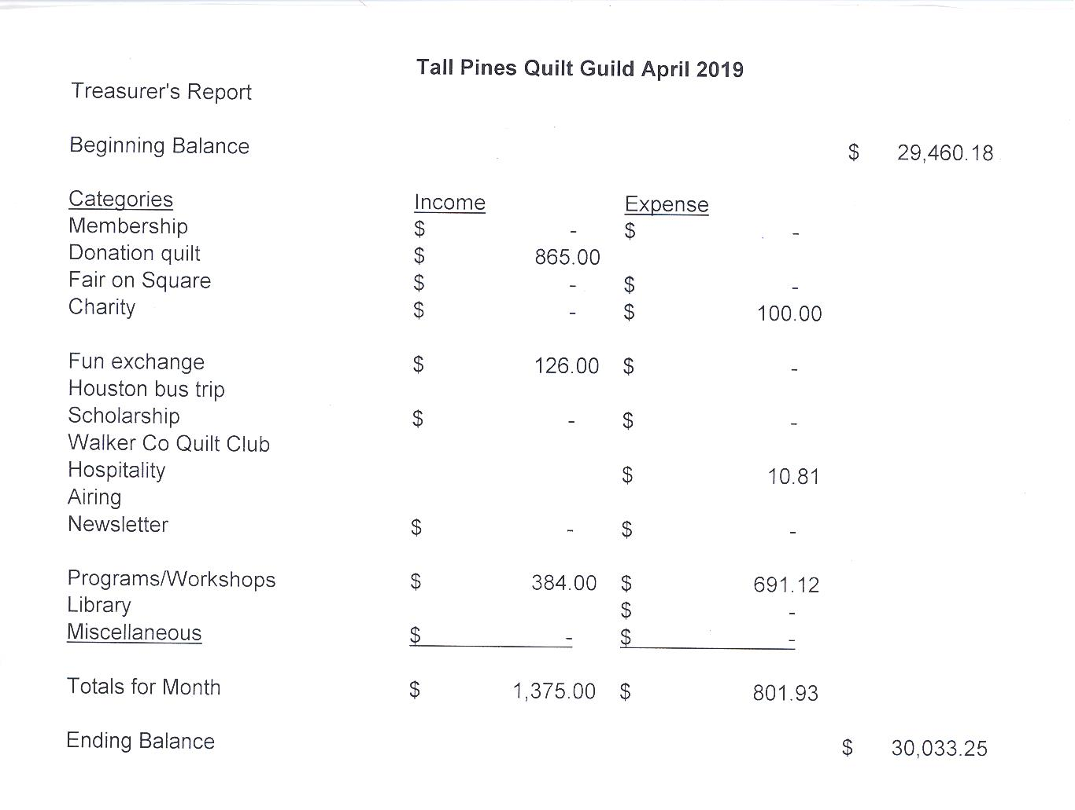
Tall Pines Quilt Guild Minutes of Meeting
Tall Pines Quilt Guild
Meeting Minutes
May 6, 2019
University Heights Baptist Church

President, Martha Wilson, called the meeting to order, welcomed members and guests and recognized May birthdays.

The April minutes were printed in the newsletter. Janis Voldbakken made a motion to accept the minutes as printed. Ashley Buehring seconded the motion. Motion passed.

Kay Ohendalski provided the treasurer’s report for members’ review.

Tonight, the Woodlands Quilt Guild was here selling tickets for their Donation Quilt.

Martha Wilson announced that the June 10th guild meeting will be held at the Sam Houston Museum. Due to the change, the menu for the meal will be sandwiches, chips and cookies only.

Judy Oliver is looking for a few more volunteers to serve on the scholarship committee.

The guild will again be participating in Fair on the Square on October 5th. There will be items for sale in the classroom at Fabric Carousel. Members are encouraged to make table runners and other small items for the sale.

The winning ticket was drawn at noon on Saturday, May 4th for the Donation Quilt. The winner was called by Martha Wilson.

Door prizes were awarded and fun exchange tickets were drawn. Congratulations to the winners.

#6 was drawn for the UFO.

D-Ann Gilmore told about upcoming programs and introduced tonight’s presenter, who was Sherry Mark from Loft Supply. She gave an informative presentation of different batting choices and their specific characteristics.

Committee reports were given.

Ashley Buehring hosted Show and Tell.

The next Executive Board meeting for all officers and committee chairs will be May 13th, 2019, at 5:30 PM at Fabric Carousel. Anyone is welcome to attend.

There being no further business, the meeting was adjourned.

Quilters come with strings attached !
Elaine Robinson, Secretary

Programs Updates

TALL PINES QUILT GUILD 2019 PROGRAMS
D-Ann Gilmore, Program Chairman
June 3 – Debby Walters and her daughter Kim Buchmann will give us a mother daughter trunk show from the many quilts they have made over the years. There will not be a workshop the following day. REMINDER: Please bring No. 6 listed on your challenge sheet.

July 1 – No program scheduled

August 5 – No program scheduled

August 26 – Jan Mathews of JKMQuilting.com will present a lecture on the History and Development of Foundation Piecing. There will be a workshop the following day.

October 7 - Cynthia Regone’s presentation will be “Kick It Up a Notch (brights at their best)” followed by a workshop the next day with a happy cheerful pattern called Funky Town Stars.

Fun Exchange
- 2 Yds of assorted gray fabric – Elaine Eakin
- Beach house charms plus 2 yds. – Martha Fielder
- Book and 4 1yd cuts of orange – Rebecca Lewis

Door Prizes
- 4 Fat quarters – Virginia Cooper
- 2 Quilt Books – Janis Voldbakken
- Rotary cutting mat – Kathy Pittman

Show and Tell
 | 5/6/2019
D-Ann Gilmore | All in a Row Again
Oakkhurst Bee (Melanie, Kim, Donna, Jean Marti, D-Ann | Jelly Roll Race - Charity Quilt
D-Ann Gilmore and Jean Bradley | Dancing Chickens & Flying Pigs
Susan Craig | Embroidered Pillow Case - 3 Baby Quilts
Tasha Fry | Cat Purse
Jean Bradley | Tote and Peacock Panel Wallhanging
Judy Springer | Woodland Animals
Rhonda Lynch | 2 4-H Sample Quilts
Virginia Cooper | Faithfull Mini & Woodlands bag?
Diane Harris | 2 graduation quilts
Barbara Pearson | 2 Charity Quilts
Dee Ross
Pam Ray | Pieced & Quilted Hug
Robin Rodriquez | 2 Hugs 2 Receiving 1 Pillow
Helen Cook | R2 D2
Liz Williams | Angles in the Round Table Topper
Barbara Edmondson | 2 small items
Jeanette Allen | 2 Table Runners
Elaine Robinson | X's and O's
Dorothy Wolverton | 3 "7 Sisters" Table Runners

Bee News
Charity Bee
The next Charity Bee is on Tuesday, May 21, 2019, at Fabric Carousel, beginning at 9:30 am. For the Food Bank at the May guild meeting, we collected $36, bringing the YTD total to $179! At the May meeting, several ladies showed HUGs (quilts) that they had completed for Charity Bee. (Walker caddies are delivered to local nursing homes as they are available, and HUGs are delivered to Pregnancy Care after every Bee meeting, so these don't wait till the end of the year. When crocheted baby beanies available, they are also delivered to Pregnancy Care. There is a great need for these items throughout the year.) Great job!!! There are several HUGs that are pinned and ready for quilting/finishing. They are located in the white laundry basket under the clock in the Fabric Carousel workroom. If you need one prepared for a longarm, please let me know and we will fix you up! As a reminder, Charity Bee collects Fabric Carousel fat quarter wrappers and Hobbs batting UPC labels. Still hoping that every member of the guild will complete at least one HUG for the year (and EVERY year). This would really increase our donations to our charitable recipients!! We also donate baby bibs, adult bibs, baby burps, crocheted baby beanies, baby blankets, walker caddies, adult lap quilts (for the wheelchair bound), as well as HUGs of all sizes. A big "thank you" to all who participate!

Cut-ups
Cut Ups will meet on the 2nd and 4th Friday each month at the Fabric Carousel. All are Welcome. Bring your quilting problems for lots of advice and help from your friends. Bee starts around 10 and lasts all day.

Embroidery Bee
We meet on the third Saturday of the month at 11 AM, at the Ohendalski building, next door to the Chicken place across from the mall. 1425 Brazos Dr. Contact Susan Craig for info. 436-1489

ESTATE SALE
Fri. /Sat. June 7th & 8th
8:00 a.m. until 4:00 p.m.
Tasha Fry
331 Turner Street (across from Stewart Elementary)
Beautiful quilts, crosstitch kits, fabric, crafts, antiques, furniture, cat collection, jewelry, glassware, handsewn curtains, electronics, deco kitchen towels, pictures, holiday decorations, clothes, frames etc.

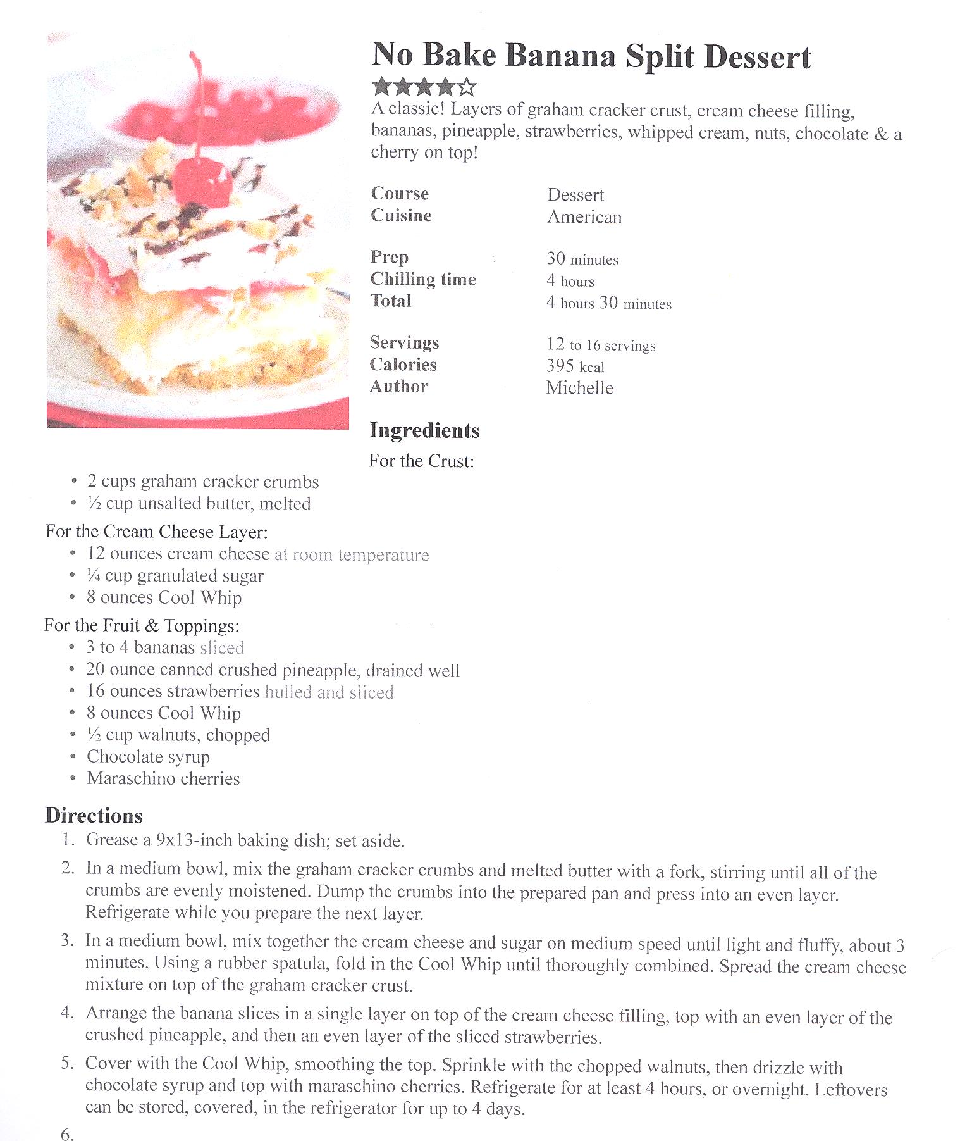

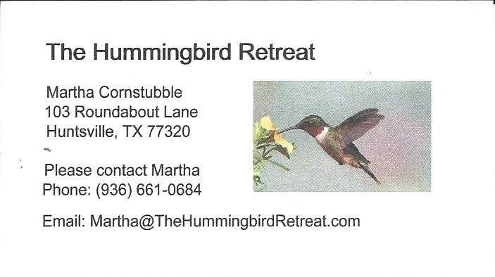
_{Newsletter ad prices are:}
$5.00 a month or $50.00 per year for a business card size advertisement.
$10.00 a month or $100.00 per year for a 3.5” x 4.5” size advertisement.
$18.00 a month or $180.00 per year for a one-half page advertisement.
$36.00 a month or $360.00 per year for a full page advertisement.
Member ads are free and will run for one month per request

_{Diane’s Grins and Tips}

_{Tall Pines Quilt Guild}
_{P.O. Box 7272}
_{Huntsville, Texas 77342-7272}

_{Tall Pines Quilt Guild Meeting} _{Guild Calendar Reminders}
You are invited to join us the first Monday of June 10, 2019 6:30 PM Guild Meeting
each month. The guild has a variety of _{May 21, 2019 Charity Bee}
programs, nationally known speakers, _{Meeting Reminders:}
_{workshop and charity projects.} _{Bring Show and Tell Items}
We meet at the University Heights Baptist Church _{Bring money for Food Bank}
_{2400 Sycamore Ave.} _{UPC Labels from Hobbs batting}
Park in the back lot off Palm Ave. _{FQ Bands from Fabric Carousel}
Refreshments are served at 6:30PM _{For Charity Bee}
and the meeting starts at 7 PM. Visit the web site @ www.tallpinesquiltguild.com
