May 2018 Whisperings from the
Tall Pines Quilt Guild
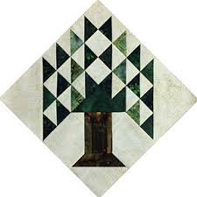

Upcoming Programs and Meetings
May 15th - Charity Bee
June 4th – Cindy Needham
“For the Love of Linens”

June Birthdays
Wendy Salsbery 6/5
Betty Bell 6/5
Jane Richmond 6/9
Janis Voldbakken 6/10
Diane Carrington 6/16
Debbie Mundell 6/18
Cathy Steinbach 6/21
Patsy Adams 6/23
Diane Harris 6/24

Publisher: Diane Carrington Volume Number 108 Issue Number 107
From the President
I am sorry I had to miss the meeting on Monday night, but I left it in good hands with Kay! Sounds like you all had a good meeting. We will have a signup sheet in June's meeting for those who want to help out at the East Texas Thimble Trail Shop. We will need coverage to sell tickets for our donation quilt. July 13th from 10:00 to 5:00, July 14th from 10:00 to 4:00. Set-up will be after 1:00 PM on Thursday. This will be the first showing of our beautiful pineapple quilt.

I am sure we are all looking forward to our June meeting and the chance to spend time with Cindy Needham.

Keep sewing!

Martha Wilson

Sunshine and Shadows
Our thoughts and prayers go out Betty Gratz, she is still having problems with her leg. Judy Oliver’s husband has been very ill, we hope that he has a speedy recovery. We want to keep Barb Flebbe’s grandson John in our prayers he is having a lot of health issues. Also we need to lift up Grettle Payne, we hope she has a safe trip back home from Hawaii. Thanks Ruth and Betty

Treasurer’s Report
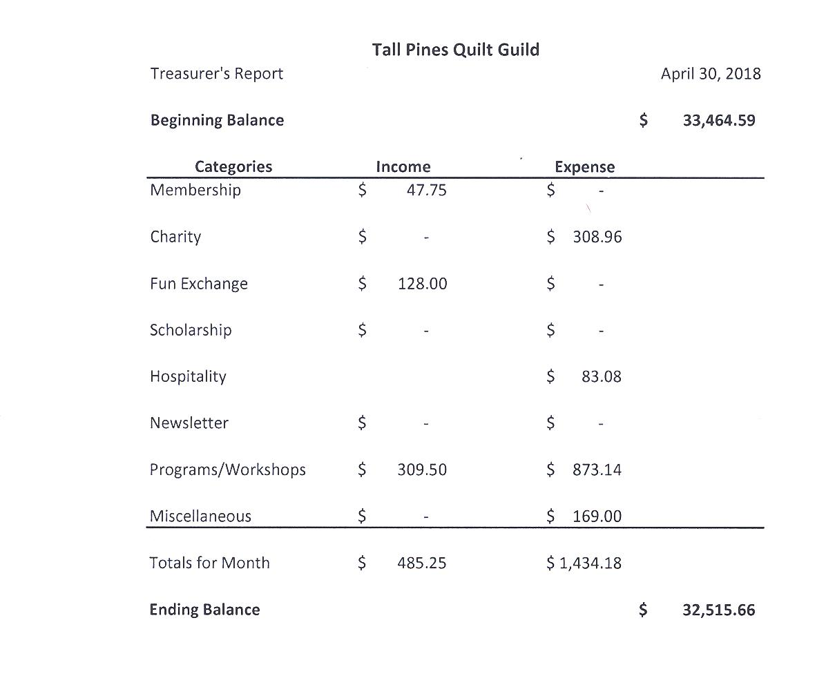
Tall Pines Quilt Guild Minutes of Meeting
Tall Pines Quilt Guild
Meeting Minutes
May 7, 2018
University Heights Baptist Church

Treasurer Kay Ohendalski called the meeting to order, welcomed members and guests and recognized May birthdays. President, Martha Wilson, was out of town on a business trip.

Special guests tonight were members of the Woodlands Area Quilt Guild who brought their beautiful appliqued quilt entitled Precious Peonies. Raffle tickets were available. The drawing will be held on December 5th. Their quilt show will be on June 22-23 at the Lone Star Convention Center in Conroe.

The April minutes were printed in the newsletter. There being no corrections noted, a motion was made by Helen Belcher and seconded by Pat Dittfurth. Motion passed.

Copies of the budget were available for review on the tables. D-Ann Gilmore made a motion to accept and Janis Voldbakken seconded. Motion passed.

Betty Nelson presented the guild with a certificate of appreciation for our participation in the muster. She said that there were lots of positive comments regarding the quilt display and the silent auction items. The guild members are invited to a Memorial Day Celebration on May 28th @ 7 pm at the Veterans Conference Center.

There will be a concert at Elkins Lake Baptist church on May 10th. All donations received will go to the Senior Center and Meals on Wheels.

Helen Belcher thanked everyone that helped with the quilt display at the Walker County Fair. If anyone has any suggestions for changes or additions to the rules, please bring those to Helen’s attention. Helen recognized Ann Moore’s achievements on receiving Best of Show and Judges’ Choice for her beautiful quilts. Congratulations to all ribbon winners.
Helen also asked that if anyone would like to make some doll-size quilts to sell at the Sam Houston Folk Festival, please turn them in to Helen or to Fabric Carousel prior to May 18th. Festival dates are 18-20 May. Members are invited to join Helen on the grounds of the festival to do handwork.

Diane Carrington showed the pineapple raffle quilt that was beautifully quilted by Lynda Muzyka. The debut showing of the quilt will be at the East Texas Thimble Trail Shop Hop on July 13th & 14th at the Walker County Fairgrounds. Raffle tickets will be available.

The guild will have a booth at the Shop Hop. Space will be limited so members are asked to make mini quilts or table runners to sell. Also, please volunteer to sell raffle tickets or help Patricia in other areas. The theme this year is “Falling In Love With Fabric”.
Patricia also told about a new event in conjunction with the Shop Hop. Huntsville Tourist Trail will begin at the Shop Hop where passports will be handed out. Participants will have two weeks to visit the local shops, ending on July 27th. More information will be forthcoming.

Jane Richmond informed the group that lots of books are available for check out from the library located at Fabric Carousel. Please remember to fill out the card and file it in the gray box on the shelf. Also, if you have had a book out for a long time, please return it so others can check it out.

Robin Rodriquez reported that there are lots of hugs that need quilting and binding. All work must be machine done for durability. There is also pre-quilted fabric from Handi Quilter that just needs decorating and binding. She also showed some crochet baby hats that were donated. The next Charity Bee will be on May 15th at Fabric Carousel beginning at 9:30 am.

Door prizes were awarded.

Ruth West reported the recent activities of the Sunshine & Shadows program.

D-Ann Gilmore gave a report on upcoming programs and informed the group that Brenda Ausmus was unable to present tonight due to a family medical emergency. In her absence, Jackie Hillman, of Two Creeks Quilts, presented a lecture and demonstration entitled, “Break Out of that Box of Crayons”. The presentation was very interesting. A workshop will be help on Tuesday, May 8th at Fabric Carousel by a Marti Mitchell representative as previously scheduled.

Fun Fund drawing was held, hosted by Doris Collins.

Show & Tell was held, hosted by Kelli Langley.

Patricia McCartney and Jammie Ackley presented everyone with a pincushion that they made in honor of Mother’s Day. Thanks to them for their thoughtfulness.

Executive Board meeting for May will be held on May 14, 2018 at 5:30 pm at Fabric Carousel.

There being no further business, the meeting was adjourned.

Quilt till you wilt,
Elaine Robinson, Secretary

Programs Updates
TALL PINES QUILT GUILD 2018-2019 PROGRAMS
D-Ann Gilmore, Program Chairman
June 4-5 – Cindy Needham, a nationally known speaker, will give a fabulous program entitled “For the Love of Linens”. Take this opportunity to take her 2-day workshop on Heirloom Feathers and Backgrounds.

July 2 – Winnie Fleming will present a program called Stars and Scrap Exchange. Her workshop the following day is a Lone Star Table Runner where we will learn how to make perfect stars without cutting off the points.

August 6 – Peggy Richards is an award-winning quilter whose trunk show will take your breath away. We will also have a show and tell of the summer project made by our young quilters from Alpha Omega.

August 27 – Patti Nethery will give us a demonstration of her rulers entitled Piecing the Ruler Revolution Way along with a trunk show of her beautiful quilts.

October 1 – Open to suggestions

November 5 – UFO Challenge

December 5 – Christmas party

January 7 – Jackie Hillman will give a Powerpoint presentation and trunk show entitled the “Goose is Loose on the Ranch” followed by a workshop the next day using flying geese to make a table runner.

April 1 – Dena Rosenberg will give us a trunk show followed by a workshop the next day making the pattern Seven Sisters.
Members
There were 68 people in attendance at the May meeting, including two new members and four visitors. We now have 113 members in the guild. Please join me in welcoming our newest members!
Barbara Corcoran
76 Gilley Rd
New Waverly, 77358
Cell: 616-844-0619
Email - barb-c@att.net
BD: 7/10
Becky Nicholas
14 Old Midway Rd
Midway, 75852
Cell: 936-662-3143
Email- nicholas.becky8898@yahoo.com
Spouse- Stephen

2018 SCHOLARSHIP:

SCHOLARSHIP DEADLINE is EXTENDED to MAY 22, 2018. Applications are available on eligible high school campus websites or in the counselors' office. Categories - PROFICIENCY in SEWING or INTENTION to MAJOR IN MATH EDUCATION. Spread the word!

This year the TPQG Board voted to award a $1,500 scholarship to a graduating senior (public, private or home school) residing within our membership area in the categories of “Proficiency in Sewing” OR “Intention to Major in Math Education”. Scholarship applications have been forwarded to all 19 high schools who service our membership area and should be available on the campus websites or in the counselors’ office. We are trying to reach the Home School seniors as well so if you know of someone who might qualify or have a contact person that can help us in disseminating the information, please let me know. Scholarship applications are available for download on our website www.tallpinesquiltguild.com tab ABOUT US/lower right corner – Scholarships. Deadline for submission is May 22, 2018. The winner will be announced at our June meeting. Also, a reminder, two large memorial donations have been made to our scholarship fund already this year by Doris Collins - for Judy Moorer’s husband and son, and for Melanie Burleson’s mother. If further contributions are made, we may be able to offer a second scholarship this year. If you would like information either about the scholarship application or memorial donations, please feel free to contact me. Judith Oliver, 2018 Scholarship Chairman – judith-oliver@sbcglobal.net or 936 439-0980.

Door Prizes
“Quick Watercolor Quilts” Book – Linda Cox
“Snowpennies” pattern and notepad – Diane Roman
Book kit – “Shh…Quiet” – Elaine Eakin
Fun Exchange
Layer cake and 2 ½ yard pieces – Wendy Salsberry
Charms and Coordinates – Diane Wingenbach
2 Books – Jammie Ackley
Box of Row x Row patterns – Diane Roman
Show and Tell
- Janis’s Fat Quarter Group – Janis, Martha, Helen, Jean - Fat Quarter Quilts
- Barbara Flebbe – One large and one baby quilt
- Ashley Buehring – Author items
- Donna Gardner – quilt
- Virginia Wilson – Funky chickens
- Ruth West – Scrappy Bear Family
- Patricia McCartney – Jelly Roll Rug and Pin Cushions for everyone (thanks!)
- Kay Ohendalski – Pies and Tarts and a baby quilt
- Janis Voldbakken – Farm Girl Vintage
- Grace Burzynski – Rodeo Avery
- Rennie Bower – Baby’s first birthday and 24 Countries
- Liz Williams – Starring Ewe
- Cathy Wilson – Scrappy bunny quilt
Bee News
Charity Bee
For the Food Bank, $61 was collected at May's guild meeting! This brings the YTD total to $251!! (If it keeps going like this, we could top $500!!!) The next Charity Bee meeting will be Tuesday, May 15, at Fabric Carousel (FC), beginning at 9:30 am. There are still several Handiquilter pieces needing decoration with appliques and binding, and several pinned HUGs in the basket at FC. We will have a lot more pinned HUGs ready after next week's Bee meeting. Thank you to all who continually work on the HUGs, donate FC fat quarter wrappers and Hobbs Batting UPC labels. Reminder that all HUGs must be completed by machine, including the binding. They need to be very durable. Hope to see a bunch of ladies at the Bee next week!!!
Cut-ups
Cut Ups will meet on the 2nd and 4th Friday each month at the Fabric Carousel. All are Welcome. Bring your quilting problems for lots of advice and help from your friends. Bee starts around 10 and lasts all day.
Embroidery Bee
We meet on the third Saturday of the month at 11 AM, at the Ohendalski building, next door to the Chicken place across from the mall. 1425 Brazos Dr. Contact Susan Craig for info. 436-1489

Wanted: Betty Yoes would like to purchase a used cutting table. If you have one, please contact Betty at 936 295-5388.

For Sale:
Tutto Machine on Wheels For Sale - Purple -Large #5222MA
22"L x 15"H x 12"D (exterior)
Brand-New, Never Used. $150 (Cheaper than Amazon!)
Maggie Smith (936) 668-0923

Donation Quilt
A huge thank you to Lynda Muzyka for doing such a beautiful job quilting our quilt. Now on to Janis for the binding…we are almost there!

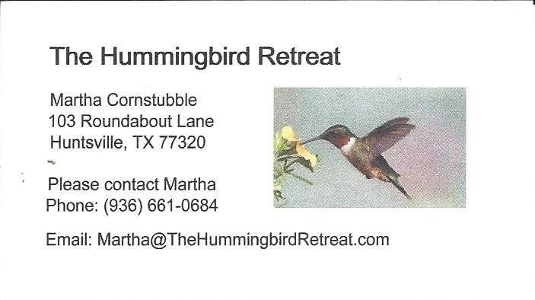
_{Newsletter ad prices are:}
$5.00 a month or $50.00 per year for a business card size advertisement.
$10.00 a month or $100.00 per year for a 3.5” x 4.5” size advertisement.
$18.00 a month or $180.00 per year for a one-half page advertisement.
$36.00 a month or $360.00 per year for a full page advertisement.
Member ads are free and will run for one month per request

_{Tall Pines Quilt Guild}
_{P.O. Box 7272}
_{Huntsville, Texas 77342-7272}

_{Tall Pines Quilt Guild Meeting} _{Guild Calendar Reminders}
You are invited to join us the first Monday of June 4, 2018, 6:30 PM Guild Meeting
each month. The guild has a variety of _{May 15, 2018 Charity Bee}
programs, nationally known speakers, _{Meeting Reminders:}
_{workshop and charity projects.} _{Bring Show and Tell Items}
We meet at the University Heights Baptist Church _{Bring money for Food Bank}
_{2400 Sycamore Ave.} _{UPC Labels from Hobbs batting}
Park in the back lot off Palm Ave. _{FQ Bands from Fabric Carousel}
Refreshments are served at 6:30PM _{For Charity Bee}
and the meeting starts at 7 PM. Visit the web site @ www.tallpinesquiltguild.com
