May 2017 Whisperings from the
Tall Pines Quilt Guild
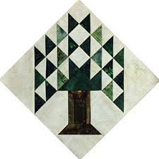

Upcoming Programs and Meetings
June 5th – Lisa Erlandson - Making Your Best Quilt
June 6th Lisa Erlandson Workshop – Kansas City Stars

June Birthdays
Betty Bell 6/5
Jane Richmond 6/9
Janis Voldbakken 6/10
Diane Carrington 6/16
Deb Mundell 6/18
Cathy Steinbach 6/21
Patsy Adams 6/23
Diane Harris 6/24

Publisher: Diane Carrington Volume Number 97 Issue Number 96
From the President

Greetings Hardworking Quilters!
Well, I believe it is safe to say that this year's edition of the Airing of the Quilts is behind us and it was an amazing success! My words cannot express how pleased I was with the event as a whole. I just want to hug and say thank you to each of you who participated and sacrificed your day to make this special day a "home run" event.
We had a great crowd, beautiful weather, great volunteers, and amazing financial generosity shown by our members and members of our community. We hope to have financial totals at the next meeting. If we get it out sooner, then we will send an email to you. As a teaser, I think we set a new record with our Silent Auction. I will let Judy share the results at the next meeting.
I am in the process of making an Airing Coordinator's Record book to record everything we did for this year's Airing. If you have comments, good or not so good, write
them down and get them to me or you can reach me by phone or email. I want to record any ideas that will result in the Airing being an even better event. Also, write an estimate of your expenses if you have any.
Looking forward to seeing you at the next meeting where we will have a great program and workshop the next day.
Blessings,
Kay Ohendalski, President

Sunshine and Shadows
Our contact info is Betty Grantz phone # 936-438-0465, email lobag1961@gmail.com or Ruth West 847-638-3899, email quilterrw@livecom. We are looking forward to hearing about your Sunshine and Shadows.
Tall Pines Quilt Guild Minutes of Meeting
Tall Pines Quilt Guild
Meeting of Minutes
May 1, 2017
University Heights Baptist Church

President Kay Ohendalski called the meeting to order and welcomed members and guests. May birthdays were recognized.
Minutes of the April meeting were printed in the newsletter. D-Ann Gilmore made the motion to accept the minutes and Pam Boyle seconded the motion. The motion passed.
The treasurer’s report will be in the newsletter.
Judy Oliver reported the scholarship deadline for applications will be extended to May 22. Anyone interested serving on the selection committee should let Judy know.
Robin Rodriquez gave an update on charity bee. Quilted fabric used for test quilting has been donated by HandiQuilter. There was enough to cut out more than 10 baby quilts. See Robin to pick one up to complete with embellishment and binding. Robin is checking with area nursing homes to find out their needs. Walker caddies and pillows stuffed with batting are needed at Creekside. The next charity bee will be Tuesday, May 16.
Pat Spear will be taking the donation quilt to the Lion’s Club meeting on Thursday.
Helen Belcher reminded everyone who took a yard sign to pick it up after the Airing and return it to Fabric Carousel.
Airing of the Quilts was the agenda for tonight’s meeting. Kay Ohandalski reviewed logistics and committee chairs gave their wrap up reports on their areas. We have 200 quilts to hang and it looks like the weather is going to cooperate. Those helping with set up will meet at 6:30 a.m. to get started.
D-Ann Gilmore gave a recap of our upcoming programs. In June, we will have Lisa Erlandson with How to Make a Better Quilt and a workshop for the Kansas City Star Quilt. The August 7 meeting program will be Redwork with Rosie deLeon-McCrady and the August 28 meeting will be the garage sale. October 3 will be the T-shirt quilt lecture with the T-shirt workshop October 4.
Helen Belcher invited anyone who wants to participate in the Folk Festival May 13 and 14, to come and sit under the tent for Mrs. Houston’s guests with a handwork project.
Door prize winners were Ann Stiles, Janis Childers, and April Miller. Fun exchange winners were Pam Boyle, Barbara Flebbe, and Judy Oliver.
Show and tell was held.
There being no further business the meeting was adjourned.
Respectfully Submitted, Secretary, Cheryl Rempel

Program Report
D-Ann Gilmore, Program Chairman
June 5 and 6 – Lisa Erlandson – Guild meeting lecture on “Making Your Best Quilt”, followed by a workshop the next day entitled Kansas City Stars. We still need more people to sign up.
July 10 – Guild meet but no speaker or workshop the next day
August 7 and 8 – Rosie de Leon McCrady - “Redwork Through the Years”, a history of redwork as well as a variety of vintage and new quilts. The workshop the next day costs $30 + a $25 kit fee. The kit includes needle, needle threader, 2 types of thread, 2 patterns, fat quarter of fabric, pigma pen, Frixon pen, and an embroidery hoop. All you need to bring is a pair of scissors (or she will have some available for purchase) and a thimble if you use one.
August 28 – Immediately following the guild meeting we will have a Garage Sale of sewing and/or craft related items. You may purchase a full table for $10 or half table for $5 – reserve your table soon. Go in with a friend to get rid of unneeded items so you’ll have room for more quilting supplies!
October 2 and 3 - Karen Dupont and Kim Phillips will present a T-shirt quilt lecture, followed by a workshop the next day on how to make a T-shirt quilt.
PQG Baby Block Challenge 2017

The Baby Block Challenge will use fabric from the Elmo and Friends collection from Sesame Workshop for Quilting Treasures. The focus fabric is bright and suitable for either boys or girls with lots of color choices. You will get a 10’ square of the focus fabric from Fabric Carousel free of charge. Doris Collins has donated all fabric for the challenge. Use additional fabrics from your stash or check out the fat quarters at the Carousel to complete your block. For those wishing to make more than one block, the fabric used in the challenge is available for purchase at Fabric Carousel. Be sure to follow all instructions for making your block.

Rules:
• Block size 12” finished – 12½” unfinished.
• Must include focus fabric.
• Use coordinating fabric of your choice (100% cotton). You may want to prewash fabrics if using bright colors.
• Can use any pattern on the block but should be appropriate for a baby quilt – no buttons, etc.
• Applique, both machine and hand, will be allowed but designs should be soft, no stiff threads.
• All finished blocks should be returned byOctober 26, 2017 to Fabric Carousel.
• Most of all have fun with designing and constructing your challenge block.
Questions - call Helen Belcher at 936-438-1470 or email at hxb004@shsu.edu

Treasurer’s Report
Tall Pines Quilt Guild
Treasurer's Report |  |  |  | April 30, 2017
Beginning Balance |  |  |  |  | $ 25,267.83
Categories |  | Income |  | Expense
Membership |  | $ - |  | $ -
Charity |  | $ - |  | $ 100.00
Fun Exchange |  | $ 97.00 |  | $ -
Hospitality |  | $ - |  | $ -
Newsletter |  | $ - |  | $ -
Programs |  | $ - |  | $ -
Donation Quilt |  | $ 385.00 |  | $ 53.00
T-shirts for Airing |  | $ 120.00 |  | $ 106.00
Airing |  | $ 1,196.00 |  | $ 250.47
Donation |  | $ - |  | $ -
Sunshine & Shadows |  | $ - |  | $ -
Totals for Month |  | $ 1,798.00 |  | $ 509.47
Ending Balance |  |  |  |  | $ 26,556.36

Show and Tell
Susan Craig – 3 Hugs
D-Ann Gilmore – Blue and yellow baby quilt and aqua and grey baby quilt
Grace Burzynski – 3 Hugs
Dorothy Wolverton – 3 doll pillows
Elaine Robinson – Merry Go Round
Diane Harris – Mini quilt and Machine quilting example
Ann Moore – Jean Ann’s Garden
April Miller- Blue and green quilt top
Becki Marsh – Poor Henrietta, 20 PCC bibs, and 1 charity quilt
Ruth West – 2 baby quilts
Door Prizes
- Book “Beyond the Block” – Anne Stiles
- Book “Rose of Sharon Block Book” – Janis Childers
- Tablet or Phone Holder – April Miller
Fun Exchange
Quilters tote with fabric and notions – Pam Boyle
$20.00 gift certificate to Fabric Carousel – donated by Betty Gratz – Barbara Flebbe
Lazy Angle ruler and book – Judy Oliver
Membership Updates
At the May meeting, there were 59 in attendance including one new member and two visitors. There are still many members who have not received their 2017 membership card. Be sure to check with me at the next meeting to get yours.
Please welcome our newest member:
Debbie Birdwell BD: 5/3
54 Southwood Forest Rd. Home: 936-291-0640
Huntsville, 77340. Cell: 936-661-1186
Email: Birdwell@SHSU.EDU
Upcoming classes
- Medallion Quilt Class Series

Take the mystery out of triangles. Learn 14 different ways to make perfect triangles as well as when and where to use them.

Design your quilt using a new time-saving technique to make piecing a complicated quilt quick and fearless.

See how to assemble your block without misplacing or turning your blocks. Make perfect intersections and corners.

2. EASY machine quilting for those who want to quilt their own quilts at home.

Details for both classes are on the FabricCarousel.com website.
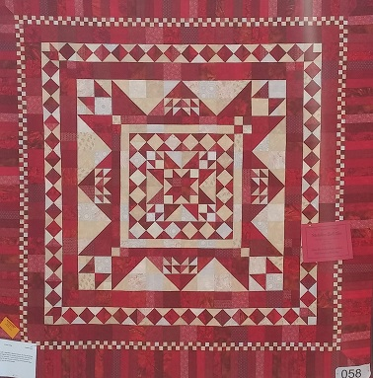

Bee News
Charity Bee
The May donation to the Food Bank is 43.00. This brings the year-to-date total to $213.00. Great job! The next Charity Bee meeting will be Tuesday, May 16, beginning at 9:30 am at Fabric Carousel (FC). Becki Marsh continues to make her cute baby bibs for Pregnancy Care Center. She gave me several more at the May meeting. I had the opportunity to speak with the Activities Director at Creekside on Sunday and asked what their needs were. They need 15 walker caddies and 15 "soft" pillows right now. (We no longer use fabric scraps to make the hard, heavy support pillows.) So if you have a stash of batting scraps, Creekside would appreciate some soft pillows. There is plenty of batting scraps and fabric for this at FC if you don't. The suggested shape was rectangular, with the length about 14 to 18 inches. (I'd guess the width to be from 8 to 12 inches.) I'm sure they can use square-shaped as well. Charity Bee is in general need of walker caddies which involves cutting the kits, or sewing them together. We have lots of walker caddie fabric just waiting for a "designer". Diaper Ministry Update: I called Becky Hernandez to let her know there is more toweling at Fabric Carousel. She thanks everyone who keeps donating their toweling for the diapers. Becky hopes that we can do a workshop as Kay O. suggested when Becky was at our April guild meeting. They have a short deadline of September or October (the time in which the diapers will be delivered to Uganda), but she said that there will be another trip and whatever quantity of diapers they have for this first trip will be great. Update on Home School Sewing Group who took ten kits to construct: I left a message for Cary Brown, but I have not heard back from her and will follow up in a day or two. In early April, I learned that Handiquilter was giving away to charity groups the "sew off" fabric that they use to test their new machines. This fabric is already quilted by their testers and comes in very long lengths. I sent the coordinator an email telling about our Charity Bee work and asked if we could participate. We were accepted and only had to pay for shipping ($16), and they only ask that we provide a few photos of the finished HUGs. The large box came just in time for April's Charity Bee meeting. Susan cut all of it into more than 10 HUGs. Several of the ladies began working on one right away. All that is needed is binding and decoration of some type which can be applique or embroidery. These are a great canvass for the artist in ALL of us. It can be simple or elaborate, but the quilting is so nice that simple decoration is all that is needed. At the May guild meeting, Susan and Grace showed the Handiquilter sew off HUGs that they had finished. All were super cute! I only took four of these blank canvass HUGs and they were snatched up immediately. There are several more in the closet at FC if you'd like to decorate one. We had hopes that this would entice some to work on a HUG who usually don't care for the quilting part as these are already quilted. To see samples of what other organizations have done, go to their website: https://handiquilter.me/quality-and-comfort/?utm_source=Handi+Quilter+Consumer+Email+List&utm_campaign=65dceee7bf-EMAIL_CAMPAIGN_2016_12_20&utm_medium=email&utm_term=0_a4e309f586-65dceee7bf-249763333. Thank you to all who do good works for Charity Bee, which in turn is doing good works for our community! We look forward to seeing everyone at Charity Bee on the 16th! Any questions, call Robin Rodriquez or Susan Craig.
Cut-ups
Cut Ups will meet on the 2nd and 4th Friday each month at the Fabric Carousel. All are Welcome. Bring your quilting problems for lots of advice and help from your friends. Bee starts around 10 and lasts all day.
Embroidery Bee
We meet on the third Saturday of the month at 11 AM, at the Ohendalski building, next door to the Chicken place across from the mall. 1425 Brazos Dr. Contact Susan Craig for info. 436-1489
Advertisements
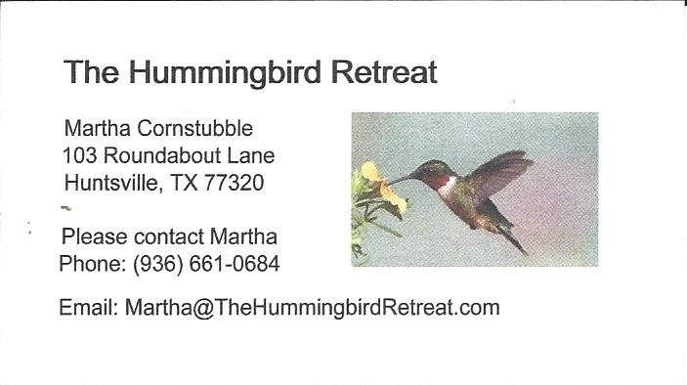
_{Newsletter ad prices are:}
$5.00 a month or $50.00 per year for a business card size advertisement.
$10.00 a month or $100.00 per year for a 3.5” x 4.5” size advertisement.
$18.00 a month or $180.00 per year for a one-half page advertisement.
$36.00 a month or $360.00 per year for a full page advertisement.
Member ads are free and will run for one month per request

_{Talll Pines Quilt Guild}
_{P.O. Box 7272}
_{Huntsville, Texas 77342-7272}

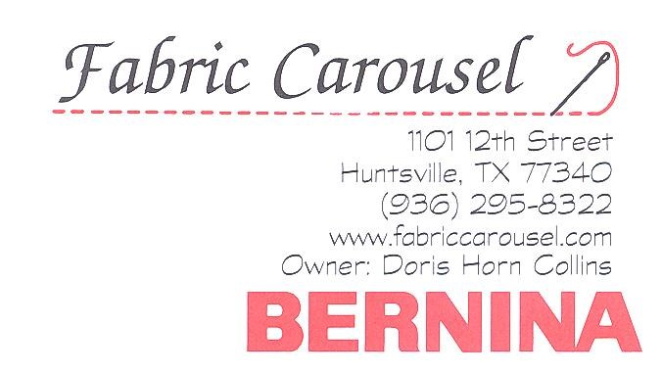

_{Tall Pines Quilt Guild Meeting} _{Guild Calendar Reminders}
You are invited to join us the first Monday of June 5th, 6:30 PM Guild Meeting
each month. The guild has a variety of _{May 16, Charity Bee}
programs, nationally known speakers, _{Meeting Reminders}
_{workshop and charity projects.} _{Bring Show and Tell Items}
We meet at the University Heights Baptist Church _{Bring money for Food Bank}
_{2400 Sycamore Ave.} _{UPC Labels from Hobbs batting}
Park in the back lot off Palm Ave. _{FQ Bands from Fabric Carousel}
Refreshments are served at 6:30PM _{For Charity Bee}
and the meeting starts at 7 PM. Visit the web site @ www.tallpinesquiltguild.com

