March 2018 Whisperings from the
Tall Pines Quilt Guild
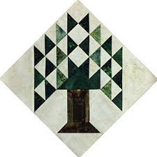

Upcoming Programs and Meetings
March 20th Charity Bee
April 2nd Shannon Brinkley – Scrappy Applique
April 6th – Turn in Quilts for Walker County Fair

April Birthdays
4/1 Melanie Burleson
4/1 Linda Cauthen
4/1 Martha Cornstubble
4/17 Mary Courtney
4/19 Rennie Bauer
4/27 Rory Ross
4/29 Randi Clower

Publisher: Diane Carrington Volume Number 106 Issue Number 105
From the President

I would like to thank Kay for holding the meeting for me on Monday. It is nice to have experienced members to fill in. From talking to members and reading the minutes, it sounds like the food was good and that the Show and Tell from members favorite quilts was a success.

Do not forget to share your patriotic quilts to display at the Veteran’s Muster on March 24th. You may drop off the quilts at Fabric Carousel. Also, get busy on a mini-quilt, if you have not already donated one. (Of course, I still have to make mine, need to get busy).

It looks like the Raffle quilt blocks are almost complete. We will show the quilt at the Texas Thimble Trail Shop Hop in July for the first time. Patricia is allowing us a booth to sell raffle tickets. Please help her out by volunteering to help at the Shop Hop. We will also need members to sell raffle tickets.

Be sure to sign up to help at the Walker County Fair. Get in touch with Helen Belcher.

Happy Sewing!

Martha Wilson

Sunshine and Shadows
We send our love and prayers to Janis Voldbakken who has been diagnosed with breast cancer. She will be having surgery on March 15th. Also congratulations to Ann Moore for receiving a Blue Ribbon at the Dallas Quilt Show. Great job Ann!
Treasurer’s Report
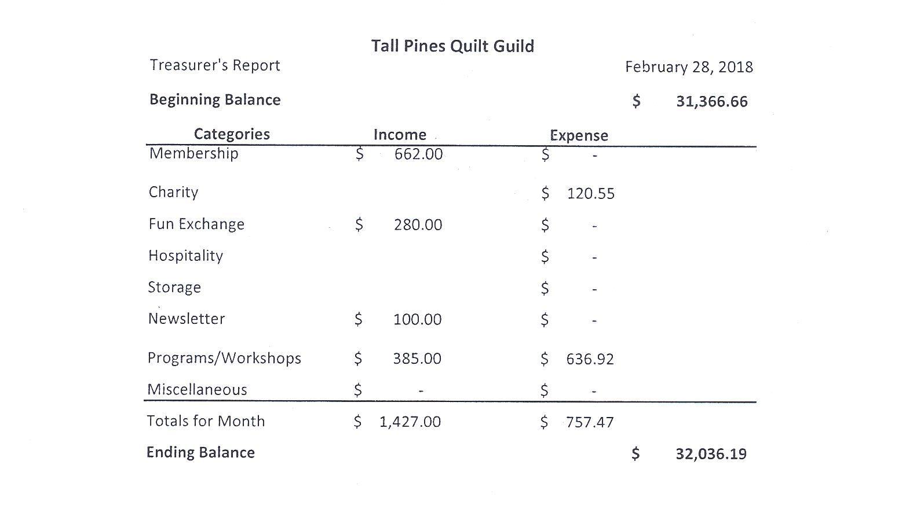

Tall Pines Quilt Guild Minutes of Meeting
Tall Pines Quilt Guild
Meeting Minutes
March 5, 2018
University Heights Baptist Church

In the absence of the president, Kay Ohendalski, Treasurer, called the meeting to order, welcomed members and guests and recognized March birthdays.

Minutes from the February meeting were printed in the newsletter. There being no corrections or additions, D-Ann Gilmore made a motion to accept, motion was seconded by Maggie Smith, motion passed.

Copies of the treasurer’s report were available on tables. No questions were raised.

Veterans Muster will be held on March 24th at the Veterans Museum. Judy Springer collected the mini quilts for the auction. Quilts for the display need to be turned in at Fabric Carousel. Quilts should have a hanging sleeve and a label with the owner’s name. Quilts should also have the measurements attached to the quilt or bag to assist Helen Belcher in the arrangement of the display.

Helen Belcher provided information on the Walker County Fair quilt display. Quilts should be turned in to Fabric Carousel on Friday, April 6th between 11 am and 5 pm. Entry fee is $5/quilt. Judging will take place on Sunday. Quilt sitters will be needed for all days of the fair, sign-up sheets were available.

Diane Carrington reported that most of the blocks for the raffle quilt have been made. The remaining papers need to be turned in as soon as possible. If you cannot complete them, please return them and someone else will make them. The quilt needs to be completed prior to the Shop Hop in July in order to sell raffle tickets. Anyone who can help remove backing paper is invited to the next Cut-Ups gathering on Friday, March 9th. She thanked everyone for their help in making the blocks.

Robin Rodriquez informed the group that the next Charity Bee will be held on March 20th at Fabric Carousel. The food bank collection amount for February was $37. They are still collecting FQ labels from Fabric Carousel and Hobbs batting labels. Several hugs were donated by Heavenly Threads quilt shop in Trinity. Rory Ross’ jelly roll race was a big success. There were 15 people sewing and several others assisting in other ways. Lots of quilt tops were made.

The East Texas Thimble Trail Shop Hop at the Walker County Fairgrounds will be held on July 13th and 14th. The guild will have a booth, selling items that are currently in storage and any items made by members. Workers will be needed at the shop hop and also at Fair on the Square on October 6th.

UFO challenge sheets are due at Fabric Carousel by March 15th. Reveal and prize awards will be done at the November guild meeting.

Cathy Wilson reported that there were 4 new members, including one junior member added to the guild. Welcome to these new members. New directories were handed out tonight. The new password for the website is “pinwheels”.

D-Ann Gilmore gave a report on the upcoming programs. Tonight’s program featured members showing their favorite quilts and a brief history of why that was their favorite.

Kelli Langley hosted Show & Tell. Some of quilts that will be displayed at the Veterans Muster were shown along with members’ latest finishes.

Door prizes and Fun Exchange items were awarded.

Patricia McCartney told the group about the No Fooling Shop Hop on April 2nd. Four shops are participating; Fabric Carousel in Huntsville, Heavenly Threads in Trinity, Quilters Quarters in Conroe and Quilters Crossing in Tomball. Visit all four shops on that day, picking up a passport at the first shop. Turn in completed passport at the last shop you visit to be entered in a drawing for a gift basket valued at $250.

The next guild meeting will be on April 2nd. Executive Board Meeting will be held on March 12, at Fabric Carousel at 5:30 PM.

There being no further business, the meeting was adjourned.

Enjoy the sew,

Elaine Robinson, Secretary
Programs Updates
TALL PINES QUILT GUILD 2018 PROGRAMS
D-Ann Gilmore, Program Chairman
April 2 – Shannon Brinkley – Scrappy Applique followed by a workshop the next day to learn the techniques and process.

May 7 – Brenda Asmus certified teacher for Marti Michell will give a lecture on “Tips from My Template Workbox” followed by a workshop on quick log cabin blocks using only 4 fat quarters.

June 4-5 – Cindy Needham, a nationally known speaker, will give a fabulous program entitled “For the Love of Linens”. Take this opportunity to take her 2-day workshop on Heirloom Feathers and Backgrounds. Payment for the 2-day workshop on Monday and Tuesday needs to be made by the May meeting, after that date we will contact those on the waiting list.

July 2 – Winnie Fleming will present a program called Stars and Scrap Exchange. Her workshop the following day is a Lone Star Table Runner where we will learn how to make perfect stars without cutting off the points.

August 6 – Peggy Richards is an award-winning quilter whose trunk show will take your breath away.

August 27 – Patti Nethery will give us a demonstration of her rulers entitled Piecing the Ruler Revolution Way along with a trunk show of her beautiful quilts.

October 1 – Open to suggestions

November 5 – UFO Challenge

December 5 – Christmas party

Membership Update

We currently have 105 members in our guild. There were 58 people in attendance including 4 visitors who are now new members. Please join me in welcoming them to the Guild!

Callie Lynch
169 FM 1696 W
Huntsville, 77320
Cell: 936-661-4872
BD: 2/12/08
RhondaLynch@rocketmail.com

Mary Jo McDonnell
12243 County Rd 269
Buffalo, 75831
Home: 903-322-6275
Cell: 979-204-8328
BD: 12/7
Spouse: Tom
Penfluff@sbcglobal.net

Kathy Perry
243 Rainbow Dr #14317
Livingston, 77399
Cell: 512-665-5764
BD: 5/13
Spouse: Rick
mkperry2@gmail.com

Alisa Willson
192 Sumac Rd.
Huntsville, 77340
Cell: 936-661-4435
BD: 10/29
appraiseralisa@gmail.com

Door Prizes
Cup of Fat Quarters and Pattern – Jean Bradley
Cup of Fat Quarters and Pattern – Evelyn Dawson
Spray starch and Pattern – Annemarie Hoffzimmer
Show and Tell
- Kay Ohendalski – Patriotic Mini, Large Patriotic quilt
- Virginia Wilson – Barns
- Kristie for Ashley – Compass
- Helen Cook – T-shirt quilt
- Debbie Mundell – Large Patriotic, Large Irish Chain, and Cross Wall Hanging
- Dorothy Wolverton – Mexican Train
- Diane Carrington – Valentine Quilt
- Debbie Birdwell – Patriotic Mini
- Judy Springer – Patriotic Quilt and Lonesome Pine
- Liz Williams - Cauliflower Pincushion, Fireworks Tablerunner
- Cathy Wilson – Trip Around the World
- Betty Bell – Favorite quilt
- Elaine Robinson – Patriotic Quilt
- Lynda Muzyka – Patriotic Quilt
Bee News
Charity Bee
The next Charity Bee meeting will be Tuesday, March 20, beginning at 9:30 am at Fabric Carousel. For the Food Bank at the March guild meeting $57 was collected! That brings the total so far this year to $132. Great start! The Jelly Roll "Race" on Saturday, March 3rd, was very successful and a lot of fun. Thank you, Rory!! There are a LOT of tops at Fabric Carousel waiting to be layered and pinned for quilting. That will be the focus for the next bee meeting. If anyone would like a top prepared for a longarm, please let us know. These tops are great for practicing your skills - either on a longarm or your domestic. We also have the pre-quilted quilts (from Handiquilter) that only need some cute appliques (can be very simple) and binding. With donated Fabric Carousel Fat Quarter Wrappers, we got two yards of great fabric which was used for a couple of backings. Keep the wrappers coming!! They are much appreciated, as are the Hobbs Batting UPC labels. Hope to see some new faces at Charity Bee this month!! Any questions, please contact Robin or Susan. On a personal note, I feel very honored to have been voted the 2017 Quilt Angel at last month's meeting. The Jim Shore Angel I received is very beautiful and it will have a great home in my sewing room. Thank you to all who voted for me! Robin
Cut-ups
Cut Ups will meet on the 2nd and 4th Friday each month at the Fabric Carousel. All are Welcome. Bring your quilting problems for lots of advice and help from your friends. Bee starts around 10 and lasts all day.
Embroidery Bee
We meet on the third Saturday of the month at 11 AM, at the Ohendalski building, next door to the Chicken place across from the mall. 1425 Brazos Dr. Contact Susan Craig for info. 436-1489

Donation Quilt
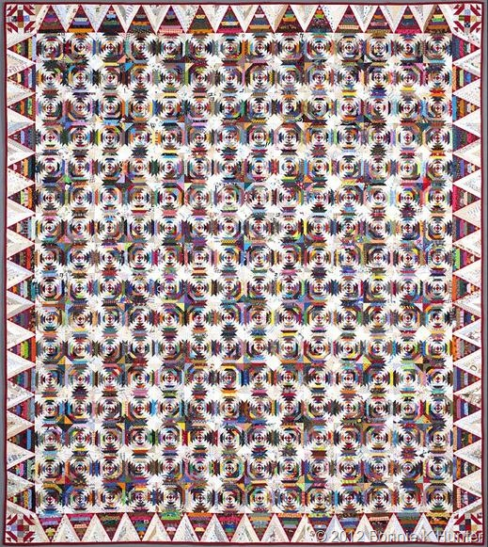
We are working hard on the donation quilt. We need 256 blocks for the center, 60 blocks for the border and 4 for the corners. That’s 320 blocks. We have 187 blocks completed and more coming in all the time. We need everyone’s help. I have the papers for the blocks at Cutups or at the Guild meetings. WE ARE ALMOST THERE!!!!! WE ARE DOING GREAT!!! THANK YOU TO EVERYONE THAT PULLED PAPER LAST FRIDAY.

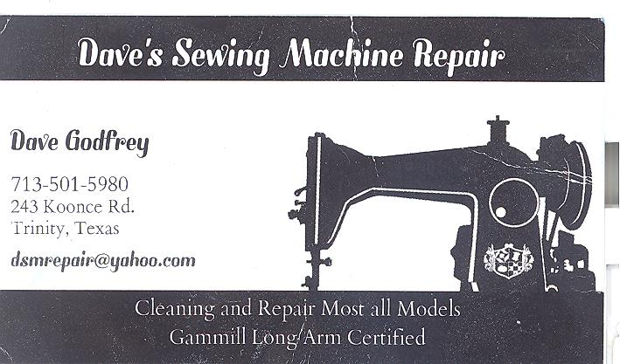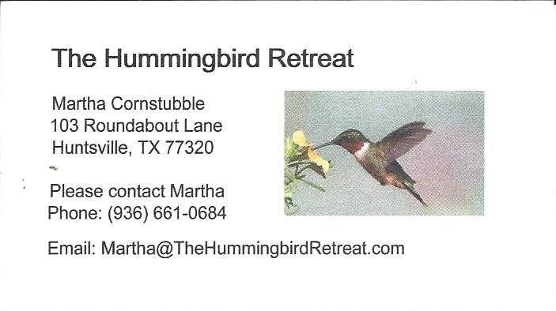
_{Newsletter ad prices are:}
$5.00 a month or $50.00 per year for a business card size advertisement.
$10.00 a month or $100.00 per year for a 3.5” x 4.5” size advertisement.
$18.00 a month or $180.00 per year for a one-half page advertisement.
$36.00 a month or $360.00 per year for a full page advertisement.
Member ads are free and will run for one month per request

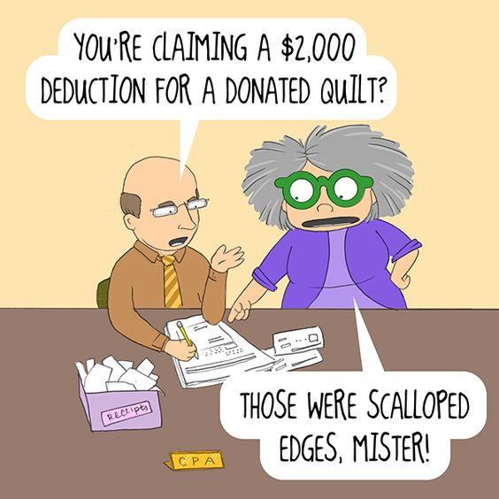
_{Tall Pines Quilt Guild}
_{P.O. Box 7272}
_{Huntsville, Texas 77342-7272}

_{Tall Pines Quilt Guild Meeting} _{Guild Calendar Reminders}
You are invited to join us the first Monday of April 2, 2018, 6:30 PM Guild Meeting
each month. The guild has a variety of _{March 20, 2018 Charity Bee}
programs, nationally known speakers, _{Meeting Reminders}
_{workshop and charity projects.} _{Bring Show and Tell Items}
We meet at the University Heights Baptist Church _{Bring money for Food Bank}
_{2400 Sycamore Ave.} _{UPC Labels from Hobbs batting}
Park in the back lot off Palm Ave. _{FQ Bands from Fabric Carousel}
Refreshments are served at 6:30PM _{For Charity Bee}
and the meeting starts at 7 PM. Visit the web site @ www.tallpinesquiltguild.com
