July 2019 Whisperings from the
Tall Pines Quilt Guild
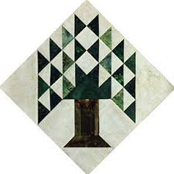

Upcoming Programs and Meetings

July 16th – Charity Bee
Aug 5th – Ann Moore Trunk Show

Aug Birthdays

Kaitlyn Long 8/5
Tasha Fry 8/8
Joyce Parish 8/9
Judy Springer 8/9
Helen Belcher 8/18
Diane Roma’n 8/20
Janis Childers 8/25
D-Ann Gilmore 8/31
Pat Tracy 8/31

Publisher: Diane Carrington Volume Number 119 Issue Number 118
From the President
Happy Fourth of July! I hope everyone had a great holiday celebrating the Nations birthday. Mine was quiet and I watched the fireworks on TV. The next event that you should be interested in is the East Texas Thimble Trail on July 26 and 27th 10:00 AM to 5:00 on Friday and 10:00 AM to 4:00 AM on Saturday. The event is being held at the Walker County Fairgrounds. If you would like to volunteer to help and get free admission, please call Patricia McCartney 936-594-1237. This should be a fun event!
How did you all like the demonstrations Monday night? I heard some good comments but I didn't get to see the demos. I will have to get a private demo from everyone! We will start the signup for the Houston International Bus Festival trip at the next meeting. Dorothy Wolverton has all the information and is ready to take your money! We will be traveling by bus on Thursday, October 31st, 2019. The cost will be similar to all the other years.
Don't forget about the Fair on the Square the first weekend in October. Doris has offered to let us use her classroom to sell items made by the Guild. We already have a few things and there is a plastic storage bin at Fabric Carousel in the classroom on the couch to put things you have made. You can donate to the Guild or sell your own things and received 85% of the sales price. This is the only money making event the Guild will have this year so please participate.
Happy Sewing!
Martha Wilson

Sunshine and Shadows
Congratulations to Cindy Rohe for the new grandson, Seth William Rohe weighing in at 7lbs. 13oz. On June 30th. Prayers for a speedy recovery for Cathy Stienbach. She had a knee replacement. Everyone have a great Fourth of July and be safe.

Tall Pines Quilt Guild Minutes of Meeting

Tall Pines Quilt Guild
Meeting Minutes
July 1, 2019
University Heights Baptist Church

President, Martha Wilson, called the meeting to order, welcomed members and guests and recognized July birthdays.

The June minutes were printed in the newsletter. Ashlely Buehring made a motion to accept the minutes as printed. Virginia Wilson seconded the motion. Motion passed.

Kay Ohendalski provided treasurer’s reports for May and June.

Alyssa Calkin was the second $1500 scholarship recipient for this year. She was recognized by Judy Oliver. Alyssa showed a quilt that she helped to make. Congratulations.

Members from the Waller County Quilt guild out of Hempstead brought a beautiful quilt to show to our guild. Raffle tickets were available for sale. The winning ticket will be drawn on November 15th. They also mentioned the Watermelon Festival which will be held on July 20th.

Rory Ross will be teaching a jelly roll race at Fabric Carousel on July 13th from 10-2. The resulting quilts will be donated to charity bee.

Fair on the Square is coming up on October 5th. The guild will have items for sale in the Fabric Carousel classroom. Members are asked to make mini quilts, wall hangings or other small items for the sale.

Door prizes and Fun Exchange was held. Congratulations to all winners.

The UFO challenge number drawn for July was #8. Items must be completed by the August 5th meeting in order to receive a ticket for the prize drawing in December.

D-Ann Gilmore told the members that Ann Moore will be doing a trunk show at the August 5th meeting. Jan Matthews will be doing a presentation at the August 26th meeting followed by a workshop the following day at Fabric Carousel. She will be teaching a class on making a Desert Star table runner. Sign up is in progress, see D-Ann for more information. Class price is $20 and the supply kit is $35.

Tonight’s program was a round robin featuring 6 different ladies each teaching a different skill.

Dorothy Woverton will be in charge of the bus trip going to the International Quilt Festival in Houston. More information will be forthcoming.

Kelli Ann Langley hosted show and tell.

The Executive Board meeting will be held on July 8th at Fabric Carousel.

Committee reports were given.

There being no further business, the meeting was adjourned

The Best Way to Finish a Quilt, Is To Simply Begin.
Elaine Robinson, Secretary

Treasurer’s Report

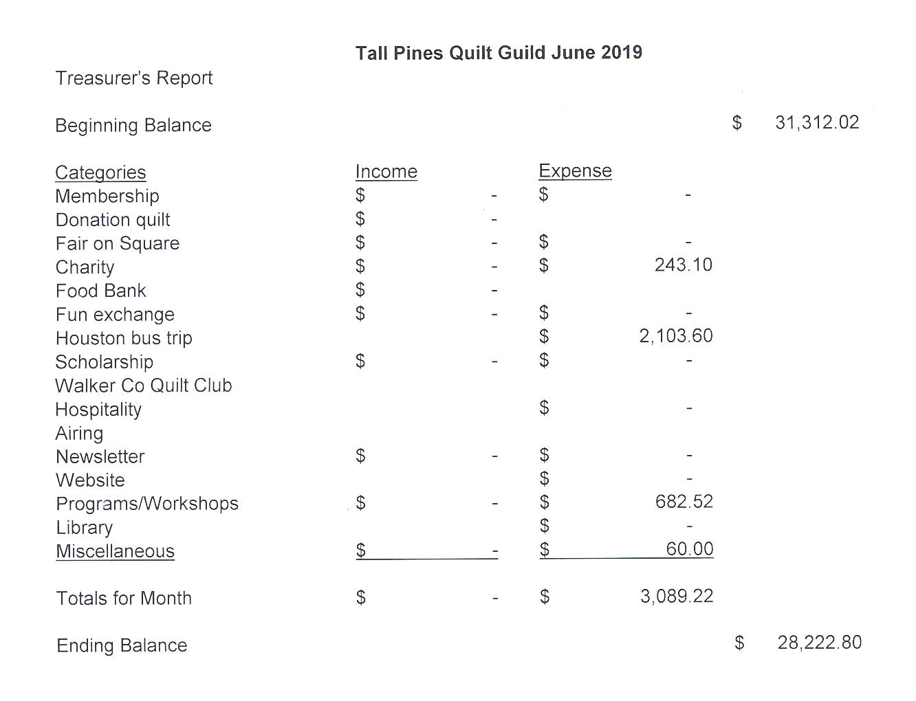
Memberships

There were 53 members who attended the July meeting and 9 visitors including 2 who joined the guild. Tall Pines currently has 117 members. Please join me in welcoming our newest members!

Lydia Klespis
224 Royal Oaks
Huntsville, 77320
Home/Cell: 936-661-7308
BD: Oct. 18
Spouse: Mark
lklespis@yahoo.com

Kaitlyn Long
731A Vicki Dr
Huntsville, 77340
Home: 832-612-6821
BD: Aug. 5
Spouse: Garrick
kaitlyn.g.long@gmail.com

Programs
TALL PINES QUILT GUILD 2019 PROGRAMS
D-Ann Gilmore, Program Chairman

August 5 – Ann Moore will provide us with a wonderful trunk show of her amazing quilts. REMINDER: Please bring No. 8 listed on your challenge sheet

August 26 – Jan Mathews of JKMQuilting.com – The History and Development of Foundation Piecing. The workshop on Tuesday will be a table runner named Desert Sky designed by Judy Niemeyer using paper piece techniques.

October 7 - Cynthia Regone’s presentation will be “Kick It Up a Notch (brights at their best)” followed by a workshop the next day with a happy cheerful pattern called Funky Town Stars.

Bus Trip to the Quilt Festival

Our guild bus trip to the International Quilt Festival is going to be on
Thursday, October 31st this year. We leave from the JCPenney corner of West Hill Mall at 8:00 and head home at 5:00 pm, arriving around 6:30.
The price this year is $50, which will include bus drivers tip. You can start signing up at the August 5th guild meeting and need to pay by October 7th guild meeting. Doris can also take your reservation at Fabric Carousel or you can mail it to me at the following address:

Dorothy Wolverton
8 Lily Cove
Huntsville, TX 77340

PLEASE POSTDATE CHECKS SEPTEMBER-up to OCTOBER 7th.

As always, guild members have first dibs, then non-members, but we usually have room for all.

Dorothy

Jelly Roll Race

There will be a jelly roll race at Fabric Carousel July 13th, from 10:00 - 2:00. All fabric will be provided and all the quilts will be donated to charity. Just bring your sewing machine and thread and sew, sew, sew.

Show and Tell
- Susan Craig – Wallhanging, Lap quilt and Tablerunner
- Barbara Pearson – Jelly Roll Baby quilt
- Barbara Barnes – Sew Vintage quilt
- Barbara Edmondson – blouse and quilt
- D-Ann Gilmore – Baby Animals, Pink Toile, Burp towels and Happy Jacks quilt
- Martha Wilson – Big Bag
- Kaitlyn Long – Baby items
- Ashley Buehing – stuff
- Maggie Smith – T-shirt quilt
- Liz Williams – Cactus Flowers Tablerunner
- Wendy Salsbery – Gears Wallhanging
- Kelli Langley – Mermaid Lagoon cross-stitch

Fun Exchange
- Moda Layer Cake – Jean Bradley
- Five ½ yard pieces and book – Barbara Edmondson
- Patriotic pattern and panel – Melanie Burleson

Bee News
Charity Bee
The next Charity Bee is on Tuesday, JULY 16, 2019, at Fabric Carousel, beginning at 9:30 am. Hopefully we'll have a BUNCH of Jelly Roll tops ready to layer and pin from the JELLY ROLL "RACE" taking place on Saturday, July 13, beginning at 10:00 am. Join is on July 13 for this fun charity event. Bring your sewing machine and typical sewing notions. This can be your opportunity to do your part in "getting one done for the year". (We'll likely order lunches from Mayflower Bakery for $5.50 each.) For the Food Bank at the July guild meeting, we collected $34, bringing the YTD total to $235! As a reminder, Charity Bee collects Fabric Carousel fat quarter wrappers and Hobbs batting UPC labels. Still hoping that every member of the guild will complete at least one HUG for the year (and EVERY year). (Completing a HUG doesn't mean from start to finish, although that would be fantastic; you can JUST piece a top or you can JUST quilt a pinned top. OR make a baby blanket!) This would really increase our donations to our charitable recipients!! We also donate baby bibs, adult bibs, baby burps, crocheted baby beanies, baby blankets, walker caddies, adult lap quilts (for the wheelchair bound), as well as HUGs of all sizes. As always, big "thank you" to all who participate!

Cut-ups
Cut Ups will meet on the 2nd and 4th Friday each month at the Fabric Carousel. All are Welcome. Bring your quilting problems for lots of advice and help from your friends. Bee starts around 10 and lasts all day.

Embroidery Bee
We meet on the third Saturday of the month at 11 AM, at the Ohendalski building, next door to the Chicken place across from the mall. 1425 Brazos Dr. Contact Susan Craig for info. 436-1489

Diane’s Tips and Grins

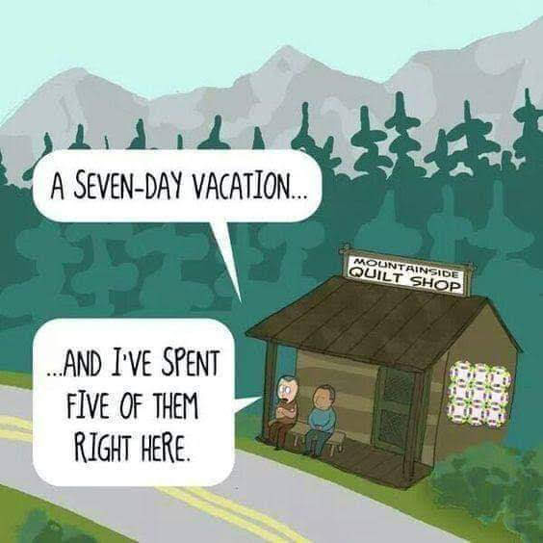

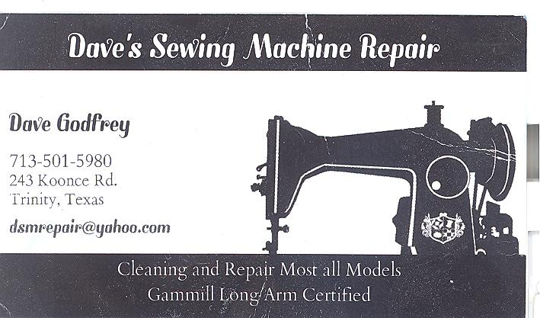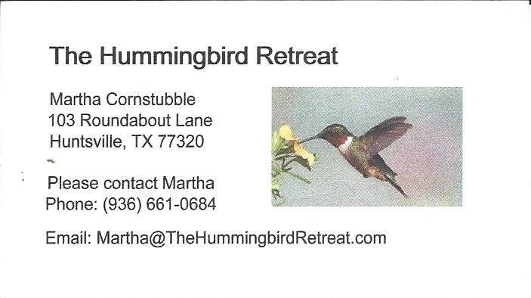
_{Newsletter ad prices are:}
$5.00 a month or $50.00 per year for a business card size advertisement.
$10.00 a month or $100.00 per year for a 3.5” x 4.5” size advertisement.
$18.00 a month or $180.00 per year for a one-half page advertisement.
$36.00 a month or $360.00 per year for a full page advertisement.
Member ads are free and will run for one month per request
_{Tall Pines Quilt Guild}
_{P.O. Box 7272}
_{Huntsville, Texas 77342-7272}

_{Tall Pines Quilt Guild Meeting} _{Guild Calendar Reminders}
You are invited to join us the first Monday of Aug 5, 2019 6:30 PM Guild Meeting
each month. The guild has a variety of _{July 16, 2019 Charity Bee}
programs, nationally known speakers, _{Meeting Reminders:}
_{workshop and charity projects.} _{Bring Show and Tell Items}
We meet at the University Heights Baptist Church _{Bring money for Food Bank}
_{2400 Sycamore Ave.} _{UPC Labels from Hobbs batting}
Park in the back lot off Palm Ave. _{FQ Bands from Fabric Carousel}
Refreshments are served at 6:30PM _{For Charity Bee}
and the meeting starts at 7 PM. Visit the web site @ www.tallpinesquiltguild.com
