February 2018 Whisperings from the
Tall Pines Quilt Guild
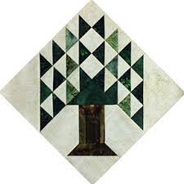

Upcoming Programs and Meetings
February 20, Charity Bee
March 3, Jelly Roll Race for Charity
March 5, Meeting – Bring your favorite quilt. Super Show and Tell

March Birthdays
Doris Collins 3/5
Carole Boney 3/14
Susan Craig 3/18
Grettle Payne 3/21
Pam Ray 3/28
Barbara Flebbe 3/29
Kay Ohendalski 3/29

Publisher: Diane Carrington Volume Number 105 Issue Number 104
From the President
Happy Valentine’s Day!
I hope you get all the flowers and candy that you desire from your valentine. Monday night’s meeting was great, it was wonderful to see all the ways you can use embroidery in everyday quilts. Kind of makes me want to get a machine that will do all this! I guess I will stick to hand embroidery. Brenda is a talented quilter and is so much fun to be around.
Be sure to get your UFO challenge list together. You may think it is a waste of time. I finally finished one on my list last year. Hopefully I can get 2 out of 5 this next year. Also, start working on the Mini Quilts for the Veterans Muster that will be held on 3/24/18.
Happy Sewing,
Martha Wilson

Sunshine and Shadows
Hi Everyone, Please keep Judy Moorer in your prayers for the loss of family members and Grettle Payne for health problems she is having. As always we encourage everyone to let us know about sunshine and shadows for our members. Thanks Ruth and Betty
Honoring Heros

Ladies in the Tall Pines Quilt Guild will be participating in the first H.E.A.R.T.S. Festival (Muster) on Saturday, March 24, 2018. There will be a quilt show of patriotic quilts and a mini patriotic quilt auction to benefit the veterans museum. Also being honored during the festival will be first responders (law enforcement and EMTs).

If you have questions, please call Toni Bruner, 936-295-5892 or 936-661-0330.

Tall Pines Quilt Guild Minutes of Meeting
Tall Pines Quilt Guild
Meeting Minutes
February 5, 2018
University Heights Baptist Church

President Martha Wilson called the meeting to order, welcomed members and guests and recognized February birthdays.

Minutes from the January meeting were printed in the newsletter. There being no corrections or additions, Janis Voldbakken made a motion to accept, motion was seconded by Jean Garner, motion passed.

Ballots were available for voting for this year’s quilt angel. The ballots will be tabulated and the winner will be announced after the break.

Sunshine and Shadows slips are available for members to notify the committee of any events that require cards to be sent on behalf of the guild.

Robin Rodriquez expressed her appreciation for all that has been done for the Charity Bee this past year. Her desire is that every member get involved in some way. The Bee meets every 3rd Tuesday of the month at Fabric Carousel beginning at 9:30AM. Last year, hugs were donated to area centers for distribution. For durability purposes, hugs must be machine pieced, machine quilted and machine bound. Other needs are walker caddies, lap quilts and bibs for both adults and children. Robin brings kits to guild meetings or they can be picked up at Fabric Carousel.

Rory Ross announced a jelly-roll race on Saturday, March 3rd from 10-3 at Fabric Carousel. Jelly rolls will be provided. A sign-up sheet is available tonight.

Toni Bruner reminded members of the upcoming Veterans Muster Festival and mini quilt auction at the storm shelter, located adjacent to the Veterans Museum, to be held on March 24th. These items are to be brought to the March meeting. All money raised by the mini quilt auction will be donated to the Veterans Museum. Quilts can then be entered in the Walker County Fair show.

Helen Belcher provided information on the Walker County Fair quilt display. Quilts should be turned in to Fabric Carousel on the Friday before the fair. Fair dates are April 6-14. Judging will take place on Sunday and quilts will be returned on Friday. Quilt sitters will be needed. Sign up sheets will be forthcoming. Quilt entry fee is $5 per quilt.

Diane Carrington showed her pineapple quilt as an example of the raffle quilt that members are working on for Airing of the Quilts 2019. A total of 256 blocks are needed for the center of the quilt and 60 blocks are needed for the border. To date, about 150 center blocks have been turned in. If anyone has taken papers to sew and cannot complete them, please turn them back in so others can do them. All blocks are due by the end of February.

Door prizes were awarded.

D-Ann Gilmore gave a report on future programs. She also reminded members that UFO sheets need to be turned in by the March meeting. Reveal will be in November. Prizes will be awarded in several categories.

Tonight’s presenter was Brenda Jeschke. Her machine-embroidered quilts were stunning. A workshop will be help on Tuesday at Fabric Carousel beginning at 10 AM.

Robin Rodriquez was named as this year’s quilt angel. Congratulations Robin!

Fun Fund drawing was held.

Show & Tell was held, hosted by Kelli Langley.

The next guild meeting will be on March 5th. Executive Board Meeting will be held on February 12, at Fabric Carousel at 5:30 PM.

There being no further business, the meeting was adjourned.

That “seams” to be all the news,

Elaine Robinson, Secretary

Programs Updates
TALL PINES QUILT GUILD 2018 PROGRAMS
D-Ann Gilmore, Program Chairman
March 5 – Bring silent auction patriotic quilts. We will have a super show and tell. Please bring your favorite quilt to show. If you are participating in the UFO Challenge the sign-up sheet is due to Fabric Carousel by March 16.

April 2 – Shannon Brinkley – Scrappy Applique followed by a workshop the next day to learn the techniques and process.

May 7 – Brenda Asmus certified teacher for Marti Michell will give a lecture on “Tips from My Template Workbox” followed by a workshop on quick log cabin blocks using only 4 fat quarters.

June 4-5 – Cindy Needham, a nationally known speaker, will give a fabulous program entitled “For the Love of Linens”. Take this opportunity to take her 2-day workshop on Heirloom Feathers and Backgrounds. The 2-day workshop is Monday and Tuesday is full with a wait list.

July 2 – Winnie Fleming will present a program on Stars and Scrap Exchange. Her workshop the following day is a Lone Star Table Runner where we will learn how to make perfect stars without cutting off the points.

August 6 – Peggy Richards is an award-winning quilter whose trunk show will take your breath away.

October 1 – Open to suggestions

November 5 – UFO Challenge

December 5 – Christmas party

Membership Update
Thanks to everyone who paid their dues at Monday’s meeting! This is the last month to renew your membership for 2018. If you have not paid your dues by the end of February, your name will not be included in the new directory which will be available at the March meeting and you will no longer receive the monthly newsletter. Dues are $25, $20 for age 70 and above, and $5 for junior members under 18. You can leave your money at Fabric Carousel or mail it to me at:
Cathy Wilson
29479 Red Top Rd
Richards, TX 77873
If you have questions or just can’t remember if you’ve renewed or not, call me at 713-806-9108.
There were 62 members present at the February meeting, 4 visitors, one new and one returning member. Please welcome:
Linda AuBuchon
P.O.Box 208
Oakhurst, 77359
Cell: 936-661-2471
lindalou.heartsandcrafts@gmail.com
BD: 12/21
Spouse: Frank
Jan Hill
Cell: 936-577-1512
janlaurenhill@gmail.com
BD: 1/1
Spouse: Len
Door Prizes
Pincushion & Note Pad – Elaine Robinson
Pincushion & Note Pad – Joyce Parrish
Rotary Cutter Case & Seam Ripper – Janis Childers
Show and Tell
Barbara Pearson – 3 quilts
Evelyn Dawson – Scrappy crib quilt
D-Ann Gilmore – Inch Worm
Elaine Robinson – Snowglobe quilt
Jean Garner – Thimble quilt
Bee News
Charity Bee
For the Food Bank the Guild collected $37 at the February meeting. The next Charity Bee meeting will be Tuesday, February 20, at Fabric Carousel, beginning at 9:30. At this meeting we will focus on cutting 2.5 inch strips which will be used on Saturday, March 3, for a fun Jelly Roll Race (thank you, Rory, for coming up with the idea and heading this up!). If you have a jelly roll you'd like to donate, we'd be happy to accept it for this event. Please mark your calendar to come join the fun from 10:00 to 3:00 on March 3 at Fabric Carousel. (Rory said there'd be prizes!) If you are attending, please let Rory Ross know so we will have enough jelly rolls for all to participate. If you'd like to make your own jelly roll race quilt at home and donate, that would be fantastic! Please direct any questions for the Jelly Roll Race to Rory.

At the February Guild meeting, Robin talked about what Charity Bee is about and encouraged every member to participate in some way. Here are the highlights:
One of the purposes of joining the Guild should be to give back to the community. The Guild is a non-profit and in order to maintain this status and not pay taxes, we must do charitable work.
Membership should be more than just coming to the meetings to enjoy the food, fellowship and programs.
Our wish is that every member will participate, either at Charity Bee or at home.
Main focus of Charity Bee is HUGs (quilts for four local charitable recipients: Pregnancy Care Center, SAAFE House, Hospitality House, and CPS). These can be most any size.
Guidelines for HUGs: they MUST be machine pieced, quilted and bound. They have to be very durable.
There are many "jobs" at Charity Bee and you can pretty much choose the parts you'd like to do - or even complete a project from start to finish. A sewing machine is not required, but would be SO VERY helpful!
Longarmers: If you would like a HUG to quilt on a longarm, please let us know and we will prepare one for you.
Other Projects that need volunteers: Walker Caddies (very simple bags that need to be cut out and constructed), Lap Quilts (can be as simple as two fabrics sewn together with batting, turned right side out, with minimal quilting), Bibs (very quick and simple - for adults as well as babies), Crocheted Items: Pregnancy care needs crocheted baby caps and booties.
As you can see, Charity Bee stays very busy and historically it has been the same handful of faithful who do the work. Some of the ladies are burning out.
Please think about what you'd like to do to help and get involved. We have a lot of fun at Charity Bee, but if you're not able to come, we'd be happy to provide you with projects to complete at home. Robin tries to bring some projects to the Guild meetings to hand out.
Anything anyone does to help is greatly appreciated. The recipient agencies are so thankful for what we do for them and their clients.
If you have any questions, Robin or Susan Craig would be happy to answer.

Cut-ups
Cut Ups will meet on the 2nd and 4th Friday each month at the Fabric Carousel. All are Welcome. Bring your quilting problems for lots of advice and help from your friends. Bee starts around 10 and lasts all day.

Embroidery Bee
We meet on the third Saturday of the month at 11 AM, at the Ohendalski building, next door to the Chicken place across from the mall. 1425 Brazos Dr. Contact Susan Craig for info. 436-1489

Donation Quilt
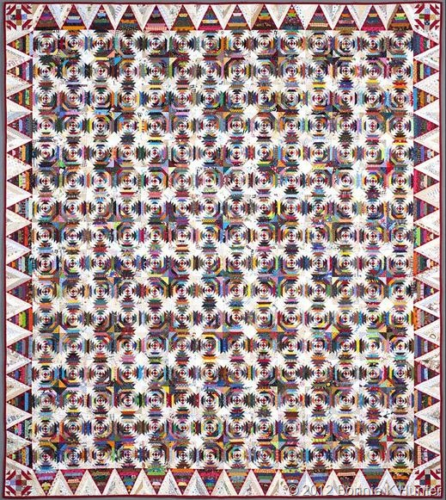
We are working hard on the donation quilt. We need 256 blocks for the center, 60 blocks for the border and 4 for the corners. That’s 320 blocks. We have 187 blocks completed and more coming in all the time. We need everyone’s help. I have the papers for the blocks at Cutups or at the Guild meetings. WE HAVE 133 BLOCKS TO GO!!!!! WE ARE DOING GREAT!!!

Fabric Carousel
…will be launching their Saturday Sample on February 17th at 9 a.m. Pay your $15.00 registration fee along with $7.50 for your first blocks and you could get a year’s worth of blocks (24 total) for free is you join us each Second Saturday at 9a.m. with your completed block. You will see a demo on that months block, draw for door prizes, learn new tips and tricks and join in show and tell.
Other upcoming classes:
February 17 – Introduction to Ruler Work/Janis Voldbakken
March 8 – Beginner Quilting/Grettle Payne
March 10 – Walking Foot Class/Grettle Payne
March 17 – Applique Demo Day
March 21 – Double Wide Dresden/D-Ann Gilmore
936/295-8322 Paid Advertisement www.fabriccarousel.com

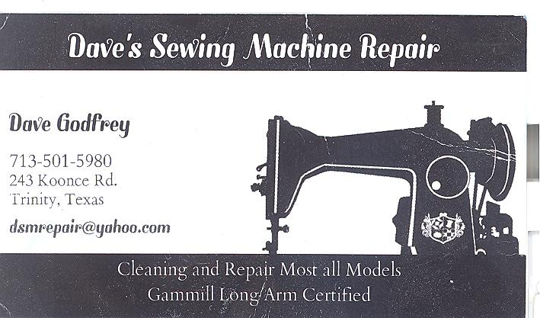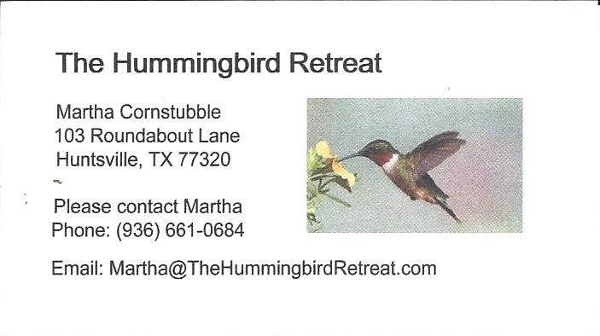
_{Newsletter ad prices are:}
$5.00 a month or $50.00 per year for a business card size advertisement.
$10.00 a month or $100.00 per year for a 3.5” x 4.5” size advertisement.
$18.00 a month or $180.00 per year for a one-half page advertisement.
$36.00 a month or $360.00 per year for a full page advertisement.
Member ads are free and will run for one month per request

_{Tall Pines Quilt Guild}
_{P.O. Box 7272}
_{Huntsville, Texas 77342-7272}

_{Tall Pines Quilt Guild Meeting} _{Guild Calendar Reminders}
You are invited to join us the first Monday of March 5, 2018, 6:30 PM Guild Meeting
each month. The guild has a variety of _{February 20, 2018 Charity Bee}
programs, nationally known speakers, _{Meeting Reminders}
_{workshop and charity projects.} _{Bring Show and Tell Items}
We meet at the University Heights Baptist Church _{Bring money for Food Bank}
_{2400 Sycamore Ave.} _{UPC Labels from Hobbs batting}
Park in the back lot off Palm Ave. _{FQ Bands from Fabric Carousel}
Refreshments are served at 6:30PM _{For Charity Bee}
and the meeting starts at 7 PM. Visit the web site @ www.tallpinesquiltguild.com
