December 2017 Whisperings from the
Tall Pines Quilt Guild
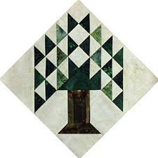

Upcoming Programs and Meetings
January 8, 2018 Baby Shower for the Pregnancy Crisis Center and Baby Block Challenge

January Birthdays
Pam Boyle 1/5
Debbie Walton 1/6
Betty Grantz 1/8
Tamara Bobbitt 1/9
Rhonda Lynch 1/10
Nancy Nelson 1/10
Pat Dittfurth 1/18
Jean Bradley 1/23
Sandra McKaskie 1/25
Martha Felder 1/29
Cindy Rohe 1/30
Virginia Wilson 1/31

Publisher: Diane Carrington Volume Number 103 Issue Number 102
From the President
Dear fellow quilters,
Well, this is it! This is the last letter from me as the president of the Tall Pines Quilt Guild.
Wow, it is hard to believe that it has been three years since I became president. I will have to say, time has just flown by. It has been busy, but not over whelming.
There are too many people to thank for making my term so easy and enjoyable. So I will just send out thank you to everyone who worked on a committee, served as an officer, and who never said no when a request was made to you. You, the hard-working quilters, are the reason our guild is so successful. I love everything about our guild. I love the members, the dedication and hard work, and the giving spirit of each and every one of you. I'm so blessed by you and the ministry and service that we provide for our community.
We have another great team of officers and committee chairman that will be busy and active in 2018. I look forward to all the exciting and fun things that we will do next year.
I hope you do too.
May God bless you and your family during this Christmas season.
Much love,
Kay Ohendalski, Outgoing President

Sunshine and Shadows
Our thoughts and prayers go out to Kathy Shute’s grandson Dillon Linton he found out he has masses of stomach, pelvic and lung cancer. He was married on Nov. 4 this year and found out about the cancer last week. Ann Barker has the flu, we wish her a speedy recovery. D-Ann Gilmore daughter Hannah got engaged. Jane Richmond reported her niece got married, Brother in law made Lt. Commander, She will be a great aunt in March or April and her sister in law finished radiation treatments and is doing real well. Betty Gratz son Ed needs our prayers. When he went for his check-up, the Drs. found a lesion in his head, let’s pray that it doesn’t have anything to do with the cancer that they removed. Let us know your sunshine and shadows so we can let our members know. Merry Christmas and have a Blessed and Happy New Year Ruth West and Betty Gratz

Meals on Wheels Project
Thank you, Thank you, Thank you all, for your generous giving of time, talent and money (approximately $165 donated). We particularly want to thank those ladies who made and sewed the adorable Christmas stockings. It was a "herculean" effort. We hope that you enjoyed making the Christmas ornaments too, because they really turned out pretty. We have some amazing talent in our Guild. Because of your generosity we were able to provide some Christmas "cheer" to 153 "Meals on Wheels Friends". The Christmas ornaments you made were beautiful and very much appreciated by the recipients of our gift. Some of the packets have been delivered already, the remainder will be delivered the week of December 11th. I personally delivered one route on Thursday and I can share with you that I witnessed much joy on the faces of the recipients. They were very touched that you thought of them and made a "special" gift for them. Each "Meals on Wheels Friend" received a packet with one of your hand made ornaments, a Christmas stocking stuffed with treats, and a Christmas card from the Tall Pines Quilt Guild. Your thoughtfulness brought some happiness to our Walker County Meals on Wheels Friends, who are oftentimes forgotten. FYI - hot meals are prepared daily (Monday - Friday) at the Senior Center of Walker County. Deliveries are made by volunteers to all corners of Walker County, including as far as Bedias, Livingston, New Waverly, Riverside and of course the Huntsville area. Thank you for supporting this special project and bringing "cheer" to our "Meals on Wheels Friends". Merry Christmas and may God Bless you and your families for all of your "love" and "generosity".

Judy Springer and Judy Oliver
Co-Chairmen of the Meals on Wheels Christmas Project

Honoring Heros

Ladies in the Tall Pines Quilt Guild will be participating in the first H.E.A.R.T.S. Festival (Muster) on Saturday, March 24, 2018. There will be a quilt show of patriotic quilts and a mini patriotic quilt auction to benefit the veterans museum. Also being honored during the festival will be first responders (law enforcement and EMTs).

A mini quilt workshop is scheduled for Wednesday, January 10, at 10 a.m., at the Fabric Carousel. Ladies who wish to particiipate in getting started on their minis are are asked to bring the following supplies: sewing machine and supplies, and any patterns and patriotic fabric in their stash. PLEASE DO NOT PURCHASE NEW FABRIC FOR THIS PROJECT - let's share and use what we have!

Bring a yummy lunch or plan to order out - we'll sew as long as you want!

If you have questions, please call Toni Bruner, 936-295-5892 or 936-661-0330.

Tall Pines Quilt Guild Minutes of Meeting
Tall Pines Quilt Guild
Meeting Minutes
December 4, 2017
University Heights Baptist Church

President Kay Ohendalski called the meeting to order, welcomed members and guests and recognized December birthdays.

Minutes from November meeting were printed in the newsletter. There being no corrections or additions, Ruth West made a motion to accept, motion was seconded by Virginia Cooper, motion passed.

Voting on the officers for the 2018 year was held. Officers are as follows; PRESIDENT, Martha Wilson, VICE-PRESIDENT, D-Ann Gilmore, TREASURER, Kay Ohendalski, VICE- TREASURER, Dorothy Wolverton and SECRETARY, Elaine Robinson. The membership unanimously voted to accept the slate of officers.

Robin Rodiquez gave the final report on the Charity Bee for 2017. Ninety-four hugs were made this year. Most hugs have been donated but the remaining ones will be delivered on Wednesday, December 6^{th,} along with some checks. The next Charity Bee will be held on January 16, 2018. A total of $510 was given to the food bank this year.

Toni Bruner informed the group about a Patriotic Quilt Show at the storm shelter, adjacent to the Veterans Museum. The quilts would hang in the hallway of the shelter, beginning on March 24th. Members are encouraged to make quilts or finish up some that have been started. Doris Collins suggested that members could make some mini quilts, 24” x 24”, to auction during the same time frame. This would help raise money for the museum. Both quilts and mini quilts would be due by the March guild meeting.

Rory Ross reported that the pole has been decorated in front of Fabric Carousel. She thanked all who helped with this effort.

D-Ann Gilmore reminded members that the January meeting will be the annual baby shower for the Care Center and also the judging of the blocks from the Baby Block Challenge. Helen Belcher reported that 25 blocks have been turned in. These will be displayed for members to vote for their favorites. Prizes will be awarded.

It is time to renew memberships for 2018. These are due by the February meeting. Annual dues are $25.

Tonight’s meeting was the guild Christmas party. Soups, salads, breads and desserts were served. Also, stockings were stuffed and ornaments made for the Meals on Wheels recipients. D-Ann Gilmore read a cute Christmas story and everyone received a box containing a tote bag, donated by Doris Collins along with items that keep you focused on quilting. Quilting should be fun!!!

Show and Tell of items that are being given as gifts was held.

The Executive Board Meeting will be held Monday, December 11, @ 5:30 pm at Kay Oheldalski’s home.

There being no further business, the meeting was adjourned.

It’s been a “stash” tastic year,
Elaine Robinson, Secretary

Treasurer’s Report
 | Tall Pines Quilt Guild
 | Treasurer's Report |  |  |  | November 30, 2017
 | Beginning Balance |  |  |  |  | $ 32,349.38
 | Categories |  | Income |  | Expense
 | Membership |  | $ - |  | $ -
 | Charity |  | $ - |  | $ 75.00
 | Fun Exchange |  | $ 100.00 |  | $ -
 | Hospitality |  | $ - |  | $ -
 | Newsletter |  | $ - |  | $ -
 | Programs/Workshops |  | $ - |  | $ 297.91
 | Fair on the Square
 | Festival Bus Trip |  | $ 135.00 |  | $ 167.11
 | Auction Quilt |  | $ -
 | Totals for Month |  | $ 235.00 |  | $ 540.02
 | Ending Balance |  |  |  |  | $ 32,044.36

Programs Updates
D-Ann Gilmore, Program Chairman
January 8 – Baby block challenge and shower for the Pregnancy Crisis Center, hand out sheets for UFO Challenge

February 5 – Brenda Jeschke’s – Machine Embroidery Marries Quilts with a presentation of over 30 machine embroidered quilts. The workshop teaching you how to incorporate the machine embroidery into a quilt.

March 5 – Bring silent auction patriotic quilts

April 2 – Shannon Brinkley – Scrappy Applique followed by a workshop the next day to learn the techniques and process.

May 7 – Brenda Asmus, certified teacher for Marti Michell will give a lecture on “Tips from My Template Workbox” followed by a workshop on quick log cabin blocks using only 4 fat quarters.

June 4-5 – Cindy Needham, a nationally known speaker will give a fabulous program entitled “For the Love of Linens”. Take this opportunity to take her 2-day workshop on Heirloom Feathers and Backgrounds. The workshop is Monday (the day of the guild meeting) and Tuesday.

November 5 – UFO Challenge
Membership Update
It is time to renew your membership for 2018! I will be collecting payments at the Jan. and Feb. meetings. ($25, $20 for members aged 70 or older, and $5 for members under 18) If you are unable to attend either of those meetings, you can leave your renewal at Fabric Carousel or mail it to:
Cathy Wilson
29479 Red Top Rd
Richards, TX 77873
If you have not renewed your membership by the February meeting, your name will be removed from the mailing list. A new membership directory will be distributed at the March meeting so if there are any changes to your information, please let me know.

Our membership total is up to 120 members! At the December meeting, 55 members, 2 new members, and 1 visitor were in attendance. Please welcome our new members to the guild!
Kimberly Street Annemarie Hoffzimmer
591 Carter Road 2413 Settlers Way
Coldspring, 77331 Huntsville
Cell: 936-661-8944 Cell: 936-661-3833
kstreet13@yahool.com nhoffzimmer@yahoo.com
BD: 11/13 BD: 5/9
Spouse: Brad
Bee News
Charity Bee
For the local Food Bank, $124.00 was collected at the December guild meeting! This brings the year-end total to $510.00. Wonderful job, everyone! There are LOTs of pinned HUGs in the laundry basket at Fabric Carousel (FC) needing to be quilted. There are HUG kits prepared in a small container just inside the closet at FC. These tops do not have to be all the way completed, but you're welcome to do so. The next Charity Bee meeting will be on Tuesday, January 16, 2018, beginning at 9:30 am at FC (NO BEE MEETING IN DECEMBER). This starts a new year and hopefully more members will become involved in helping to make HUGs and other items for our local charity recipients. Thank you to all who do their part to further the Guild's mission and PURPOSE. On that note, I want to report that we bettered last year's HUG total by four with a grand total of 94! A complete accounting is available in this newsletter. Again, a huge THANK YOU to all who did their part to make this possible!!! Please, all members, make a commitment in the new year to make at least one HUG for Charity Bee!!! We all should be participating as charitable works is the foundation of our guild, and the reason we have a tax exempt status. At an upcoming guild meeting, I will explain for the newer members what Charity Bee does and how ALL can help!!! For any information, please contact Robin Rodriquez or Susan Craig.

Cut-ups
Cut Ups will meet on the 2nd and 4th Friday each month at the Fabric Carousel. All are Welcome. Bring your quilting problems for lots of advice and help from your friends. Bee starts around 10 and lasts all day.
Embroidery Bee
We meet on the third Saturday of the month at 11 AM, at the Ohendalski building, next door to the Chicken place across from the mall. 1425 Brazos Dr. Contact Susan Craig for info. 436-1489

Donation Quilt
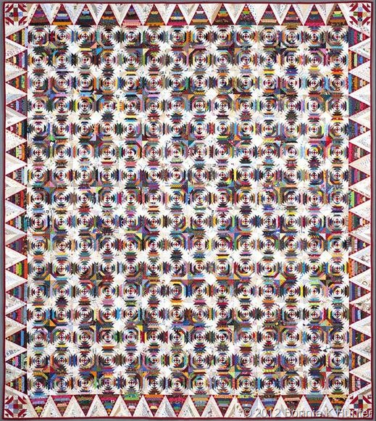
We are working hard on the donation quilt. We need 256 blocks for the center, 60 blocks for the border and 4 for the corners. That’s 320 blocks. We have 85 blocks completed and more coming in all the time. We need everyone’s help. I have the papers for the blocks at Cutups or at the Guild meetings. WE HAVE 235 BLOCKS TO GO!!!!!

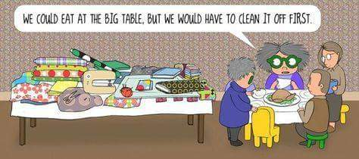
Fabulous Soup Recipe

Potato Bacon Chowder ( 6 servings)

Ingredients:
1 lb. potatoes, peeled and cubed (Yukon Gold or Russet)
1 cup water (or enough to cover potatoes)
8 bacon strips
1 med. onion, chopped
1 celery rib, chopped
1/2 c. frozen sweet corn, (optional)
1 can Cream of Chicken soup, undiluted
1 3/4 c. whole milk
1 c. (8oz.) sour cream
1/2 tsp. salt
Dash of pepper
1 Tbl. minced fresh parsley, (optional)

Directions:
1. Place potatoes in saucepan and cover with the water. Bring to a boil, reduce heat, cover and cook for 10 to 15 min. till tender. (do not drain)
2. Meanwhile, in large skillet, cook bacon until crispy. Drain on paper towels and set aside. Crumble when cool.
3. Sauté onion and celery in bacon drippings until tender. Add to undrained potatoes.
4. Stir in remaining ingredients. Cook on low for about 10 min. till heated through. Add crumbled bacon.

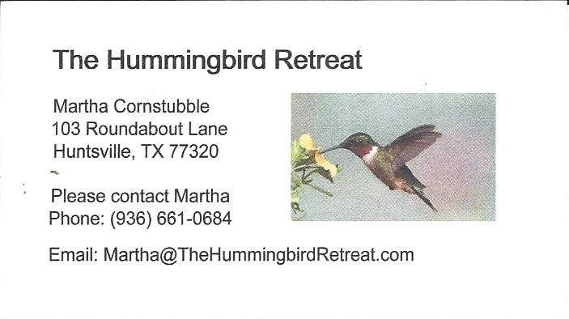
_{Newsletter ad prices are:}
$5.00 a month or $50.00 per year for a business card size advertisement.
$10.00 a month or $100.00 per year for a 3.5” x 4.5” size advertisement.
$18.00 a month or $180.00 per year for a one-half page advertisement.
$36.00 a month or $360.00 per year for a full page advertisement.
Member ads are free and will run for one month per request
_{Tall Pines Quilt Guild}
_{P.O. Box 7272}
_{Huntsville, Texas 77342-7272}

_{Tall Pines Quilt Guild Meeting} _{Guild Calendar Reminders}
You are invited to join us the first Monday of January 8, 2018, 6:30 PM Guild Meeting
each month. The guild has a variety of _{January 16, 2018 Charity Bee}
programs, nationally known speakers, _{Meeting Reminders}
_{workshop and charity projects.} _{Bring Show and Tell Items}
We meet at the University Heights Baptist Church _{Bring money for Food Bank}
_{2400 Sycamore Ave.} _{UPC Labels from Hobbs batting}
Park in the back lot off Palm Ave. _{FQ Bands from Fabric Carousel}
Refreshments are served at 6:30PM _{For Charity Bee}
and the meeting starts at 7 PM. Visit the web site @ www.tallpinesquiltguild.com
