August 2019 Whisperings from the
Tall Pines Quilt Guild
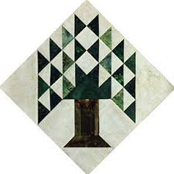

Upcoming Programs and Meetings

August 20th – Charity Bee
August 26th – Jan Mathews
Foundation Paper Piecing

September Birthdays

Tracy Szymczak 9/1
Jean Newman 9/8
Grace Burzynski 9/11
Virginia Cooper 9/15
Cynthia Cross 9/17
Mona Smidt 9/18
Cathy Wilson 9/18
Nancy Hageland 9/27
Helen Cook 9/30

Publisher: Diane Carrington Volume Number 120 Issue Number 119
From the President
Greetings my Quilting Friends!
Is it hot enough for you? I am looking forward to a cool front, but I don't think that is going to happen in August. We can all just stay inside and sew! You could make things for the Fair on the Square to sell. What a great idea! I will bring some patterns with me to the next meeting and the forms to complete for items that you want to donate to the guild,
I really enjoyed Ann Moore's program on Monday night. I think she has the makings of her new career after retirement from the insurance business. She has come a long way in a short time. Beautiful quilts and entertaining program.
Speaking of Fair on the Square, Jeanette Allen is holding a small workshop on Saturday, August 24th at Fabric Carousel. Bring your fabric and patterns and help her make things for the Fair. You can contact her for additional information. Hopefully we can get together sometime before the 1st weekend in October to make additional items.
Hope you all have a great August. See you soon.
Martha Wilson

Sunshine and Shadows
Congratulations to D-Ann Gilmore and her family. They have welcomed their first grandchild to the family, Ellie Mae. Helen Belcher will be having your gall bladder out Tuesday 8/13. Keep her in your prayers.

Tall Pines Quilt Guild Minutes of Meeting

Tall Pines Quilt Guild
Meeting Minutes
August 5, 2019
University Heights Baptist Church

President, Martha Wilson, called the meeting to order, welcomed members and guests and recognized August birthdays.

The July minutes were printed in the newsletter. Janice Voldbakken made a motion to accept the minutes as printed. D-Ann Gilmore seconded the motion. Motion passed.

There was no treasurer’s report presented as no new transactions were made.

The Tri-County Quilt Guild had their donation quilt for members to view and purchase tickets. The drawing will be held March 7th.

Cathy Wilson reported that there are currently 118 members in the guild.

The jelly roll race participants made approximately 20 quilt tops recently.

Grettle Payne held an Amish potholder workshop and 33 have been made so far.

Fair on the Square is coming up on October 5th. The guild will have items for sale in the Fabric Carousel classroom. Members are asked to make mini quilts, wall hangings or other small items for the sale. Please turn in donated items by September 28th.

Door prizes and Fun Exchange was held. Congratulations to all winners.

The UFO challenge number for August 26th was #5. Items must be completed by the August 26th meeting in order to receive a ticket for the prize drawing in December.

If interested in a bus seat to the International Quilt Festival in Houston, see Dorothy Wolverton.

Rhonda Lynch introduced 4 of the girls who participated in the summer quilt classes. Each girl showed their landscape quilt. Good Job!!! A new class will begin on October 3^{rd,} Helpers are needed and donations of rulers would be helpful. She will be bringing a raffle quilt to the next meeting.

D-Ann Gilmore introduced Ann Moore who gave a trunk show. She showed beautiful quilts and talked about using rulers for quilting.

Several officer positions will be open for the 2020 guild year. Please consider serving in one of the positions. It is a great way to get involved. If interested, please speak with Martha Wilson.

Jeannette Allen’s group made lots of items to sell at Fair on the Square. She challenged the membership to “Get Er’ Done” and make lots of items to donate.

Kelli Ann Langley hosted show and tell.

The Executive Board meeting will be held on August 12th at Fabric Carousel.

Committee reports were given.

There being no further business, the meeting was adjourned.

Sew While the Iron is Hot,

Elaine Robinson, Secretary

.

Treasurer’s Report

No report this month
Memberships

We had a full house at July’s meeting! There were 60 members and 12 visitors who attended. We had one new member join in July so our total membership is now 118! Please join me in welcoming our newest member:

Betsy Carney
324 Coral Gables
Trinity, 75862
Cell: 951-973-4815
BD: April 15
betsycarney@hotmail.com

Programs
TALL PINES QUILT GUILD 2019 PROGRAMS
D-Ann Gilmore, Program Chairman

August 26 – Jan Mathews of JKMQuilting.com – The History and Development of Foundation Piecing. The workshop on Tuesday will be a table runner named Desert Sky designed by Judy Niemeyer using paper piece techniques. REMINDER: Please bring No. 5 listed on your challenge sheet.

October 7 - Cynthia Regone’s presentation will be “Kick It Up a Notch (brights at their best)” followed by a workshop the next day with a happy cheerful pattern called Funky Town Stars.

Bus Trip to the Quilt Festival

Our guild bus trip to the International Quilt Festival is going to be on
Thursday, October 31st this year. We leave from the JCPenney corner of West Hill Mall at 8:00 and head home at 5:00 pm, arriving around 6:30.
The price this year is $50, which will include bus drivers tip. You can start signing up at the August 5th guild meeting and need to pay by October 7th guild meeting. Doris can also take your reservation at Fabric Carousel or you can mail it to me at the following address:

Dorothy Wolverton
8 Lily Cove
Huntsville, TX 77340

PLEASE POSTDATE CHECKS SEPTEMBER-up to OCTOBER 7th.

As always, guild members have first dibs, then non-members, but we usually have room for all.

Dorothy

Show and Tell
- Barbara Pearson – 4 charity quilts
- Cathy Wilson – Row by row
- Robin Rodriquez – Jelly Roll race for charity
- Jean Bradley – Lap quilt
- Joyce Parrish – 3 paintings with fabric
- Dorothy Wolverton – Winnie Flemming Mystery Boarders quilt top
- Liz Williams – Tennie Tiny flamingo Collage
- Elaine Robinson – Civil War, Bluework birds, woolwork birds
- Wendy Salsbery – Desert sky
- Kim Street – Black and White

Door Prizes
- Faith Mathis – Patterns
- Kathy Shute – book and decal
- Betty Gratz – ruler

Fun Exchange
- Diane Roman – bundle of flannels
- Diane Roman – bundle of brights
- Linda Summers – grab bag with 20 items
- Elaine Eakin – grab bag with 11 items

Bee News
Charity Bee
The next Charity Bee is on Tuesday, August 20, 2019, at Fabric Carousel, beginning at 9:30 am. For the Food Bank at the August 5 guild meeting, we collected $44, bringing the YTD total to $279! As a reminder, Charity Bee collects Fabric Carousel fat quarter wrappers and Hobbs batting UPC labels. Still hoping that every member of the guild (we now have 118 members!!!) will complete at least one HUG for the year (and EVERY year). (Completing a HUG doesn't mean from start to finish, although that would be fantastic; you can JUST piece a top or you can JUST quilt a pinned top. OR make a baby blanket!) This would really increase our donations to our charitable recipients!! Just imagine if all 118 members made JUST ONE HUG!!! We also donate baby bibs, adult bibs, baby burps, crocheted baby beanies, baby blankets, walker caddies, adult lap quilts (for the wheelchair bound), as well as HUGs of all sizes. As always, big "thank you" to all who participate!

Cut-ups
Cut Ups will meet on the 2nd and 4th Friday each month at the Fabric Carousel. All are Welcome. Bring your quilting problems for lots of advice and help from your friends. Bee starts around 10 and lasts all day.

Embroidery Bee
We meet on the third Saturday of the month at 11 AM, at the Ohendalski building, next door to the Chicken place across from the mall. 1425 Brazos Dr. Contact Susan Craig for info. 436-1489

Apple Blondies – YUM!!!

APPLE BLONDIES

Prep time: 20 minutes
Elapsed time: 55 minutes

2/3 C softened butter (“stick” version – not from a “tub”)
2 C brown sugar (or 1 C brown and 1 C granulated)
2 eggs
1 tsp vanilla
2 C all-purpose flour
2 tsp baking powder
1/4 tsp salt
1 C chopped apples
1/2 to 1 C chopped pecans

Cream butter and sugar --- add eggs and vanilla, mix well --- add flour, baking powder and salt, mix well.
By hand, stir in apples and nuts – batter will be stiff
Spread evenly in a well-greased 12x9x3 pan for 30-35 minutes at 350 degrees.

Officers Needed!!!

Do you want to be President, Program Chairman, Teasurer, Show and Tell Coordinator? There are lots of opportunities to get involved in the Guild. We need everyone’s help. Contact Martha or any Board Member if you are interested.

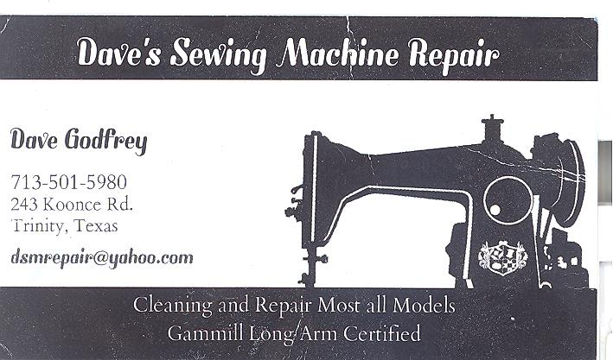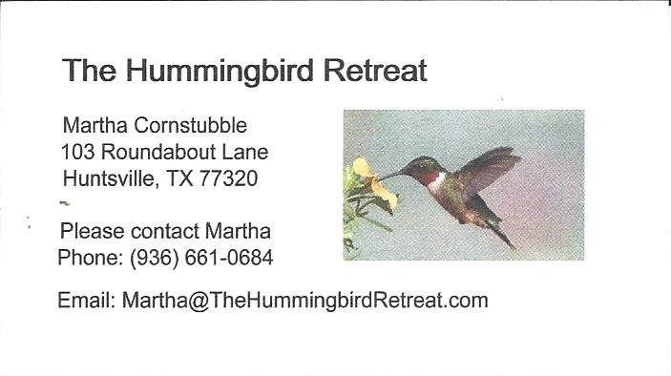
_{Newsletter ad prices are:}
$5.00 a month or $50.00 per year for a business card size advertisement.
$10.00 a month or $100.00 per year for a 3.5” x 4.5” size advertisement.
$18.00 a month or $180.00 per year for a one-half page advertisement.
$36.00 a month or $360.00 per year for a full page advertisement.
Member ads are free and will run for one month per request

Don’t forget your Fair on the Square Projects are due 9/28. We need everyone’s participation!

_{Tall Pines Quilt Guild}
_{P.O. Box 7272}
_{Huntsville, Texas 77342-7272}

_{Tall Pines Quilt Guild Meeting} _{Guild Calendar Reminders}
You are invited to join us the first Monday of August 26, 2019 6:30 PM Guild Meeting
each month. The guild has a variety of _{August 20, 2019 Charity Bee}
programs, nationally known speakers, _{Meeting Reminders:}
_{workshop and charity projects.} _{Bring Show and Tell Items}
We meet at the University Heights Baptist Church _{Bring money for Food Bank}
_{2400 Sycamore Ave.} _{UPC Labels from Hobbs batting}
Park in the back lot off Palm Ave. _{FQ Bands from Fabric Carousel}
Refreshments are served at 6:30PM _{For Charity Bee}
and the meeting starts at 7 PM. Visit the web site @ www.tallpinesquiltguild.com
