August 2017 Whisperings from the
Tall Pines Quilt Guild
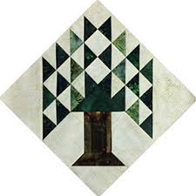

Upcoming Programs and Meetings
Remember the September meeting is August 28th – Garage Sale
Are you working on your UFO’s??

September Birthdays
Jammie Ackley 9/3
Grace Burzynski 9/11
Virginia Cooper 9/15
Nancy Meyers 9/16
Cynthia Cross 9/17
Mona Smidt 9/18
Cathy Wilson 9/18
Helen Cook 9/30

Publisher: Diane Carrington Volume Number 100 Issue Number 99
From the President
Greetings Fellow Quilter's,
I want to thank our Program Chairman for the great program and Red Work workshop we had with Rosie this past week. I recently had someone tell me that this sort of embroidery was old, out of date, and something no one does any more. HA! Ha!
She should have been to the work shop to see the interest in Red Work.
Thanks out to everyone making items for charity. We are on the downside of the year and it won't be long before Robin distributes a all the great quilts and items you have made. Keep working now that we do not have to spend a lot of time for Fair on the Square.
Hope we have a lot participate in the UFO challenge and baby block challenge. These events are right around the corner! Keep sewing!
See all of you at the next meeting and garage sale!
Kay Ohendalski, President

Sunshine and Shadows
Greetings from Sunshine and Shadows. Please keep in your thoughts and prayers Maggie Smith she is recovering from surgery, Grace Burzynski on the loss of her sister, Pam Boyle she is recovering from surgery also. If you have any sunshine or shadows to report please contact either Betty Gratz at lobag1961@gmail.com, phone number 936-438-0465, or Ruth West at quilterrw@live.com, phone number 847-638-3899 We are looking forward to hearing from you

Tall Pines Quilt Guild Minutes of Meeting

Tall Pines Quilt Guild
Meeting Minutes
August 7, 2017
University Heights Baptist Church

President Kay Ohendalski called the meeting to order, welcomed members and guests and recognized August birthdays.
A special mention was made that the Crockett guild brought their raffle guilt. Tickets were on sale. The raffle drawing will be held on November 18th at First Methodist Church in Crockett.

Minutes of the July meeting were printed in the newsletter. Since there were no corrections or additions, Virginia Wilson made a motion to accept and Janis Voldbakken seconded. Motion passed.

Robin Rodriquez told the group that the next Charity Bee would be on Tuesday, August 15, at Fabric Carousel. Five hugs were turned in tonight. A diaper workshop will be held on Saturday, August 12, at Fabric Carousel. All diaper-making supplies will be provided. You need only bring your machine and basic sewing supplies. Diapers will be sent to Uganda.

Patricia McCartney thanked the members and supporters for all their help with the Thimble Trail Shop Hop. It was estimated that 11,050 people came to the show. Plans are underway for next year’s show, entitled, “Fall in Love with Fabric”.

At the July board meeting, it was decided that the guild would not have a booth at Fair on the Square this year.

Now is the time to sign up to serve on the nominating committee. Positions that are open are President, Treasurer and Co-Treasurer. If you would like to be considered for one of these positions, please notify Kay.

A guild garage sale will be held on August 28. All craft-related items can be sold. A table can be rented for $10 or half a table for $5. Each person is responsible for their own sales so be sure to bring a cash box with cash for change.

Tonight’s program featured Rosie DeLeon-McCrary and her presentation on Redwork. Her extensive collection of quilts and other items dated back to the 1800’s. A workshop will be held on August 8th at Fabric Carousel.

October 2nd meeting will be a t-shirt quilt demonstration followed by a workshop on Tuesday, October 3rd.
November 6th meeting will be the UFO challenge results.
December 4th meeting will be the baby block reveal. All blocks must be turned in to Fabric Carousel before November 6th.

A list for ladies interested in riding the bus to the International Quilt Festival in Houston on November 2nd was passed around. The cost is $45. Payment must be made by October 2nd. After that date, if there are still seats available on the bus, it will be opened to non-members. Lynda Muzyka is in charge of details.

Door prizes were won by Pam Boyle, Jessie Grant, Mona Smidt and Ann Moore.

Fun exchange winners were Pam Ray, Susan Thomas and Virginia Wilson.

Cathy Wilson reported that there were 54 members, 4 visitors and 1 new member present tonight.

Show and Tell was held.

EXECUTIVE BOARD MEETING -Monday, August 14th, at Fabric Carousel, 5:30 PM.

There being no further business, the meeting was adjourned.

Keep on “bobbin” along, Elaine Robinson, Secretary

Program Report
D-Ann Gilmore, Program Chairman
August 28 – Immediately following the guild meeting we will have a Garage Sale of sewing and/or craft related items. You may purchase a full table for $10 or half table for $5 – reserve your table soon. Go in with a friend to get rid of unneeded items so you’ll have room for more quilting supplies!
October 2 and 3 - Karen Dupont and Kim Phillips will present a T-shirt quilt lecture, followed by a workshop the next day on how to make a T-shirt quilt.
November 6 – UFO challenge is due

PQG Baby Block Challenge 2017

The Baby Block Challenge will use fabric from the Elmo and Friends collection from Sesame Workshop for Quilting Treasures. The focus fabric is bright and suitable for either boys or girls with lots of color choices. You will get a 10’ square of the focus fabric from Fabric Carousel free of charge. Doris Collins has donated all fabric for the challenge. Use additional fabrics from your stash or check out the fat quarters at the Carousel to complete your block. For those wishing to make more than one block, the fabric used in the challenge is available for purchase at Fabric Carousel. Be sure to follow all instructions for making your block.

Rules:
• Block size 12” finished – 12½” unfinished.
• Must include focus fabric.
• Use coordinating fabric of your choice (100% cotton). You may want to prewash fabrics if using bright colors.
• Can use any pattern on the block but should be appropriate for a baby quilt – no buttons, etc.
• Applique, both machine and hand, will be allowed but designs should be soft, no stiff threads.
• All finished blocks should be returned byOctober 26, 2017 to Fabric Carousel.
• Most of all have fun with designing and constructing your challenge block.
Questions - call Helen Belcher at 936-438-1470 or email at hxb004@shsu.edu

Treasurer’s Report
Tall Pines Quilt Guild
Treasurer's Report |  |  |  | July 31, 2017
Beginning Balance |  |  |  |  | $ 32,852.48
Categories |  | Income |  | Expense
Membership |  | $ - |  | $ -
Charity |  | $ 42.00 |  | $ 100.00
Fun Exchange |  | $ 94.00 |  | $ -
Hospitality |  | $ - |  | $ -
Newsletter |  | $ - |  | $ 28.80
Programs/Workshops |  | $ 120.00 |  | $ 363.16
Scholarships |  | $ - |  | $ -
Festival Bus Trip |  | $ - |  | $ 1,006.95
Auction Quilt |  | $ -
Sunshine & Shadows |  | $ - |  | $ -
Totals for Month |  | $ 256.00 |  | $ 1,498.91
Ending Balance |  |  |  |  | $ 31,609.57

Membership Updates
MEMBERSHIP REPORT
There were 54 members present at Monday's meeting and 4 visitors. One of the visitors joined the guild so we presently have a total of 116 members. Please welcome our new member!
Kathie Fanning
564 Timber Bay Dr
Trinity, 75862
kathiefanning@gmail.com
719-250-0296
B.D. 5/15
Spouse- Buz
Also, the information for our new member from last month was incomplete:
Hannah Henley
1300 ElkinsLake
Huntsville, 77340
Hm: 936-439-6212
Cell: 918-407-2139
hchenley@msn.com
B.D. 10/27
Spouse- Charles
Door Prizes
- Book – “Simple Friendships” – Pam Boyle
- Book – “Quilt Fiesta” – Jessie Grant
- Pattern – Back to School – Mona Smidt
- Note Cards – Anne Moore
Fun Exchange
- Quilt Puzzle – Susan Thompson
- Organizer Basket – Virginia Wilson
- Batting and Stabilizers – Pam Ray
Show and Tell
Dorothy Wolverton – Charity Bunny quilt, and Chocolate Bunny Table Runner
Barbara Pearson – Camper Quilt
Judy Springer – Charity quilt and Charity Disappearing Pinwheel quilt
Susan Craig – Dear Jane, Stars and Stripes Forever and Mt. Pine quilts
Pam Boyle – Summer Garden quilts and Tall Pines charity quilt
Ann Barker – Blue Danube scrappy quilt
Barbara Edmondson – 3 small quilts
Lynda Muzyka – Alaska quilt
Tamara Bobbitt – memory quilt
Bee News
Charity Bee
We collected $29 for the Food Bank at the August 7 guild meeting. Thank you, all! The next Charity Bee meeting will be at Fabric Carousel on August 15, beginning at 9:30. Come one, come all! Hopefully we'll also have a good turnout for the diaper workshop this Saturday (report next newsletter). There are several HUGs in the basket in the work room at Fabric Carousel ready for someone to show their quilting style or to practice your quilting style. The Kids/Moms are always thrilled to receive these HUGs, and as you've heard from Pregnancy Care, even the Dads become overwhelmed at the thought that someone cares about them and their new baby. (I took several kits to this week's guild meeting, and I will return them on Saturday, but there are other kits in the closet waiting to be constructed.) If anyone would like a HUG prepared for a Long Arm, please let us know. As always, your help in any way is so much appreciated. For questions, please call Robin or Susan.
Cut-ups
Cut Ups will meet on the 2nd and 4th Friday each month at the Fabric Carousel. All are Welcome. Bring your quilting problems for lots of advice and help from your friends. Bee starts around 10 and lasts all day.
Embroidery Bee
We meet on the third Saturday of the month at 11 AM, at the Ohendalski building, next door to the Chicken place across from the mall. 1425 Brazos Dr. Contact Susan Craig for info. 436-1489

Diane’s Grins and Tips
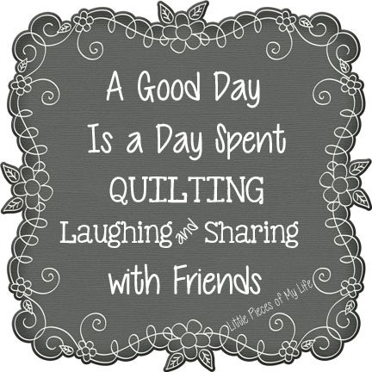
Advertisements
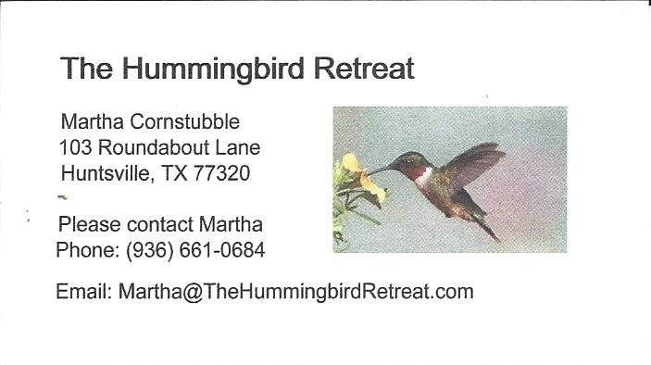
_{Newsletter ad prices are:}
$5.00 a month or $50.00 per year for a business card size advertisement.
$10.00 a month or $100.00 per year for a 3.5” x 4.5” size advertisement.
$18.00 a month or $180.00 per year for a one-half page advertisement.
$36.00 a month or $360.00 per year for a full page advertisement.
Member ads are free and will run for one month per request

_{Tall Pines Quilt Guild}
_{P.O. Box 7272}
_{Huntsville, Texas 77342-7272}

_{Tall Pines Quilt Guild Meeting} _{Guild Calendar Reminders}
You are invited to join us the first Monday of August 28, 2017, 6:30 PM Guild Meeting
each month. The guild has a variety of _{August 15, 2017 Charity Bee}
programs, nationally known speakers, _{Meeting Reminders}
_{workshop and charity projects.} _{Bring Show and Tell Items}
We meet at the University Heights Baptist Church _{Bring money for Food Bank}
_{2400 Sycamore Ave.} _{UPC Labels from Hobbs batting}
Park in the back lot off Palm Ave. _{FQ Bands from Fabric Carousel}
Refreshments are served at 6:30PM _{For Charity Bee}
and the meeting starts at 7 PM. Visit the web site @ www.tallpinesquiltguild.com

