April 2018 Whisperings from the
Tall Pines Quilt Guild
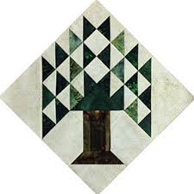

Upcoming Programs and Meetings
April 17th – Charity Bee
May 7th – Brenda Asmus – “Tips from My Template Workbox”

May Birthdays
5/7 Susan Montoya
5/9 Judy Oliver
5/9 Annemarie Hoffzimmer
5/9 Anetha Wylie
5/12 Patricia McCartney
5/13 Kathy Perry
5/14 Martha Wilson
5/18 Martha Hoover
5/20 Cheryl Rempel
5/27 Maggie Smith

Publisher: Diane Carrington Volume Number 107 Issue Number 106
From the President
What a wonderful meeting we had Monday night! The food was good, the lecture was great and all the quilts were beautiful. I hope all that took the workshop enjoyed their time sewing. The next event we have coming up is the Walker County Fair. The quilts will be turned in before you get this newsletter but be sure and come out to the fairgrounds to view the quilts that were made by our talented guild members and others. From what I saw being turned in Friday, it is going to be a great show with lots of competition. Please be sure to volunteer to sit with the quilts during the week. The show can't go on without all your participation.

One event we are considering participating in is the Sam Houston Folk Festival. Helen Belcher has mentioned that people are always wanting to buy handmade items. We thought we could have mini quilts or doll quilts there to sell. These can be made mostly from scraps (I am sure we all have a lot of these). What do you think?

In July, we will be showcasing our next donation quilt. The top is finished and is at the Quilters. We will be selling donation quilt tickets at the Shop Hop at the Walker County Fairgrounds in July. Patricia McCartney needs volunteers to help out at the show. There will be lots of vendors to buy fabric and supplies that we just have to have.

Until next month,

Martha Wilson

Sunshine and Shadows
We would like to ask for prayers for Janis Voldbakken who is breast cancer surgery. Also for Kristie. Munson who lost their home during the storm several weeks ago, and for Jammie Ackley for the loss of her mother. Please contact me or Ruth West by email or phone. Betty Gratz lobag1961@gmail.com, 936-438_0465: Ruth West quilter rrw@live.com, 847-638-3899

Treasurer’s Report
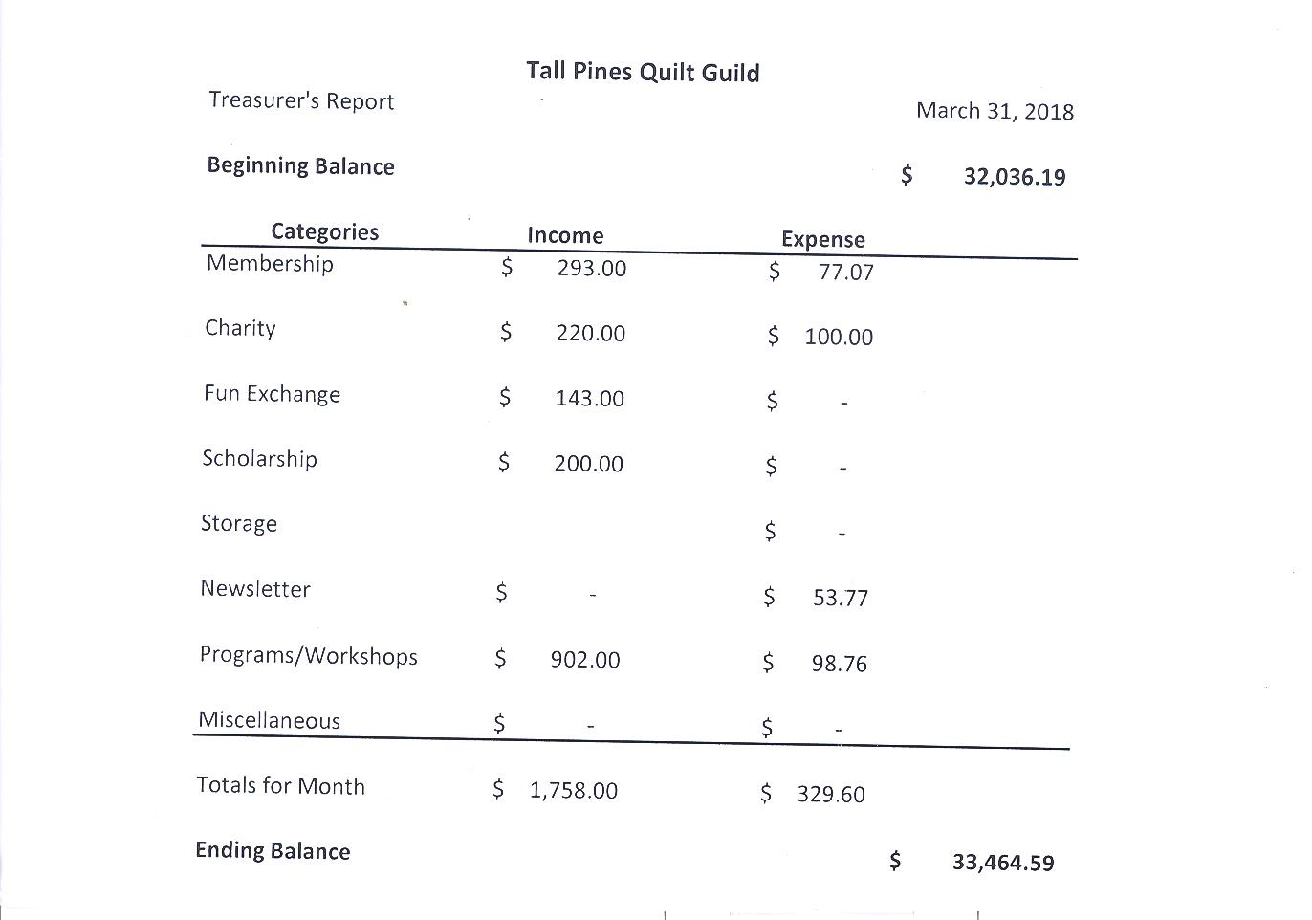

Tall Pines Quilt Guild Minutes of Meeting
Tall Pines Quilt Guild
Meeting Minutes
April 2, 2018
University Heights Baptist Church

President Martha Wilson called the meeting to order, welcomed members and guests and recognized April birthdays.

Minutes from the March meeting were printed in the newsletter. There was one correction. The judging of the quilts at the fair will be held on Monday, not Sunday as printed in the newsletter. D-Ann Gilmore made the motion to accept, seconded by Janis Voldbakken. , motion passed.

Treasurer’s reports were available on the back table.

Toni Bruner reported that the Veteran’s Muster Festival was a huge success. There were approximately 25 quilts on display and 30 mini quilts for the silent auction. Raffle tickets were sold and the silent auction netted about $1200. Thanks to all who donated and worked.

Helen Belcher still needs volunteers to quilt sit during the Walker County Fair. Volunteer pins can be picked up at Fabric Carousel which will ensure free entry to the fair on the day/evening that you volunteer. Quilts need to be turned in to Fabric Carousel on Friday, April 6th between 11 am and 5 pm.

Diane Carrington expressed her appreciation to all who helped in any way with the pineapple raffle quilt. She recognized all who had a part in it and presented D-Ann Gilmore with a pineapple and gift certificate for all that she did as her partner. She showed the finished quilt top which will be quilted by Lynda Muzyka and bound by Melanie Burleson.

The East Texas Thimble Trail Shop Hop will be held on July 13th and 14th at the Walker County Fairgrounds. The guild will have a booth in exchange for helping Patricia with the event. Items from storage will be sold along with any small items made by members. The raffle quilt will be on display and tickets will be for sale.

Door prizes were awarded.

D-Ann Gilmore gave a report on upcoming programs and introduced Shannon Brinkley who presented a wonderful program on Scrappy Applique. A workshop will be held tomorrow.

Fun Fund drawing was held.

Cathy Wilson reported that there were 64 members present tonight and 2 new members.

Robin Rodriquez reported that $58 was collected for the food bank and a private donation of $240 was received. The next Charity Bee meeting will be Tuesday, April 17th at 9:30 am at Fabric Carousel. Cut-ups is held on the second and fourth Friday at 10 am at Fabric Carousel.

Deadline to get information into the newsletter is Friday, April 6th at noon.

Show & Tell was held, hosted by Kelli Langley.

Executive Board meeting for April will be held on April 9, 2018 at 5:30 pm at Fabric Carousel.

There being no further business, the meeting was adjourned.

Quilting is sew pieceful,
Elaine Robinson, Secretary

Programs Updates
TALL PINES QUILT GUILD 2018 PROGRAMS
D-Ann Gilmore, Program Chairman
May 7 – Brenda Asmus certified teacher for Marti Michell will give a lecture on “Tips from My Template Workbox” followed by a workshop on quick log cabin blocks using only 4 fat quarters.
June 4-5 – Cindy Needham, a nationally known speaker, will give a fabulous program entitled “For the Love of Linens”. Take this opportunity to take her 2-day workshop on Heirloom Feathers and Backgrounds. Payment for the 2-day workshop on Monday and Tuesday needs to be made by the May meeting, after that date we will contact those on the waiting list.
July 2 – Winnie Fleming will present a program called Stars and Scrap Exchange. Her workshop the following day is a Lone Star Table Runner where we will learn how to make perfect stars without cutting off the points.
August 6 – Peggy Richards is an award-winning quilter whose trunk show will take your breath away.
August 27 – Patti Nethery will give us a demonstration of her rulers entitled Piecing the Ruler Revolution Way along with a trunk show of her beautiful quilts.
October 1 – Open to suggestions
November 5 – UFO Challenge
December 5 – Christmas party

Membership Update
As of the April meeting, we currently have 108 members in the guild. There were 66 people in attendance at Monday's meeting including two new members. Please join me in welcoming our newest members, Wendy Salsbery and Diane Roma'n!!

Wendy Salsbery
121 Brookside Dr
Huntsville, 77320
Cell: 270-670-9707
Email: ufoquiltersos@live.com
BD: June 5

Diane Roma'n
21 Rose Hill Ct.
Huntsville, 77320
Cell: 916-340-4818
Email: dromanphd@gmail.com
BD: Aug 20
Spouse: Rene'

2018 SCHOLARSHIP:

This year the TPQG Board voted to award a $1,500 scholarship to a graduating senior (public, private or home school) residing within our membership area in the categories of “Proficiency in Sewing” OR “Intention to Major in Math Education”. Scholarship applications have been forwarded to all 19 high schools who service our membership area and should be available on the campus websites or in the counselors’ office. We are trying to reach the Home School seniors as well so if you know of someone who might qualify or have a contact person that can help us in disseminating the information, please let me know. Scholarship applications are available for download on our website www.tallpinesquiltguild.com tab ABOUT US/lower right corner – Scholarships. Deadline for submission is May 12, 2018. The winner will be announced at our June meeting. Also, a reminder, two large memorial donations have been made to our scholarship fund already this year by Doris Collins - for Judy Moorer’s husband and son, and for Melanie Burleson’s mother. If further contributions are made, we may be able to offer a second scholarship this year. If you would like information either about the scholarship application or memorial donations, please feel free to contact me. Judith Oliver, 2018 Scholarship Chairman – judith-oliver@sbcglobal.net or 936 439-0980.

MEALS ON WHEELS CHRISTMAS PROJECT UPDATE

I just wanted to share with you an example of how much our Christmas stocking & ornament project meant to the recipients of our local Meals on Wheels friends. Last week I delivered Meals and was pleasantly surprised to find one of our Christmas stockings hanging on the inside door of a man’s apartment. The man is confined to a wheelchair, so his movements are limited. His caregiver told me that he wanted it hung there so he could appreciate it every day. It brought tears to my eyes because our “stocking” meant so much to him. Another home had our 2016 Christmas tree ornament hung on the bulletin board. Just wanted you ladies to know that all your hard work IS appreciated. Thank you for your support of this worthy project for the seniors of our community. Judith Oliver/Judy Springer – Co-chairmen.

Door Prizes
Book, Tea Towels and Applique – Diane Roma’n
Book, Tea Towel and Applique – Annemarie Hoffzimmer
Book and Charm pack – Alisa Willson
Show and Tell
1. Jean Bradley – Sweethearts
2. Helen Belcher – Two Embroidered Small Quilts
3. Grace Burzywski – Mom’s Quilt
4. D-Ann Gilmore – Charity quilt and Elephant Pillow
5. Elaine Robinson – Crochet Barbie Dress
6. Annemarie Hoffzimmer – Texas Flag Mini Quilt
7. Virginia Cooper – American Flag Quilt
8. Liz William – Quilts Across Texas, IPad Case, Sparrow Felted, Bayeux Tapestry, Purse
9. D-Ann’s Class – Completed Double Wide Dresden quilts and table runners
Bee News
Charity Bee
The next Charity Bee meeting will be Tuesday, April 17, beginning at 9:30 am at Fabric Carousel (FC). Come have some fun while serving our community with our charitable projects! At the April guild meeting, $58 was collected for the Good Shepherd Food Bank!! Great job! This brings the YTD total to $190.00!! Thank you to the ladies who took one or two of the HUGs I brought to the April meeting. There are many more pinned HUGs at FC waiting for quilting. Also, there are many more of the Handiquilter already quilted HUGs ready for applique and binding. I can see that the scrappy applique technique that was presented at the guild meeting would be precious on those Handiquilter HUGs. And thank you for all who have donated and plan to donate the Fabric Carousel fat quarter wrappers, as well as the Hobbs Batting UPC labels. Every one helps!!

Cut-ups
Cut Ups will meet on the 2nd and 4th Friday each month at the Fabric Carousel. All are Welcome. Bring your quilting problems for lots of advice and help from your friends. Bee starts around 10 and lasts all day.
Embroidery Bee
We meet on the third Saturday of the month at 11 AM, at the Ohendalski building, next door to the Chicken place across from the mall. 1425 Brazos Dr. Contact Susan Craig for info. 436-1489

Donation Quilt
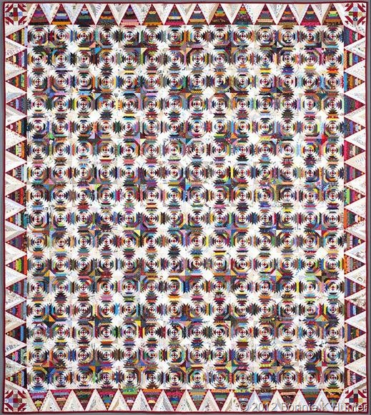
The top is done!!! Thank you so much to all that worked on the top. This was truly a group effort. On to Lynda for quilting. Thanks again.

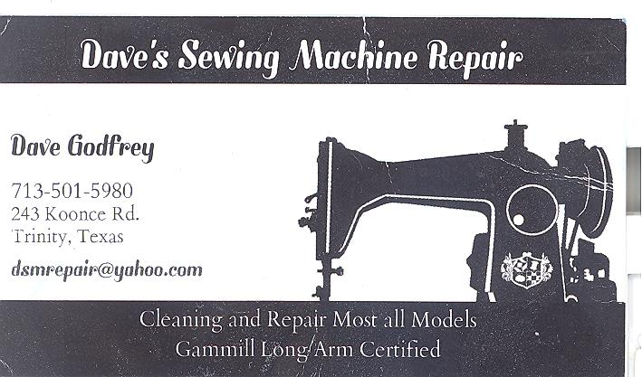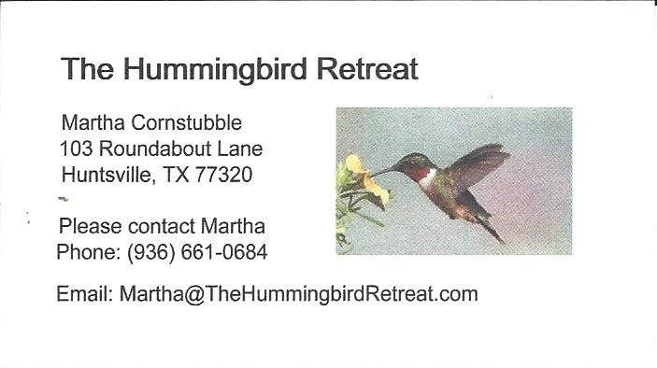
_{Newsletter ad prices are:}
$5.00 a month or $50.00 per year for a business card size advertisement.
$10.00 a month or $100.00 per year for a 3.5” x 4.5” size advertisement.
$18.00 a month or $180.00 per year for a one-half page advertisement.
$36.00 a month or $360.00 per year for a full page advertisement.
Member ads are free and will run for one month per request

_{Tall Pines Quilt Guild}
_{P.O. Box 7272}
_{Huntsville, Texas 77342-7272}

_{Tall Pines Quilt Guild Meeting} _{Guild Calendar Reminders}
You are invited to join us the first Monday of May 7,, 2018, 6:30 PM Guild Meeting
each month. The guild has a variety of _{April 17, 2018 Charity Bee}
programs, nationally known speakers, _{Meeting Reminders}
_{workshop and charity projects.} _{Bring Show and Tell Items}
We meet at the University Heights Baptist Church _{Bring money for Food Bank}
_{2400 Sycamore Ave.} _{UPC Labels from Hobbs batting}
Park in the back lot off Palm Ave. _{FQ Bands from Fabric Carousel}
Refreshments are served at 6:30PM _{For Charity Bee}
and the meeting starts at 7 PM. Visit the web site @ www.tallpinesquiltguild.com
