April 2017 Whisperings from the
Tall Pines Quilt Guild
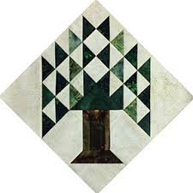

Upcoming Programs and Meetings
May - Planning for Airing of the Quilts
May 6th – Airing of the Quilts
June – Lisa Erlandson - Making Your Best Quilt

May Birthdays
5/7 Susan Montoya
5/9 Judy Oliver
5/9 Anetha Wylie
5/12 Patricia McCartney
5/14 Martha Wilson
5/18 Martha Hoover
5/20 Cheryl Rempel
5/27 Maggie Smith

Publisher: Diane Carrington Volume Number 96 Issue Number 95
From the President
Greetings Talented Quilters!
Congratulations to all of you who entered a quilt in the Walker County Fair quilt show. All of them are just beautiful. A special congratulations to all of you who won a ribbon. Your hard work and talent was very visible in these beautiful quilts. What was exciting for me to see is so many first time guild members who entered a quilt. Keep up the good work!.
Thank you so much to Helen Belcher who has been chairman of this event for 11 years. We so appreciate all your hard work. We put on a show that the community can be proud of. My only regret is that so many of you live out of the county and are not able to enter your beautiful quilts. A very special thank you to Doris Collins and Fabric Carousel for sponsoring this event. We definitely would not have it if it weren't for you. Thank you for your generosity and most important your dedication to our guild and the continuation of these types of events.
Thank all of you for your attendance at the guild meeting last Monday night. I know it was not the most educational or entertaining guild meeting. But all the details of the airing of the quilt must be worked out at our meetings. I encourage all of you to continue on with your appointed duties and finish strong! Me included! Let's put on a show that we can be proud of!
Just a reminder of the brief board meeting and airing meeting this Monday night April 10. If we have a good attendance and get everything ironed out this could be our last major meeting. We will be meeting at 5:30 at the Legacy Group building. This is across the street from the compass Bank. It is on Brazos Drive.
See you soon!
Kay Ohendalski, President

County Fair
Thank you all for your support of the 2017 Walker County Fair Quilt Show. Hope you got a chance to view the fifty-five beautiful quilts displayed this week and got some inspiration for a quilt for next year. There was a wonderful variety of styles represented from hand quilted to hand and machine embroidered to applique. There were traditional patterns, contemporary, art and just unbelievable quilts. Visitors at the Fair had great comments and some wanted to purchase the quilts!!!! They were invited to come to the Airing and see if their favorite quilt was on sale.

Congratulations to Grettle Payne for her Best of Show and Donna Hoffman for Judge’s Choice, both outstanding quilts! Some categories were divided between owner quilted and professional quilted this year which was a recommendation from last year’s show. There should be a list of the winners in all categories on the Fair website and there is one available at Fabric Carousel.

Fabric Carousel, Doris and Karl Collins are fantastic supporters of the show. Their time, use of the Class Room at the Carousel, judges and the awards make a great show each year. Thanks to the Sunday morning hanging crew and to all the quilt sitters during the week. David and Grettle Payne are so good to bring the LDS missionaries to take down the show on Saturday morning. Thanks again to each of you for your continued support. Remember to start working on your entry for 2018!
2017 Walker County Fair Quilt Show
All Categories

Best of Show Grettle Payne A Touch of Red
Judges Choice Donna Hoffman Irish Chain

Judging Categories
Junior Entries
1st Place Victoria Bounds Autumn Bloom (wreath)
2nd Place Victoria Bounds Zig-Zagging Your Way to Christmas
Mini Quilt
1st Place Helen Belcher Pinwheel Flowers
2nd Place Susan Craig Centennial
3rd Place Dorothy Wolverton Purple Pinwheels
Small Wall Quilts 44”-66”
1st Place Ann Moore Jean Ann’s Garden
2nd Place Kay Ohendalski Flower Power
3rd Place Dorothy Wolverton Starshine
Grettle Payne Fall Leftovers
Virginia Wilson Town Square Rose Garden
Cindy Rohe ‘Tis the Season
Medium Wall Quilts 84”-107”
1st Place Judy Springer Scrappy Stars
2nd Place Helen Belcher Civil War Stars
3rd Place Susan Craig Berry Pickin’
Betty Bell Patriotic
Dorothy Wolverton Baby Spiderweb
Small Hand Embroidered
1st Place Kay Ohendalski Teapots
2nd Place Diane Carrington Esther’s Garden
3rd Place Diane Carrington Essie’s China
Diane Carrington S is for Snowman
Helen Belcher Feathers and Flora
Small Quilts/Quilted by Owner
1st Place Ann Moore Big Sky
2nd Place Ann Moore Red Bloomers
3rd Place Susan Craig Tutti-Fruitee Pineapple Parfait
Diane Carrington OMG
Tasha Fry Feline Frenzy
Susan Montoya Lonestar Fiesta
Susan Montoya Carnavale de Flores
Virginia Wilson All Things Grow with Love
Virginia Wilson The Big House
Small Quilts/Professional Quilted
1st Place Judy Springer Autumn Sampler
2nd Place Martha Wilson Barn Star
3rd Place Dorothy Wolverton Sticks and Stones
Grettle Payne Snowballs for Mickey
Ruby Driver/Virginia Cooper Midnight Blues
Martha Wilson Barn Raising
Large Quilts/Hand Quilted
1st Place Donna Hoffman Irish Chain
2nd Place Cheryl Kelley Wacky Nine Patch Has the Blues
3rd Place Elaine Robinson Crackerbox
Elaine Robinson Braid in a Day
Elaine Robinson Cotton Candy
Large Quilts/Quilted by Owner
1st Place Janis Voldbakken Scrappy Kaleidoscope
2nd Place Virginia Wilson Little Big Town
3rd Place Elaine Robinson Dresden Star
Virginia Cooper Ruby’s Bugs
Janis Voldbakken That Town and County Quilt
Janis Voldbakken Prairie Wagon Wheels
Large Quilts/Professionally Quilted
1st Place Grettle Payne A Touch of Red
2nd Place Dorothy Wolverton Roll, Roll, Cotton Boll
3rd Place Toni Bruner Sadie’s Camp Shirts
Debbie Birdwell Birthday
Randi Clower Feelin’ Groovy
Virginia Cooper Spring’s Hope
Grettle Payne Fall in Vermont
Becky Nicholas The Bull
Airing News
Airing General Store
If anyone wants to sell items in the General Store at Airing of the Quilts, you can pick up the forms at Fabric Carousel. They are in the classroom area, right inside the door. Green forms are for member sales. Please have your inventory sheet to me by April 28th. I will need to know what is needed to display and how many more tables I may need.

If anyone has items they are making for the Guild, please have them to the Fabric Carousel by 4/28 so that we can get them priced.

Thank you!

Airing of the Quilts Silent Auction
This year we are having other items besides the miniature quilts in the silent auction. We will have a couple of larger quilts and several baskets of sewing notions and supplies. If you have a unique item that you would like to donate, please bring it to the next meeting or leave it at Fabric Carousel.
Airing of the Quilts is fast approaching. We need to have at least 50 miniature quilts for the Silent Auction. It has always been a terrific fund raiser. This year miniature quilts can be up to 24” x 24”. They must have a hanging sleeve and a label. Please turn in your entries at the next meeting or at Fabric Carousel. The deadline for miniature quilt turn in is April 29th. Your name will be entered in a drawing for a $25.00 gift certificate to Fabric Carousel for each entry. Miniature quilts are donated to Tall Pines Quilt Guild with all proceeds benefitting the guild. JUDY SPRINGER 936-661-8126

Sunshine and Shadows
Our contact info is Betty Grantz phone # 936-438-0465, email lobag1961@gmail.com or Ruth West 847-638-3899, email quilterrw@livecom. We are looking forward to hearing about your Sunshine and Shadows.
Tall Pines Quilt Guild Minutes of Meeting
Tall Pines Quilt Guild
Meeting of Minutes
April 3, 2017
University Heights Baptist Church

President Kay Ohendalski called the meeting to order and welcomed members and guests. March
birthdays were recognized.
Minutes of the March meeting were printed in the newsletter. Betty Gratz made the motion to accept the minutes and Martha Wilson seconded the motion. The motion passed.
LouAnn Nichols sold tickets for the Conroe Golden Needle Quilt Guild donation quilt.
Robin Rodriquez gave an update on Charity Bee. She has made a delivery of bibs to PCC. The next Charity Bee will be Tuesday, April 18. Elaine Robinson and Cathy Wilson shared their completed hugs and blankets. Becky Hernandez spoke about Wilderness Ministries and Won without Borders in Haiti. They need seamstresses to sew diapers out of towels. We will look into doing a diaper making workshop some time after the Airing.
Doris Collins announced the results from the Walker County Fair quilt judging. There were 55 quilts entered this year. The raffle quilt will be at the fair all day Thursday.
Tonight, our focus was on Airing of the Quilts planning. Kay Ohendalski discussed logistics. Flyers and rack cards are available to take to businesses. Also, this year new yard signs were bought for advertising the Airing around town. A sheet went around for signing up to helping put out signs and to suggest street corners to post signs.
Martha Wilson brought projects that need to be completed for the general store. DeAnn has made mini design boards in different sizes for sale. Green forms were available tonight to be filled out and turned in with an inventory list for those wishing to sell their own items.
Maggie went over the sign-up sheets and there are still places that need to be filled.
Judy Springer reported 36 mini quilts have been turned in for the silent auction. Her goal is to have 50, so there is still time to finish them up and have them turned in by April 29 to Fabric Carousel.
Donations of cases of water can be brought to Fabric Carousel classroom on quilt check-in day, April 29, or after.
If you are selling quilts fill out the form and have it ready to turn in with your quilt(s) the morning of the Airing. Unsold quilts will need to be picked up the same day.
Let Lynda Muzyka know how many tables and chairs you will need for your area.
Everyone is encouraged to attend the Airing meeting Monday, April 10, at 5:30 at the Legacy Group building.
D-Ann Gilmore updated our upcoming programs. June’s program will be Lisa Erlandson with a workshop the following Tuesday. August will be the redwork workshop; and the T-shirt quilt lecture and workshop has been moved to October.
Door prize winners were Diane Harris, Barbara Pearson, and Jean Bradley. Fun exchange winners were Betty Gratz, Martha Fielder, and Rennie Bauer.
Show and tell was held.
There being no further business the meeting was adjourned.
Respectfully Submitted,
Secretary, Cheryl Rempel
Program Report
D-Ann​ ​Gilmore,​ ​Program​ ​Chairman
May​ ​-​ ​​ ​​Planning​ ​for​ ​Airing​ ​of​ ​the​ ​Quilts,​ ​May​ ​6​^{th​}.
June ​– Lisa Erlandson - Making Your Best Quilt, followed by a workshop the next day entitled
Kansas​ ​City​ ​Stars.
August ​– Rosie deLeon McCrady - “Redwork Through the Years”, a history of redwork as well as
a variety of vintage and new quilts. Workshop the next day with a $25 kit fee that includes
everything​ ​you’ll​ ​need​ ​but​ ​a​ ​pair​ ​of​ ​scissors​ ​and​ ​a​ ​thimble​ ​if​ ​you​ ​use​ ​one.
October - Karen Dupont and Kim Phillips - T-shirt quilt lecture, followed by a workshop the next
day.

Treasurer’s Report
Tall Pines Quilt Guild
Treasurer's Report |  |  |  | March 31, 2017
Beginning Balance |  |  |  |  | $ 23,710.50
Categories |  | Income |  | Expense
Membership |  | $ 369.30 |  | $ 151.53
Charity |  | $ - |  | $ 293.84
Fun Exchange |  | $ 137.00 |  | $ -
Hospitality |  | $ - |  | $ -
Newsletter |  |  |  | $ 14.40
Programs |  | $ - |  | $ 271.40
Donation Quilt |  | $ 383.00 |  | $ -
T-shirts for Airing |  | $ 340.00 |  | $ -
Airing |  | $ 356.00 |  | $ 256.80
Donation |  | $ 1,000.00 |  | $ -
Auction Quilt |  | $ -
Sunshine & Shadows |  | $ - |  | $ 40.00
Totals for Month |  | $ 2,585.30 |  | $ 1,027.97
Ending Balance |  |  |  |  | $ 25,267.83

Show and Tell
- Batik Stars – Diane Harris
- Bibs and Dish cloths – Becki Marsh
- Queen quilt – Barbara Barnes

Door Prizes
- Coloring Book and Artist Pencils – Diane Harris
- America’s Best Quilting Projects – Barbara Pearson
- Debbie Mumm’s Country Quilts – Jean Bradley
Fun Exchange
- Tutto tote – Betty Gratz
- Sewing Caddy with book and notions – Martha Fielder
- Easter basket with patterns and notions – Rennie Bauer
Membership Updates
There were 60 members and 2 visitors present at the April meeting. We currently have 107 members in the guild. The membership roster has been updated on the guild website and any corrections to contact information will be made there. If you have not received your 2017 membership card, please let Cathy Wilson know.
Bee News
Charity Bee
Another outstanding donation to the Food Bank from the April guild meeting. $50.00!!! The next Charity Bee meeting will be Tuesday, April 18, beginning at 9:30 am at Fabric Carousel. (Hoping to have a treat for the ladies this time!) At the March meeting we focused on cutting kits. We got eleven done and ten were given to the home school sewing group at the request of Cary Brown. The sewing group girls range in age from about eleven on up. It will be interesting to see the tops returned!! (Cary said the sewing Moms would be there for assistance. Yay!) Becki Marsh has been busy making the cutest baby bibs. Most have been delivered already to the Pregnancy Care Center (PCC) and the number is approaching 100. Becki asked that a couple of super cute ones be included in the Airing sale. THANK YOU, BECKI!! Blanket, bib, and HUG deliveries are made to PCC throughout the year as they have a tremendous need. On that note, we hope that each guild member will find a little time to do just one HUG this year. (More would be great!) Any amount of construction would be appreciated. There is always a member who prefers to piece or to do binding, or whatever is needed. A reminder that a HUG column has been added to the guild meeting sign in sheet so that you may check off if you have worked on charity items in the past month. I hope we can see that column full each month!! We are in need of walker caddies which involves cutting the kits, or sewing them together. We have lots of walker caddie fabric just waiting for a "designer". We had a presentation by Becky Hernandez at the April meeting describing the diaper ministry her group is involved with, and that their biggest need is seamstresses to sew the diapers. They also need materials to make the diapers which includes old toweling and tee shirt fabric. If you would like to help in that ministry, contact Robin for more details or to donate the materials. They have a short deadline of September or October (the time in which the diapers will be delivered to Uganda). (Kay mentioned that we might be able to have a workshop sometime after the Airing to work on diapers for them.) And as always, Charity Bee collects Fabric Carousel fat quarter wrappers and Hobbs batting UPC labels. We look forward to seeing everyone at Charity Bee on the 18th! Any questions, call Robin Rodriquez or Susan Craig.
Cut-ups
Cut Ups will meet on the 2nd and 4th Friday each month at the Fabric Carousel. All are Welcome. Bring your quilting problems for lots of advice and help from your friends. Bee starts around 10 and lasts all day.
Embroidery Bee
We meet on the third Saturday of the month at 11 AM, at the Ohendalski building, next door to the Chicken place across from the mall. 1425 Brazos Dr. Contact Susan Craig for info. 436-1489
For Sale
FOR SALE:
KOALA CUB PLUS IV SEWING CABINET. American Birdseye Maple Finish, electric lift, leaf extension on back, Works great.
ALSO, KOALA ROLLABOUT PLUS IV STORAGE CABINET, matches other cabinet, 3 soft close drawers, leaf extension on back.
Both purchased new 2/1/14.
Selling because I have a new cabinet. Call or text for pictures, dimensions, price.
Mary Ellen Johnson
979-777-0189
Advertisements
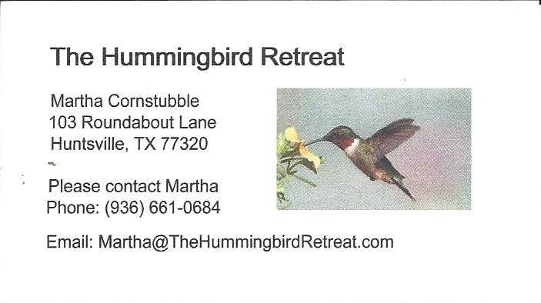
_{Newsletter ad prices are:}
$5.00 a month or $50.00 per year for a business card size advertisement.
$10.00 a month or $100.00 per year for a 3.5” x 4.5” size advertisement.
$18.00 a month or $180.00 per year for a one-half page advertisement.
$36.00 a month or $360.00 per year for a full page advertisement.
Member ads are free and will run for one month per request

Diane’s Tips and Grins
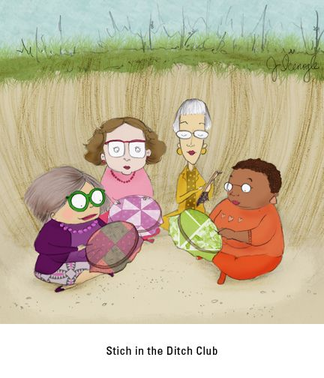

_{Talll Pines Quilt Guild}
_{P.O. Box 7272}
_{Huntsville, Texas 77342-7272}

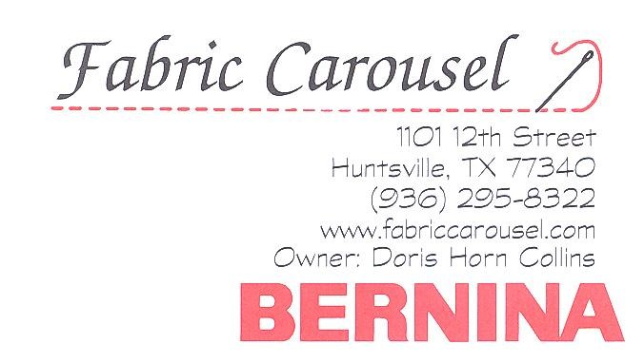

_{Tall Pines Quilt Guild Meeting} _{Guild Calendar Reminders}
You are invited to join us the first Monday of _{May 1st, 6:30 PM Guild Meeting}
each month. The guild has a variety of _{April 18th, Charity Bee}
programs, nationally known speakers, _{Meeting Reminders}
_{workshop and charity projects.} _{Bring Show and Tell Items}
We meet at the University Heights Baptist Church _{Bring money for Food Bank}
_{2400 Sycamore Ave.} _{UPC Labels from Hobbs batting}
Park in the back lot off Palm Ave. _{FQ Bands from Fabric Carousel}
Refreshments are served at 6:30PM _{For Charity Bee}
and the meeting starts at 7 PM. Visit the web site @ www.tallpinesquiltguild.com

