October 2018 Whisperings from the
Tall Pines Quilt Guild
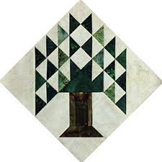

Upcoming Programs and Meetings
Don’t forget your bus money for the Quilt Show has to be in by October 15th.
November 5th –
UFO Challenge

November Birthdays
Donna Hoffman – 11/9
Kimberly Street – 11/13
Anne Barker – 11/18
Robin Rodriquez – 11/24
Liz Williams – 11/24
Julie Wood – 11/26
Kristie Munson – 11/29

Publisher: Diane Carrington Volume Number 113 Issue Number 112
From the President
Happy October!

Being from Tennessee, October always meant cooler temperatures and fall colors. Living in Texas, fall has a different meaning. International Quilt Festival, Fair on the Square and other fall events that still require shorts and short sleeves! And the humidity! I always thought my hair was straight, but not these days. But, I still love Texas and the warmer weather in the winter and almost no snow.

I REALLY enjoyed Rhonda Dort's lecture and trunk show on Monday night. I took some pictures and sent to my sister, Sylvia, in Tennessee - she enjoyed the show too. I also had the privilege of taking the workshop on Tuesday at Fabric Carousel. We all learned so much! You should have seen all the priceless linens, laces and doilies. Our group had some fabulous items and we bought more from Rhonda! Now, I just need to find the time to take what I learned and make it into a wall hanging.

Next up is International Quilt Festival in Houston on November 8th. If you haven't paid, you will need to get your payment to Dorothy Wolverton by the 15th of October in order to secure your seat on the bus. Before Festival on 11/5, our November meeting and the UFO challenge. Better get busy and sew!

Martha Wilson

Sunshine and Shadows
Jayne Richmond’s mom moved to Crockett and mom says it wonderful she is really happy with the move. Dorthy Wolverton had back surgery and doing real well. We were all happy to see her at the meeting. Keep the news coming. Ruth West and Betty Gratz
Treasurers Report
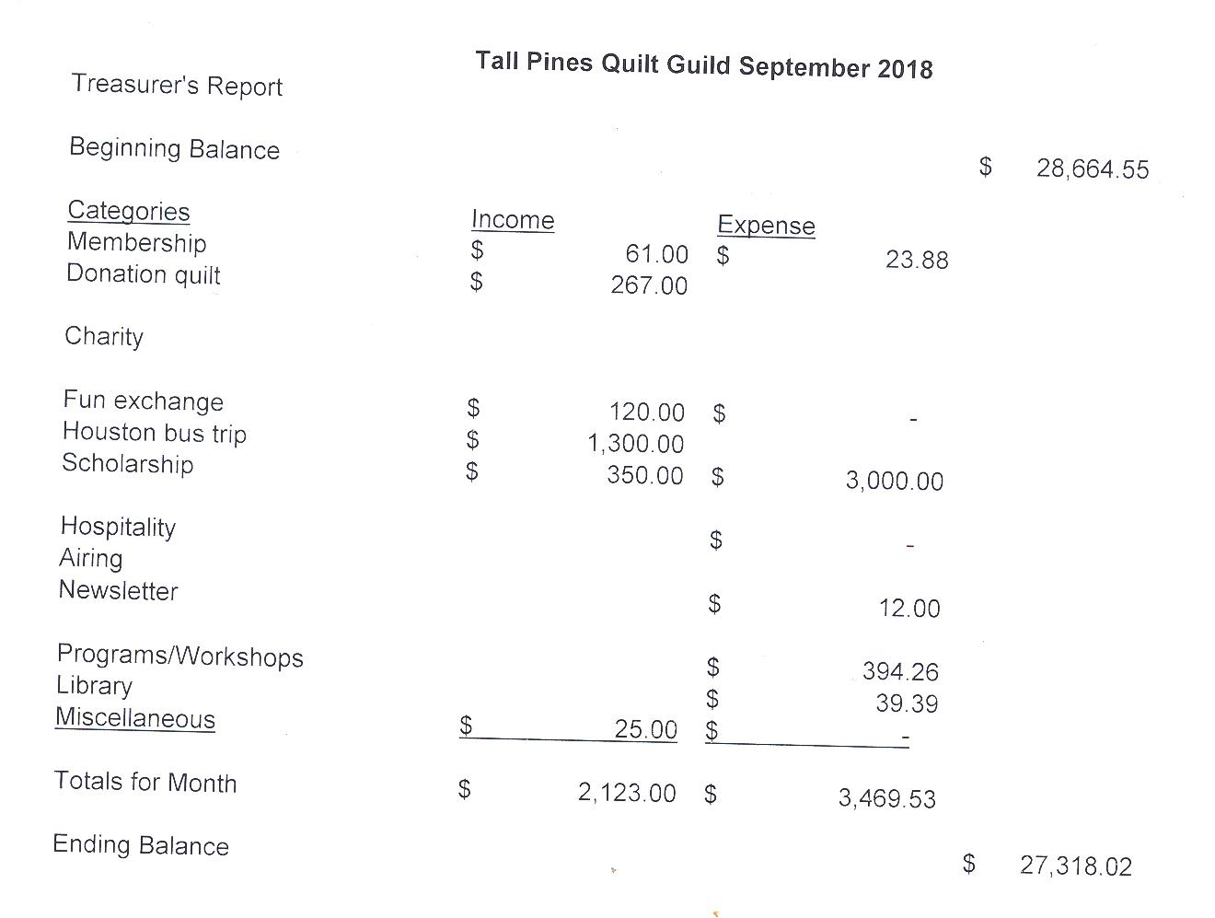
Tall Pines Quilt Guild Minutes of Meeting
Tall Pines Quilt Guild
Meeting Minutes
October 1, 2018
University Heights Baptist Church

President, Martha Wilson, called the meeting to order, welcomed members and guests and recognized October birthdays.

The August 27th minutes were printed in the newsletter. As there were no additions or corrections noted, Betty Gratz made a motion to accept the minutes as printed. Betty Bell seconded the motion. Motion passed.

Kay Ohendalski provided the treasurer’s report for members’ review. Any questions should be directed to Kay.

Rhonda Lynch is heading up the young girls’ sewing group at Fabric Carousel. They will be meeting once a month. There are 10-20 girls expected to participate. The girls will be participating in the Paducah Block Challenge for Young Girls. Anyone wishing to donate basic sewing supplies to be made into kits to give to the girls are encouraged to do so. Sign-up sheets are available for anyone who would like to help at the meetings.

The West Houston Quilt Guild sold tickets for their raffle quilt. The winning ticket will be drawn at their show in March.

Tickets are available to sell for the raffle quilt. All members are encouraged to get tickets from Doris Collins.

Doris Collins has offered the front portion of her classroom area to sell raffle tickets and other items during Fair on the Square on October 6th. There is a sign up sheet available as volunteers will be needed to oversee the sales. If members would like to sell something for themselves, let Martha know so space can be available. If you plan on selling personal items, please be sure to volunteer to work.

Tickets for the bus trip to the International Quilt Festival in Houston, on November 8th, are $50. Payment must be made by October 15th to reserve your seat. There are currently 5 seats available. Direct questions to Dorothy Wolverton.

Someone, or a group, is needed to head up the Airing of the Quilts show in May, 2019.

The next Charity Bee will be held on October 16th at Fabric Carousel. The November bee will be the last one for 2018. Members are encouraged to finish one (or more) quilts next year.

Door prize and Fun Fund drawings were held. Congratulations winners.

- Ann Gilmore gave an update on upcoming programs and also reviewed the rules for the 2019 UFO Challenge which will begin in December of 2018. Forms were available for anyone who wants to participate. Forms need to be turned in prior to the December meeting.

Tonight’s presenter was Rhonda Dort, featuring 30 of her quilts, most made from antique linens. A workshop will be held on Tuesday.

Kelli Anne Langley hosted Show and Tell.

The next Executive Board meeting for all officers and committee chairs will be October 8, 2018, at 5:30 PM at Fabric Carousel. Anyone is welcome to attend.

There being no further business, the meeting was adjourned.
It’s Sew Easy to be Creative,
Elaine Robinson, Secretary

Programs Updates
TALL PINES QUILT GUILD 2018-2019 PROGRAMS
D-Ann Gilmore, Program Chairman
November 5 – UFO Challenge. Bring finished projects you listed earlier this year for a special show and tell and a chance to win a prize for completing your challenges.

December 5 – Christmas party and making gifts for Meals on Wheels.

January 7 – Jackie Hillman will give a slideshow presentation and trunk show entitled the “Goose is Loose on the Ranch” followed by a workshop the next day using flying geese in unusual arrangements to make a table runner.

February 4 – Pregnancy Care baby shower

March 4 – A Block by Any Other Name will be the program by Mary Anne Fay from Fat Quarter Café. Mary Ann will discuss the different names that have been given blocks. At the workshop we will take our scraps and make blocks that free us from trying to be perfect.

April 1 – Dena Rosenberg will give a trunk show followed by a workshop the next day making the pattern Seven Sisters.

May 6 – Sherry Mark with Loft Supply will give a presentation on the importance of the batting you use in your quilt and the various choices you have available.

June 3-4 – Debby Walters and her daughter Kim Buchmann will give us a mother daughter trunk show from the many quilts they have made over the years. There will be a 2-day workshop on Designing with Strips and Curves using Louisa L. Smith’s templates.

Members
There are currently 118 members in the guild. At the October 1st meeting, we had 53 members and 11 visitors. Several of the visitors expressed interest in joining next year! I will begin collecting dues for 2019 at the December meeting.
Door Prizes:
- Pattern, Notebook, and Phone Lounger – Diane Carrington
- Pattern, Stickers and Clipboard – Rory Ross
- Ruler and Foundation Stencils – Cathy Steinback

Fun Exchange:
- 3 yards of Christmas Fabric – Melanie Burleson (donated by Cathy Steinbach)
- Layer cake and 5 Coordinates – Cathy Wilson
- 2 Halloween Patterns – D-Ann Gilmore
- Christmas pattern and Tablerunner Kit – Ruth West

Show and Tell
- Virginia Wilson – travel bags and 4 quilts
- Ann Moore – travel bags and 1 quilt
- Diane Carrington – baby quilt
- Barbara Pearson – 1 star quilt
- Rory Ross, Tasha Fry and Diane Roman – Rag bowls
- Virginia Cooper – mug rugs
- Robin, Lynda, and Susan – BGB Bags
- Mariette Curnutt – table runner and queen quilt
- Grace Burzynski – Bag
- Nancy Nelson – 1 baby quilts and 1 Texas quilt
- D-Ann Gilmore – Party table runner, Pink Dresden plate quilt, Redwork quilts, Four-by-four redwork quilt
- Elaine Eakin – Make-up travel bag, Scarf bib
- Dorothy Wolverton – Reproduction 9-Patch quilt, Tulip tablerunner, Sherbert Confetti lap quilt and 2 pillowcases
- Wendy Salsbery – 2 Halloween wallhangings
- Judy Springer – 3 Charity quilts made by Kay Hawkins
Bee News
Charity Bee
Donations to the Good Shepherd Food Bank at the October 2018 guild meeting were $37! The next Charity Bee meeting will be October 16, 2018 at 9:30 at Fabric Carousel. We have only two remaining Bee meetings for this year (Oct & Nov), so if you are working on HUGs and want them in the count for this year, please get them in by the November Bee meeting. There are a few pinned HUGs in the laundry basket at Carousel if anyone needs one to do!! As always, we appreciate so much your efforts for making this year's counts as high as possible.

Cut-ups
Cut Ups will meet on the 2nd and 4th Friday each month at the Fabric Carousel. All are Welcome. Bring your quilting problems for lots of advice and help from your friends. Bee starts around 10 and lasts all day.
Embroidery Bee
We meet on the third Saturday of the month at 11 AM, at the Ohendalski building, next door to the Chicken place across from the mall. 1425 Brazos Dr. Contact Susan Craig for info. 436-1489

Diane’s Tips and Grins

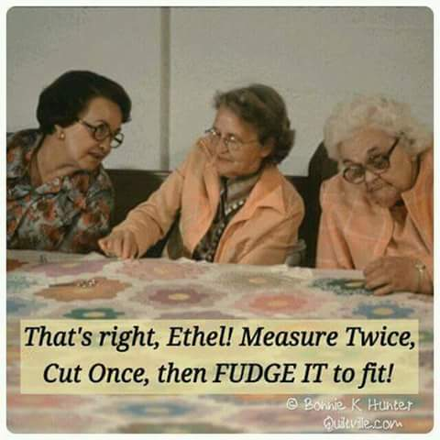

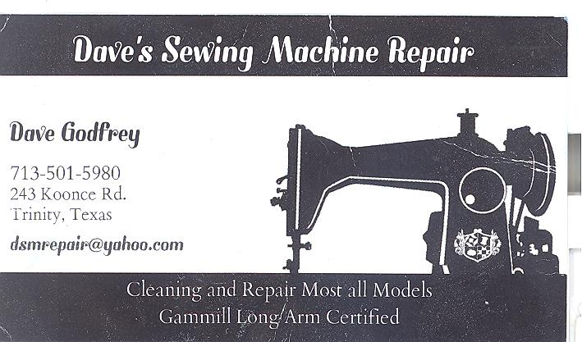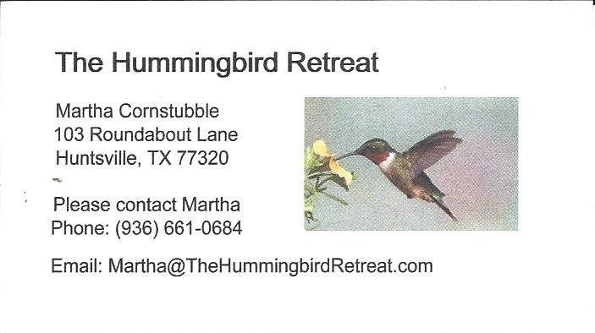
_{Newsletter ad prices are:}
$5.00 a month or $50.00 per year for a business card size advertisement.
$10.00 a month or $100.00 per year for a 3.5” x 4.5” size advertisement.
$18.00 a month or $180.00 per year for a one-half page advertisement.
$36.00 a month or $360.00 per year for a full page advertisement.
Member ads are free and will run for one month per request

_{Tall Pines Quilt Guild}
_{P.O. Box 7272}
_{Huntsville, Texas 77342-7272}

_{Tall Pines Quilt Guild Meeting} _{Guild Calendar Reminders}
You are invited to join us the first Monday of November 5, 2018, 6:30 PM Guild Meeting
each month. The guild has a variety of _{October 16, 2018 Charity Bee}
programs, nationally known speakers, _{Meeting Reminders:}
_{workshop and charity projects.} _{Bring Show and Tell Items}
We meet at the University Heights Baptist Church _{Bring money for Food Bank}
_{2400 Sycamore Ave.} _{UPC Labels from Hobbs batting}
Park in the back lot off Palm Ave. _{FQ Bands from Fabric Carousel}
Refreshments are served at 6:30PM _{For Charity Bee}
and the meeting starts at 7 PM. Visit the web site @ www.tallpinesquiltguild.com
