February 2019 Whisperings from the
Tall Pines Quilt Guild
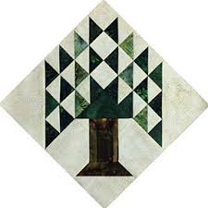

Upcoming Programs and Meetings
February 19th – Charity Bee
March 4th – Meeting
Dr. Maggie McGuire
Feed Sacks and Chicken Linen

March Birthdays

Doris Collins 3/5
Carole Boney 3/14
Catherine Weston 3/14
Susan Craig 3/18
Grettle Payne 3/21
Kimberly Carney 3/24
Pam Ray 3/28
Barbara Flebbe 3/29
Kay Ohendalski 3/29

Publisher: Diane Carrington Volume Number 115 Issue Number 114
From the President
Greetings fellow quilters!

Happy Valentine's day to all of you, hope you get sweets from your sweetie! We have several events coming up in the next few months. First event will be the Mini-quilt show and Donation Quilt Sales on March 1st and 2nd at Fabric Carousel. Rory Ross has an article that will explain more about this event. We will be participating in the Veteran's Museum Muster that is being held March 30, 2019 and we will be hanging a quilt show at the Walker County Fair on March 24th. Since we won't be asking for help for the Airing this year, please pitch in and help out when you can.

It is always a joy to hear about the Pregnancy Care Center and all the good deeds they do for the Community. I am so glad we are able to help them with the annual Baby Shower and also by donating Hugs (small quilts) for new babies.

Martha Wilson

Veteran's Muster - March 30, 2019, 10:00 AM to 4:00 PM

Tall Pines Quilt Guild will be participating in the Veteran's Muster again this year. We will not be able to hang all the quilts like before, as our frames will be at the Walker County Fair Quilt Show. However, we will have a mini-quilt, table-runner, or small wall hanging silent auction to benefit the Museum. In return, the Museum is allowing us to present our Donation Quilt and sell tickets at the event. We are asking for members to donate a small quilt, mini-quilt, table-runners that can be used in the Silent Auction. Please be sure to attach your name to these when you turn them in because there will be prizes! One prize for the most donated and one prize will be drawn for all that donate a quilted item. We will need help that day to sell tickets and monitor the auction. There will be a sign-up sheet at the next meeting and then at Fabric Carousel. Any questions? Contact Martha Wilson.

Sunshine and Shadows
Congratulations to Grace Burzynskik, she is going to be a new grandma. Ruth West is celebrating her 50th Wedding Anniversary this month. Betty Gratz would like to thank everyone for all your thoughts and prayers. If you hear of any members in need of prayer or with happy events in their lives be sure to contact Betty Gratz or Ruth West

Treasurers Report
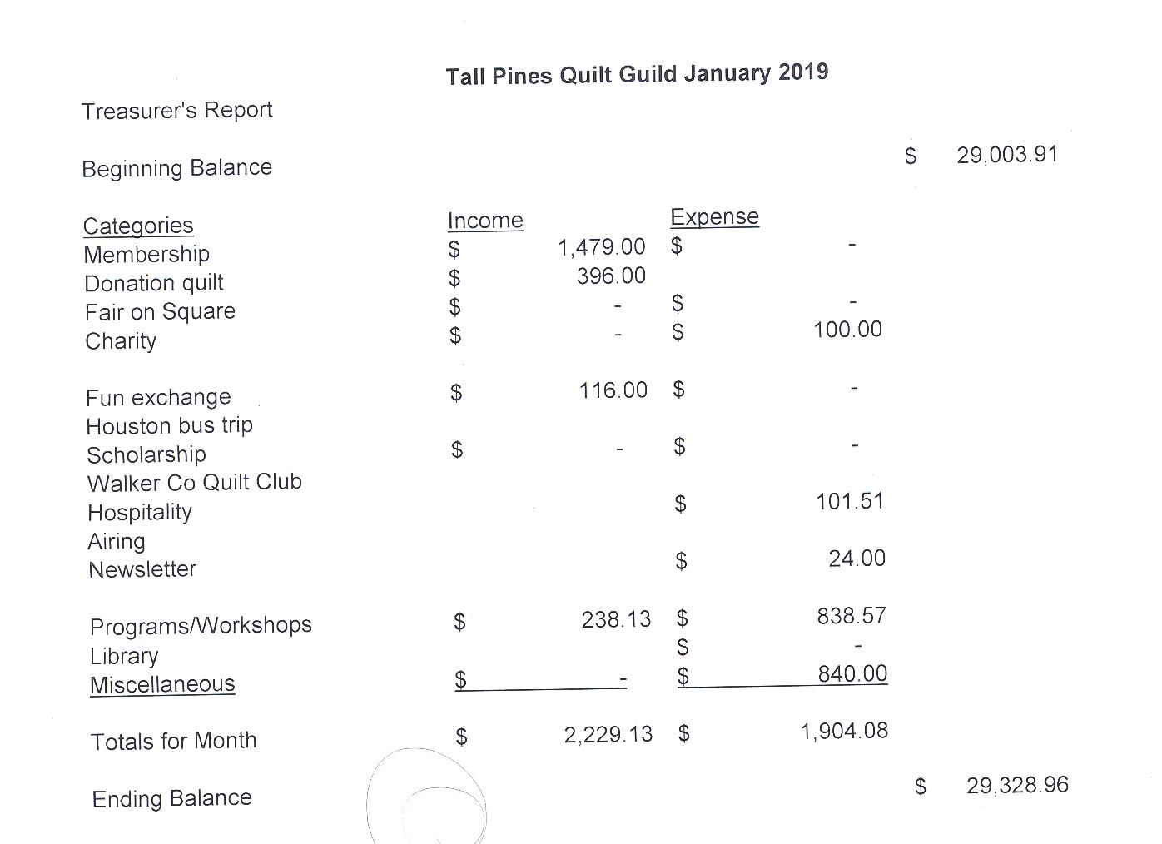

Tall Pines Quilt Guild Minutes of Meeting
Tall Pines Quilt Guild
Meeting Minutes
February 4, 2019
University Heights Baptist Church

President, Martha Wilson, called the meeting to order, welcomed members and guests and recognized February birthdays.

The January minutes were printed in the newsletter. , Janis Voldbakken made a motion to accept the minutes as printed. Kelli Anne Langley seconded the motion. Motion passed.

Installation of officers was held.

Kay Ohendalski provided the treasurer’s report for members’ review.

Rhonda Lynch announced that the girls will show their quilts at the Walker County Fair.

Cathy Wilson recognized one new member. Welcome!

There are four events coming up.
- ….Prison City Film Festival on Saturday March 2nd. Mini quilt show and donation quilt sales will be held at Fabric Carousel. Please bring any donations of mini quilts to Fabric Carousel by February 22nd.
- ….The Rusty Chippy show will be held on March 9th. Arrangements are pending as to whether we can display our donation quilt there and sell tickets.
- ….Donation quilt sales and mini quilt auction at the Veterans’ Muster on March 30th. Donations of mini quilts, small wall hangings, table runners are needed. Money raised from the sales of these items will benefit the museum. Please bring any donations to Fabric Carousel by March 22nd.
4 …Walker County Fair Quilt Show-headed up by Diane Carrington and Helen Belcher. Turn in quilts on March 22nd. Hanging of the quilts will be on March 24th and quilts will be taken down on March 30th. Please plan to pick up your quilts between 10-12 or make other arrangements.

There is still a need for someone to open and close the church on guild meeting nights. Two people are needed to set up and two to take down.

Charity Bee will be on February 19th. Embroidery Bee will be February 16th. Cut-Ups on February 22nd.

#1 was drawn for the UFO Challenge. These items need to be brought to the March meeting. D-Ann Gilmore gave a report on the upcoming programs and workshops.

This evening’s program was a baby shower for the Care Center. Kathy Hazlewood spoke about what is offered at the center and shared some stories of how appreciative clients are for the handmade items given to them that were made by guild members.

Door prizes were awarded and fun exchange tickets were drawn. Congratulations to the winners.

D-Ann Gilmore was named 2019 Quilt Angel. Congratulations D-Ann, well deserved!

Committee reports were given.

Kelli Anne Langley hosted Show and Tell.

The next Executive Board meeting for all officers and committee chairs will be February 11, 2019, at 5:30 PM at Fabric Carousel. Anyone is welcome to attend.

There being no further business, the meeting was adjourned. We are sewciopaths!!!!
Elaine Robinson, Secretary

Membership

We now have 130 members in the guild which may be a new record! That's the good news but unfortunately, 39 of those members have not yet renewed their membership in the guild. I know some of those have moved but that leaves many whose names will be removed from the new membership directory (which I'll be printing later this month) and who will no longer receive the newsletter. I will email reminders to those who haven't renewed yet. You can leave your dues with Doris at Fabric Carousel or mail them to me:
Cathy Wilson
29479 Red Top Rd,
Richards, TX 77873

At the February meeting, there were 76 people in attendance which included 69 members, 6 visitors, and 1 new member. Please join me in welcoming our newest member!
Jean Newman
214 Arizona Lane
Huntsville, 77320
Cell: 337-563-1384
BD: Sept. 8
Spouse: Allen
lilbitdusty@hotmail.com

Programs Updates
TALL PINES QUILT GUILD 2019 PROGRAMS
D-Ann Gilmore, Program Chairman
March 4 – Dr. Maggie McGuire will give a program entitled “Feed Sacks and Chicken Linen: Using What They Had”. In addition, SHSU students will present quilts they have made for Program Head Start.

April 1 – Dena Rosenberg will give a trunk show followed by a workshop the next day making the pattern Seven Sisters.

May 6 – Sherry Mark with Loft Supply will give a presentation on the importance of the batting you use in your quilt and the various choices you have available.

June 3-4 – Debby Walters and her daughter Kim Buchmann will give us a mother daughter trunk show from the many quilts they have made over the years. There will be a 2-day workshop on Designing with Strips and Curves using Louisa L. Smith’s templates.

Fun Exchange
- My Happy Place Layercake – Cathy Steinbach
- Magic Vine Quilt Book – Jane Richmond
- Hobo Quilts Book and Fabric – Elaine Eakin
- Hearts Jelly Roll – Maggie Smith

Door Prizes
- Fat quarters – Susan Craig
- Stonehenge 10 Year Anniversary Panel and Bag – Janis Voldbakken
- Quilt box and pendant – Ruth West

Show and Tell

- Kelli Langley – Cross Stitch “Trunk Show”
- Janis Voldbakken – Fat Quarter Challenge Daphne’s Quilt
- Robin Rodriquez – Block of the Month and Charity quilt
- Rory Ross – Free Standing Lace Ship
- Grace Burzynski – Texas Table Runner, Scrapy Flower Quilt Top
- Diane Carrington – Red and White Mini Quilt
- Rennie Bauer – Block of the Month
- Nancy Hageland – First quilt
- Lauren Gardener – Fire Department T-shirt quilt
- D-Ann Gilmore – Jackie Hillman table runner, Ten Sisters Panel quilt
- Cathy Steinbach – quilt and table runner
- Kimberly – Table runner
- Rhonda Lynch – Heart quilt
- Kim Street – gray and white quilt
- Ashley B – hexi pillow

Bee News
Charity Bee
Collected at the February guild meeting for the Good Shepherd Food Bank was $41.00! We're off to a really good start for this year!! (Our total so far is $74.) The next Charity Bee meeting at Fabric Carousel will be Tuesday, February 19, 2019, beginning at 9:30 am. There are several HUGs (quilts) in the laundry basket in the Carousel workroom waiting for some finishing (quilting). These are wonderful small quilts that you can use to practice new quilting skills. Hope to see some new faces at Charity Bee, along with the same faithful. If you have questions, please call Robin Rodriquez or Susan Craig.

Cut-ups
Cut Ups will meet on the 2nd and 4th Friday each month at the Fabric Carousel. All are Welcome. Bring your quilting problems for lots of advice and help from your friends. Bee starts around 10 and lasts all day.
Embroidery Bee
We meet on the third Saturday of the month at 11 AM, at the Ohendalski building, next door to the Chicken place across from the mall. 1425 Brazos Dr. Contact Susan Craig for info. 436-1489

Diane’s Tips and Grins
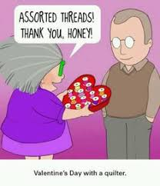

Earthquake Cake

1 box German Chocolate cake mix (I used a chocolate fudge cake mix)
1 cup unsweetened coconut
1 1/2 cups chopped pecans
8 oz. cream cheese
1 stick butter (1/2 cup)
4 cups powdered sugar

-Preheat oven to 350. Grease & flour a 9 x 13 baking dish.
-Spread coconut & pecans in bottom of prepared dish. (Recipe said you could also add a bag of chocolate chips here. I used a bag of salted caramel chips.)
-Mix cake mix according to package directions and spread over top of coconut & pecans.
-Melt butter & cream cheese over low-medium heat in medium saucepan; whisk til smooth. Add powdered sugar & whisk til combined.
-Spread cream cheese mixture over top of cake batter & smooth the top.
-Bake 50-60 minutes until cake tests done with toothpick.
-Cool completely before cutting into squares. Store tightly covered.
-After 2 days, store any leftovers in refrigerator

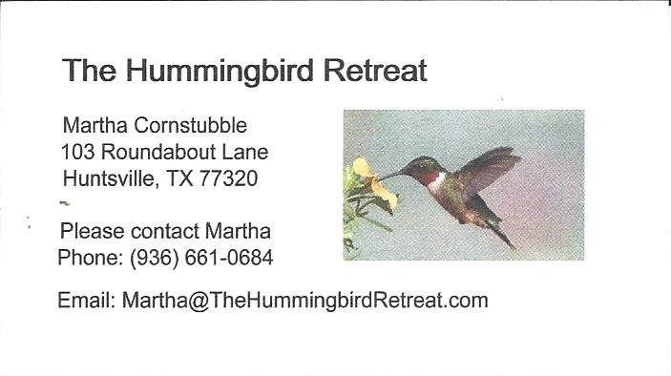
_{Newsletter ad prices are:}
$5.00 a month or $50.00 per year for a business card size advertisement.
$10.00 a month or $100.00 per year for a 3.5” x 4.5” size advertisement.
$18.00 a month or $180.00 per year for a one-half page advertisement.
$36.00 a month or $360.00 per year for a full page advertisement.
Member ads are free and will run for one month per request

_{Tall Pines Quilt Guild}
_{P.O. Box 7272}
_{Huntsville, Texas 77342-7272}

_{Tall Pines Quilt Guild Meeting} _{Guild Calendar Reminders}
You are invited to join us the first Monday of March 4, 2019 6:30 PM Guild Meeting
each month. The guild has a variety of _{February 19, 2019 Charity Bee}
programs, nationally known speakers, _{Meeting Reminders:}
_{workshop and charity projects.} _{Bring Show and Tell Items}
We meet at the University Heights Baptist Church _{Bring money for Food Bank}
_{2400 Sycamore Ave.} _{UPC Labels from Hobbs batting}
Park in the back lot off Palm Ave. _{FQ Bands from Fabric Carousel}
Refreshments are served at 6:30PM _{For Charity Bee}
and the meeting starts at 7 PM. Visit the web site @ www.tallpinesquiltguild.com
