Send this form and $5.oo non-refundable entry fee to:  Tall Pines Quilt Guild  P.O. Box 7272  Huntsville, TX 77342  Deadline for submitting entry forms is  March15  Quilts are due last  Saturday in April | 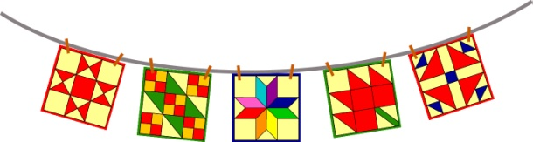  Airing of the Quilts  May 6, 2017  Historic Downtown Huntsville, Texas | For Guild Use Only  Entry Number ____________  Entry Fee _______________  Payment ________________  Member TPQG ___________

Name of Exhibitor:
Address:
City, State and Zip:
Email: |  | Phone number:
Title of Quilt:
Top made by: | Quilted by:
Dimensions: Height: Width:
Construction Technique: Pieced Appliqué Mixed Wholecloth Other
Story of the Quilt: The story will be displayed on the quilt. Please print or type the story in 30 words or less. Please give information such as: What inspired the quilt? What would you like others to know about the quilt? Was it made for a special person or occasion? Narrative is subject to editing.

- Quilts must have a sleeve and label. See Guidelines for details.
- Please include a photograph of the entry. Write exhibitor’s name on back of photo. Photo is required. Photo will not be returned.
- One check for total amount of entry fees may be used for multiple entries.
Method of Pick-up
Entries must be picked up at 6:00 PM on day of Airing
I will pick up my entry in person
My agent, _________________________, will pick up my entry
Deliver entry by mail/service (pre-paid mailing label enclosed)
Method of Delivery:
Quilts may be delivered on last Saturday in April
I will be delivering my entry in person
I will be mailing my entry by UPS/FedEx
I will be mailing my entry by US Post Office

RELEASE OF LIABILITY
Neither the City of Huntsville nor the Tall Pines Quilt Guild or its members are responsible for loss due to theft, fire, vandalism or acts of God to any quilt, display item, or any associated material left with the Airing of the Quilts Committee. I acknowledge that I have read the above statement and agree to abide by the City of Huntsville and the Tall Pines Quilt Guild show rules.

Signature ______________________________________________________________________ Date _____________________________

